The project is co-financed by the European Union from the European Social Fund
as part of technical assistance under the Operational Programme for the Opole Province for 2014-2020

Report on the implementation of evaluation research entitled:
“In-depth analysis and assessment of the impact of projects implemented under Measures 7.1, 7.2 and 7.3 of the Operational Programme for the Opole Province for 2014-2020 on the improvement in the labour market situation of the inhabitants of the Opole region”.

Research implemented by:
Silesian Institute in Opole

The report has been developed by a team composed of:
prof. dr hab. Krystian Heffner – research head
dr hab. Brygida Solga, prof. of the State Research Institute – Silesian Institute
dr Marek Korzeniowski
dr Piotr Gibas
mgr Robert Wieczorek

Opole, May 2020

TABLE OF CONTENTS
1 STRESZCZENIE 3
2 SUMMARY 10
3 SITUATION ON THE REGIONAL LABOR MARKET IN 2014-2019 16
4 PANDEMIC SITUATION AND ITS IMPACT ON THE LABOUR MARKET 22
5 METHODOLOGICAL ASSUMPTIONS 28
5.1 Main goal and specific objectives of the evaluation 28
5.2 Evaluation criteria applied 29
5.3 Research and analytical methods and techniques used 29
6 ASSESSMENT OF THE ADEQUACY OF SUPPORT TO THE NEEDS OF THE OPOLE LABOUR MARKET AND CHALLENGES FACED BY IT 32
6.1 Assessment of the adequacy of support forms 32
6.1.1 Spatial distribution of support 32
6.1.2 Target groups of support beneficiaries 37
6.1.3 Spatial distribution of support in the future financial framework 41
6.1.4 Beneficiaries of support in the future financial framework 44
6.2 Assessment of the effectiveness of support forms 49
6.2.1 Competences, qualifications and skills acquired as a result of participation in the support 49
6.2.2 Cannibalisation of products and services in the Programme 57
6.2.3 Impact of participation in support on taking up work 65
6.2.4 Impact of participation in support on occupational mobility 73
6.2.5 Impact of participation in support on building the capacity of regional specialisations 76
6.3 Assessment of the effectiveness of support forms 79
6.3.1 Effectiveness of the forms of support in terms of economic activation 79
6.3.1 Effectiveness of the forms of support in self-employment 86
6.3.2 Employment efficiency of companies established as a result of co-financing 97
6.4 Assessment of the usefulness of support forms 99
6.4.1 Usefulness of support instruments in terms of economic activation 100
6.4.2 Usefulness of support instruments in terms of self-employment 105
6.5 Assessment of the durability of support effects 111
6.5.1 Durability of the effects of support in terms of economic activation 111
6.5.2 Durability of the effects of support in terms of in self-employment 125
7 TOTAL IMPACT OF SUPPORT EFFECTS 129
8 ASSESSMENT OF THE CORRECTNESS OF THE FORMULAS FOR THE IMPLEMENTATION OF INTERVENTIONS UNDER THE OPERATIONAL PROGRAMME FOR THE OPOLE PROVINCE FOR 2014-2020 AND THEIR RELEVANCE IN 2021-2027 136
9 RECOMMENDATIONS 144
10 REFERENCES 154
11 SPIS TABEL, RYCIN I WYKRESÓW 156

SUMMARY
Pandemic situation and its potential impact on the labour market
There is no doubt that the pandemic will have a significant impact on the economic situation of the region. However, currently, due to its highly dynamic nature and lack of sufficient hard macroeconomic data, it is not possible to clearly estimate the scale of this impact. All that can be done is to try to estimate its scope and size. Low unemployment combined with the so-called automatic stabilisers of the economic situation may slightly alleviate the issues on the labour market triggered by the epidemic, but this will happen only if the situation will go back to normal relatively soon. Otherwise, the situation on the labour market will deteriorate steadily and progressively.
The changes expected to occur on the Opole labour market may be close to the national average. In the most pessimistic scenario, which assumes that the pandemic will not be over by the end of the year, the unemployment may significantly grow. At this point, it is fairly difficult to predict the trends in inflows and outflows to and from the Opole labour market. Companies in the Opole region may be greatly affected by the temporary or permanent shortage of foreign workers, especially since immigrant-oriented companies constitute the high percentage of all companies and the foreigners constitute the high percentage of all employees in the Opole region, both being among the highest percentages at the national level. Currently, we observe first serious effects of the pandemic on the labour market, which is a widespread suspension of businesses. Industries which recorded the most applications for the suspension of business include retailing (excluding motor vehicles), transport, education and healthcare. Current analyses indicate that the number of job offers may decrease by half after a 4-week quarantine period. Moreover, as much as 70.0% of Polish employers are reporting the pandemic-related difficulties resulting from quarantine, travel restrictions, collapse of the supply chain and other factors. The service sector, in a broad sense, including tourism industry, passenger transport, catering, trade and entertainment, is most seriously affected. These industries are followed by production workers in the companies which record a decline in the number of orders or the collapse of supply chains. Workers employed under civil-law contracts are at the risk of dismissal in a short time. This means that the profile of the unemployed is likely to change to include educated, qualified and experienced workers. On the other hand, there are reasons to believe that some sectors, critical to the economy of the Opole region, will maintain stable employment. Agri-food industry, logistics and new technology industries are the industries which will probably not be significantly affected by the slowdown. On the contrary, the chances are that these industries will record the growth of employment and production. The construction industry is yet another area which seems to be in a good condition, which is due to their projects being underway. However, due to the inevitable economic slowdown and the reduced number of new construction investments, the fall of employment in this industry should be also expected. Due to the closure of borders, the suspension of transport and the fall in demand abroad, all industries which are based on export, e.g. the furniture industry, are also likely to be severely affected.
Due to the impact of the pandemic, it is likely that the support under the Operational Programme for the Opole Province in 2021–2027 will need to be revised, allowing for the following:
- the number of unemployed will increase and become internally more diverse than before (to include people with specific professional qualifications);
- not only passive labour market policy tools (unemployment benefits), but also active instruments will be particularly needed (a differentiated support package targeted at people who have become unemployed as a result of the current situation should be included);
- as a new instrument of economic activation, the companies which closed down/collapsed as a result of the pandemic should receive funds for reactivation;
- key recommendations for the project include:
- demand system,
- larger group of support beneficiaries,
- support for people aged 50 or more and women,
- the increase in the amount of loans for reactivation of the company,
- greater importance of the relocation voucher and the housing voucher.
The analysis of local labour market 2014–2019
Until March 2020, unemployment was not a key problem of the local labour market. According to the statistics, the number of unemployed has progressively decreased since 2013 and the rate of unemployment was only 5.8% in 2019. However, the situation on the Opole labour market was worse than in other regions of the country. Structurally, spatial diversification of the level of unemployment was a significant problem. While some areas recorded a low level of unemployment (the natural rate of unemployment), it was relatively high on a few local labour markets, i.e. in Prudnik district (9.0%), in Głubczyce district (8.8%), in Namysłów Ddistrict (8.0%) and in Brzeg district (7.7%). Moreover, the rate of decline also varied from region to region. This was mainly due to demographic factors, including migration, and the decrease in labour supply.
The socio-demographic characteristics of residents of the Opole Province are as follows. The unemployed were mainly young people aged 25–34. The vast majority of the unemployed (59.5%) had vocational education or lower. General secondary education (9.6%) and tertiary education (12.2%) accounted for the fewest number of the unemployed although the number of people with tertiary education among the unemployed constantly increased in the period from 2014 to 2019. For graduates of basic vocational education schools, the figures were more favourable than in the country. In 2017, the rate of unemployment in this group was 4.6 with the national average at 6.4.
The group of people facing special situation on the labour market is largely represented by long-term unemployed. More than a half the registered unemployed were women, rural residents, the unemployed not entitled to unemployment benefit, young people under 25 and the unemployed aged at least 55. This shows that the problem of unemployment on the Opole labour market concerns the underserved, i.e. people who face huge difficulties in finding and keeping a job and experience long periods of unemployment. Women and people with disabilities are the two largest marginalised groups.
The studies on the Opole labour market indicated that the employer’s market was gradually transformed into the employee’s market as some professions started to experience recruitment difficulties. On the other hand, the demand for people with tertiary education did not significantly increase and thus the Opole labour market still served as an “auxiliary employee’s market.” This may change as the social consequences of the pandemic can substantially impact the labour market and the economic situation of the region.
There are two factors which determine the circumstances of the local labour market. The first one is migration which deeply affects human capital resources in the region, hinders competitive economy and has a great influence on the indicators of entrepreneurship.
The second one is demographic crisis in the region. This crisis is caused not only by intensified migration processes, but also by the effects of low-fertility trap: the progressive depopulation of some areas of the Opole Province, especially border areas and those with native residents, as well as fewer and aging labour resources. The rate of decrease in population and labour resources will be higher than the national average, and the labour resources in the mobile production group may decrease to almost 50.0% of the current state. The situation on individual local labour markets will also change significantly. In the districts of Głubczyce, Kędzierzyn-Koźle, Nysa and Prudnik, the number of people of working age will decline to about 40% while the number of older people in the local population structure will rise to over 30%. Another important factor is the lack of qualified workers resulting in the inflow of foreign labour force. Note that the Opole region is on the third place in this respect, placed behind the Mazowsze Province and the Warmia-Mazury Province. However, due to the effects of the pandemic, the inflow of foreign workers to Poland is subject to restrictions and the outflow of those who are still in Poland, especially Ukrainian workers, tends to grow. Therefore, it is likely that the pandemic will affect the factors discussed above and deteriorate the situation of the labour market of the Opole Province and local labour markets.
The impact of Priority Axis 7 on the situation of the labour market in the Opole Province
Local documents specifying the conditions and scope of measures to address the labour market have been prepared in line with the national guidelines. Occupational activation programmes have been adapted to the current situation on the labour market in the region. However, due to the projected impact of the pandemic on the labour market and local economy, they will have to be substantially revised in the new programming period (Operational Programme for the Opole Province for 2021–2027).
Analysis and assessment of the adequacy of support
Priority Axis 7 granted the support for the unemployed, jobseekers and the economically inactive to increase employment and occupational activation of marginalised people. The aid addressed to the unemployed included various forms of support. The study explored selected forms of support: internships/traineeships, standard and additional equipment at work, training courses and funds/loans for start-ups. The study has revealed the degree of adequacy of the distribution and intensity of support granted to the Opole Province under Priority Axis 7. In general, the support was provided to the districts with the highest number of the unemployed, i.e. Nysa and Brzeg. Prudnik, Namysłów, Kluczbork received less support than was reported in the statistics. The least amount of support was given to Głubczyce despite its high rate of unemployment in 2015 at the launch of the Operational Programme for the Opole Province. However, it should be noted that the support covered the local labour markets with the greatest needs in this respect and slower growth of jobs as compared to the demand, and to the districts with the low rate of entrepreneurship, i.e. Nysa and Brzeg.
Target groups were properly selected based on the situation on the labour market in Opole at that time. The following groups were supported: the unemployed, the long-term unemployed, the economically inactive, the underserved (women, the disabled, people aged at least 50), people with no or low professional qualifications and people in a particularly difficult situation on the local labour market. Importantly, the support was given to the age group with the highest economic activity, able and expected to work, i.e. people between aged between 30 and 50. The problem of the shortage of qualified employees on the Opole labour market was also addressed. The opportunity to obtain qualifications in rare professions was provided to better satisfy the needs of employers. As a result, the disparity between demand and supply on the labour market was reduced. Training topics corresponded, although to a limited extent, to local specialisations.
Analysis and assessment of the effectiveness
In general, the effects of implementation of the projects aimed at improving the employment situation of project participants are positively assessed. The key factors include financial incentives, personal involvement of the participants, and matching the offer to individual needs and the needs of labour market. Note that both forms of support, i.e. internships/traineeships and training courses under Priority Axis 7, proved remarkably effective and had the greatest impact on the improvement of the employment situation of project participants. The majority of respondents who completed an internship/traineeship (64.0%) and a training course (63.5%) commenced work and effectively significantly changed their situation on the labour market. A fixed-term full-time employment contract was the most popular form of employment. Failure to commence employment after project completion was mostly due to the personal situation of the participant. Funds for start-ups also turned out to be an effective form of support. The majority of companies (63.4%) still operated at the time when the survey was made. However, the program exhibited the cannibalisation. The following factors prove this: a similar portfolio of support instruments, a similar frequency of their use and the same forms of support targeted at structurally identical groups (status on the labour market, sex, age, education).
People with no (32.1%) or low professional qualifications constituted a significant percentage of the registered unemployed in the Opole Province. This shows that training courses were an important form of support corresponding to their needs resulting from the difficult situation on the labour market. Training courses used by the respondents included mainly supplementary training for professional qualifications, including acquisition of new competences (64.4%) and training for the acquisition of new/other professional qualifications (58.0%). Other training courses developed software skills (37.5%), soft skills, such as self-presentation and stress management (26.0%) and communication in foreign languages (16.3%), i.e. the competences which become increasingly important for employers and increase the chances of finding a job. The offer also included training courses focusing on job seeking skills (27.0%).
The impact of support under Measures 7.1 and 7.2 on the occupational mobility varied among the participants. In particular, the majority of project participants (80.0%) did not change their place of residence due to the employment, whereas a significant number of training course participants (44.2%) moved to another location. Support beneficiaries were reluctant to accept occupational mobility not because they participated in the support project, but rather due to the effectiveness of support, especially internships/traineeships which helped them commence work in or near their place of residence. It reinforced the reluctance to migrate and weakened occupational mobility tendencies. Such attitudes were equally expressed by both training course participants (71.1%) and internship/traineeship participants (70.0%).
The impact of participation in the support project on building local specialisations was not high. Training topics and orientation of companies in which the internships/traineeships were held corresponded to local specialisations only partially. However, the skills and competencies the participants acquired quite adequately responded to the development needs of companies involved in local specialisations. Similarly, despite the fact that most profiles of new businesses fit into the areas defined in RSI, the companies were mainly oriented towards services (68.6%), trade (11.8%) and mixed activities while production companies were opened very rarely.

Analysis and assessment of the effectiveness of support
The amount allocated to Measures 7.1 and 7.2 for the most needy districts ranged between PLN 5,929,011 (Głubczyce) and PLN 26,896,201 (Nysa). The analysis of the average costs of economic activation shows that the cost effectiveness in Measure 7.1 and Measure 7.2 amounted to about PLN 6,000 and over PLN 16,000, respectively. The spatial distribution of the funds shows that the support was primarily given to the Nysa district. This is where the largest funds were invested due the particularly hard situation on the labour market as compared to other districts. The employment effectiveness for Measures 7.1, 7.2 and 7.3, measured by the number of people who started to work as a result of support was high. The proportion of the employed was much higher than of those who failed to take up work. If the effectiveness, i.e. the percentage of people employed, is checked against the number of forms of support, the participation in two or three forms of support proves most effective for activation in the labour market.
The results of the study show that the employment effectiveness of new companies was not high. Most new businesses were sole proprietorships (68.1%) based on self-employment. In the vast majority of cases, employees were employed on a full-time basis (80.8%) with all types of contracts, mostly fixed-time contracts (49.2%). These unfavourable trends in the labour market undermine job security.
Analysis and assessment of the usefulness of support
For internships/traineeships and training courses, the usefulness of support under Measures 7.1 and 7.2 was highly rated. Skills and knowledge acquired during internships/traineeships were positively assessed primarily due to broadening knowledge and acquiring new skills (64.0%). In terms of the usefulness of skills and knowledge on the labour market, the assessment was also positive. More than one-third of respondents (37.2%) found them very useful or useful while 31.2% of the respondents rated them as moderately useful. The usefulness of training courses was also rated very high. For all types of training courses (except training courses which developed foreign language communication skills), the prevailing answer was Everything I learned was new to me. More than a half of respondents (53.8%) found the skills and competences acquired during training courses very useful or useful on the labour market. No difficulties or problems (except single cases) were reported during participation in internships/traineeships and training courses. For Measures 7.1 and 7.3, one-third of support beneficiaries (32.0%) found funds/loans for business start-up fully useful while 42.6% expected them to be higher. More than a half of the respondents (62.8%) claimed that the support (financial resources) was adjusted to their needs. However, only more than one-third (34.6%) of the support beneficiaries could satisfy all their needs. In the case of some respondents (31.7%), funds/loans for start-ups were supported by positively assessed training courses aimed at transferring the knowledge and skills necessary to set up and run a business.
Analysis and assessment of the durability of support
The results of the study show that the vast majority of respondents became economically active (93.0%) having completed an internship/traineeship while more than two-thirds of them (69.2%) did so having completed a training course. The vast majority of respondents were employed on the basis of employment contract (89.8% for internships/traineeships and 73.6% for training courses). Most of internship/traineeship participants and less than a half of training course participants (40.3%) were employed on the basis of a contract for an indefinite period of time. Less than one-third of internship/traineeship participants (29.2%) and about one-third of training course participants (30.8%) remain unemployed. The respondents failed to take up work due to the lack of attractive offers on the labour market (more than half of participants of internships/traineeships and training courses) and for personal reasons. More than a half of the support beneficiaries (internship/traineeship and training courses participants) positively assessed the impact of support on their professional development opportunities. A large number of internship/traineeship participants (40.1%) and nearly one-third of training course participants admitted that they would not have a chance to obtain their current job if they did not receive the support. More than a half (66.0%), including a large number of those who ceased to be obliged to run their business (39.0%), continued to do so. The situation of the vast majority of companies (86.5%) was assessed as good (63.3%) or very good (23.1%). Half of the respondents (50.0%) intended to purchase equipment, machinery or software (61.8%) in order to develop their company. For this purpose, they intended to use external funds (loans and funds – 77.3%) obtained from public entities (PUP, OCRG – 80.0%). However, the majority of entrepreneurs did not intend to hire new employees (65.9%). Half of those who hired employees (53.5%) intended to improve their skills and the skills of their employees by further training or acquiring new professional competences (29.7%) within the next 12 months.
One-third (34.0%) of the respondents suspended or dissolved their business activity, most often due to too high social security premiums (50.8%), unprofitability of business (44.1%), less often due to family situation or ill health (38.1%). The majority of those who suspended or dissolved their activity were employed under full-time or part-time employment (58.5%). The rest searched for a job (22.0%).

SITUATION ON THE REGIONAL LABOR MARKET IN 2014-2019
Analyses of public statistics data show that from 2014 to the end of December 2019, the situation on the Opole labour market was systematically improving. A decrease in the unemployment rate was accompanied by a growing employment rate and an increase in the number of good and satisfactory jobs. Nevertheless, looking at the Opole labour market from a global perspective and thus examining it as a complex socio-economic problem, it is worth emphasising that despite a number of positive changes, unfavorable phenomena and processes persist on it.
The factors limiting the development prospects of the Opole region include, primarily, its low competitiveness, a limited inflow of private investments, low capital expenditure on technical and social infrastructure, a low innovation rate, and a low position of its capital, referred to as an “unfinished metropolis”. Although Opole dominates in the internal structure of the region, its external position, especially in terms of close proximity to metropolitan-type systems, is relatively weak. Despite the fact that in view of the foregoing the Opole Province is still classified as an area of average attractiveness, it is worth noting the constantly growing potential of the region, in particular, an increase in the number of economic entities and foreign investments.
The unfavourable situation on the Opole labour market is also due to the current structure of the demand for labour, determined by the number and type of enterprises operating on it. As for the industrial or service sectors in the Opole region, there is no significant number of companies operating in the area of high technology or high-tech services, which results in a limited number of job offers for people with tertiary education.
The current condition of the Opole labour market is also determined by the availability and quality of labour resources present on it. Although the Opole labour market is increasingly open to foreign workers, shortages in the field of human and social capital resulting, among others, from the level of education of the residents, deficits in the field of lifelong learning, and intensified foreign migrations, are still observed.
The current research also shows that the transformations observed on the regional market do not allow for abandoning its description as an “auxiliary employee market”. Teresa Sołdra-Gwiżdż has the following view in this respect: “This situation is undoubtedly related to the depth of the labour market, i.e. the relatively limited number and structure of industries that operate on it [...]. Such picture of the labour market is also determined by the low level of education of the residents and the low number of job offers for people with tertiary education”.

Table 1. Percentage of the population aged 15-64 by education level in 2014-2019 in the Opole Province and in Poland
Education type | Years
 | 2014 | 2015 | 2016 | 2017 | 2018 | 2019
Tertiary education (the Opole Province) | 20.7 | 21.9 | 21.7 | 22.8 | 22.9 | no data
Tertiary education (average for Poland) | 23.8 | 24.4 | 25.2 | 26.3 | 27.2 | no data
Post-secondary non-tertiary education (the Opole Province) | 3.2 | 3.3 | 3.2 | 3.2 | 3.4 | no data
Post-secondary non-tertiary education (average for Poland) | 3.1 | 3.1 | 3.0 | 3.0 | 2.8 | no data
Secondary vocational education (the Opole Province) | 20.1 | 20.4 | 20.8 | 20.4 | 21.0 | no data
Secondary vocational education (average for Poland) | 20.7 | 21.0 | 21.5 | 21.4 | 21.5 | no data
Secondary education (the Opole Province) | 9.3 | 9.5 | 9.9 | 9.1 | 9.9 | no data
Secondary education (average for Poland) | 10.9 | 10.7 | 10.4 | 10.5 | 10.5 | no data
Vocational education (the Opole Province) | 30.9 | 29.5 | 29.8 | 30.4 | 29.7 | no data
Vocational education (average for Poland) | 26.0 | 25.6 | 25.3 | 25.0 | 24.5 | no data
Lower secondary, primary and pre-primary education (the Province) | 15.8 | 15.4 | 14.6 | 14.1 | 13.1 | no data
Lower secondary, primary and pre-primary education (average for Poland) | 15.5 | 15.2 | 14.6 | 13.8 | 13.5 | no data
Source: own study based on the Local Data Bank of Statistics Poland
Although currently unemployment is not a key problem on the Opole labour market, as it is regularly decreasing, the situation in this respect is still worse than in other Polish regions. Thus, unemployment continues to be a major social problem in this region.
Chart 1. The unemployment rate in the Opole Province in 2013-2019
Source: own study based on the Local Data Bank of Statistics Poland
A major structural barrier in this context is its spatial differentiation. While some areas record low unemployment, oscillating around the so-called natural unemployment rate (the city of Opole – 2.7%, the districts of: Olesno – 4.0%, Strzelce – 5.1% and Krapkowice – 5.4%), there are a number of local labour markets that still record relatively high unemployment rates (i.e. in in the districts of: Prudnik – 8.9%, Głubczyce – 8.9%, Namysłów – 8.0%, and Brzeg – 7.7%).
Figure 1. Unemployment rates in districts in the Opole Province (as at December 2019)
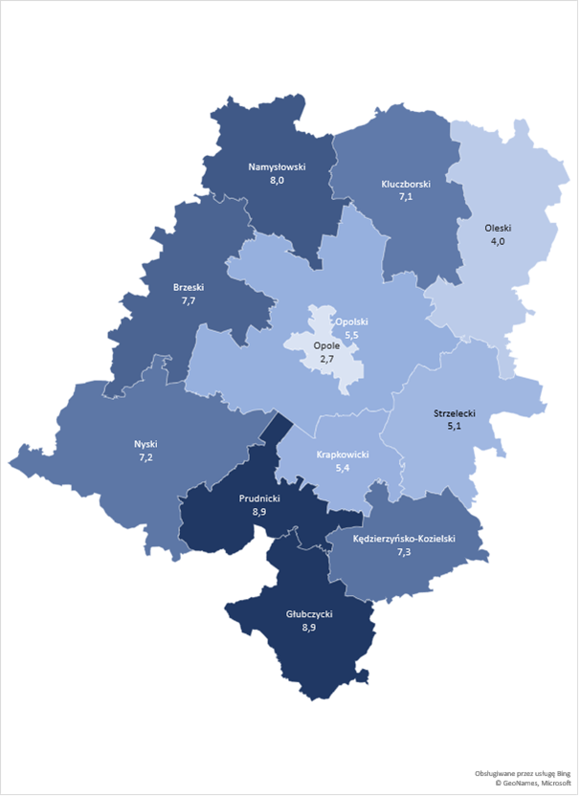
Source: own study based on data of the Provincial Labor Office in Opole

Apart from the spatial differentiation, the other indicators of the volume, scale, and structure of unemployment in the structural dimension show that the overwhelming majority of the unemployed in the province concerned are people with the lowest education. Graduates of vocational schools are in a more favorable situation, as the unemployment rate among them is lower than the average for Poland. The lowest unemployment is recorded among people with general secondary and tertiary education (although in 2014-2019, there was a constant increase in this group’s share in the total number of the unemployed).
Table 2. Percentage of registered unemployed people with tertiary education in the Opole Province in 2014-2019
Education type | Years
 | 2014 | 2015 | 2016 | 2017 | 2018 | 2019
Tertiary education (the Opole Province) | 11.0 | 11.7 | 11.9 | 12.6 | 12.2 | 12.2
Source: own study based on the Local Data Bank of Statistics Poland
The group of the registered unemployed is heavily dominated by women, rural residents, as well as young people under 25, people aged 55 and more, and people with disabilities. It is also worth noting that a large number of the registered unemployed are not entitled to unemployment benefits.
Thus, it should be stated that the problem of unemployment in the region is related to the situation of groups defined as disadvantaged, i.e. those that are in a difficult situation on the labour market, face greater barriers to taking up and a job, and experience long periods of unemployment.
What is characteristic of the Opole labour market is, above all, the progressive feminisation of unemployment. The main reasons for the significant economic inactivity of women compared to the rest of Poland include the scale of foreign migration. In those parts of the region where emigration is significant and is a long-term process (i.e. in the central-eastern part), the share of unemployed women and people with no entitlement to the unemployment benefit is significantly higher than in the other parts of the province. This situation concerns largely the non-working wives of emigrants, who are not interested in taking up employment, but only in obtaining the right to social security. Moreover, as research shows, social roles served by women, such as caring for children or aging parents, continue to collide with taking up a job. It is also worth emphasising that women over 50 years of age serve the role of a caregiver much more often than men, which is too often associated with either not taking up work or with increasing tendency to take up part-time work. The participation of women in professional work, which is lower than that of men, is also caused by their more frequent and more willing dismissal from work. In the Opole Province, women account for more than half of the people who have been dismissed from work for reasons related to the workplace. Unemployed women are also less likely than men to take up work in the “shadow economy”. Moreover, although the percentage of unemployed women that declare their willingness to participate in courses aimed at raising or changing their qualifications is similar to that of unemployed men, women are show lower occupational mobility. Unfortunately, research shows that having small children by a woman continues to be a sufficient reason for some employers to decide not to employ such a woman, regardless of her qualifications. Furthermore, despite declaring non-discrimination, some employers indicate specific jobs for which they do not intend to employ women, which is justified by them by the specific characteristics and costs of organising these jobs, as well as women’s lower physical and health predispositions.
Statistics show that the second large group excluded from access to the labour market are people with disabilities. This group’s share in the total number of registered unemployed people in the region is around 5%, and long-term unemployment is increasingly common among them. Research conducted among unemployed people with disabilities shows that most of them want to take up work and are actively looking for a job, and only one-fifth of them prefer social assistance in an amount that would let them not take up work. Research also shows that about half of people with disabilities who want to take up work have faced discrimination (e.g. refusal to employ), whereby a quarter of them more than once. It is worth confronting the above-mentioned findings with surveys conducted among employers, that show that about one-fifth of economic entities operating on the local labour market (private and public) employ people with physical disabilities. It should also be noted that for as many as a quarter of the respondents, physical disability was an obstacle to employment, whereby the most frequently mentioned barriers were of an economic or technological nature.
As for the key determinants of the situation on the Opole labour market, it can be undoubtedly stated that these are related to two factors:
- Emigration is the first and the most important one. Although its negative consequences can be observed in almost all development spheres, as for the situation on the Opole labour market, it is worth emphasising that the outflow of qualified people from the region depletes human capital resources, which results in the inability to develop a competitive economy, as the role of the human factor in the development of the province is greater than that of the economic one. The reasons for this situation should be sought in the growing human resources needs of the EU markets, as well as in the increased spatial mobility and consumption aspirations of the young generation. Currently, for many rapidly developing sectors and industries that have the economic potential for increasing employment, the lack of suitably qualified employees is a barrier that prevents or hinders their development. This problem was highlighted by research carried out in the Opole Province in 2017, that showed that almost 60.0% of entrepreneurs in the region had difficulties in recruiting employees (mainly workers and craftsmen, service and sales workers, and specialists), while countrywide, similar problems were encountered by less than half of employers. It is also worth emphasising the negative impact of emigration on the formation of entrepreneurship development indicators. In municipalities with a greater share of emigrants in the total population, a clearly lower rate of entrepreneurship can be observed, and has been so basically since the beginning of the 1990s. The area of traditional emigration drainage is characterised also by a lower growth rate. In the last decade, the increase in the number of people running a business in the municipalities in this area was one of the lowest in the region.
- The demographic crisis caused by the “low fertility trap”, resulting in progressive depopulation processes in some areas of the province (in particular, the border areas and those inhabited by native people), especially the decrease in labour resources and their aging, is the other. For the Opole labour market, this situation is particularly acute, because the rate of the decline in the population and labour resources in the region is greater than the average for Poland. This means that by 2050, the population of the Opole Province may decrease by approx. 25%, including 30% in the cities and almost 20% in the rural areas. The labour force in the mobile production group may decrease to almost 50% of its current volume, and a rapid decline in its number will occur in the next decade. The situation on particular local labour markets will also change significantly. In the districts of Głubczyce, Kędzierzyn-Koźle, Nysa, and Prudnik, the working age population will decrease to around 40% of its current number. At the same time, the share of older people in the regional structure of the population will increase to over 30%.
Summing up, it should also be noted that the depopulation processes taking place in the region are currently not sufficiently offset by the inflow of foreign labour, despite the fact that the Opole region is specific in this respect. In 2018, entrepreneurs submitted to all district labour offices over 60,000 declarations on entrusting work to foreigners (in 2019, this figure was 85,000). Thus, the share of companies employing foreigners, as well as that of foreigners among employees, is one of the highest in Poland. In both cases, this share is around 10%, and the Opole Province ranks third in this respect, after the Mazowsze Province and the Warmia-Mazury Province. Even if it is supplemented through an effectively implemented immigration policy aimed at the social and professional integration of newcomers and people returning from abroad, over time, the problems related to the diminishing labour force will be increasingly profound on the Opole labour market.
The presented picture of the labour market concerns the situation before the outbreak of the pandemic. It is, therefore, obvious that it will be modified due to factors related to the epidemic and its profound social consequences.

PANDEMIC SITUATION AND ITS IMPACT ON THE LABOUR MARKET
In the light of the statistical data published by Statistics Poland, the situation on the domestic labour market in the first months of 2020 was similar to that in the last quarter of 2019. Nevertheless, there were signs of a negative impact of the pandemic on the labour market. In March this year, the average employment in the enterprise sector decreased compared to that recorded in February this year, while in the previous months, its slight increase was recorded. The number of job offers registered in labour offices was much smaller than a month ago and a year ago. It was the lowest in the last five years. In March this year, the average employment in the enterprise sector was 0.5% lower than in February. Compared to the month ago, the employment rate decreased in all sections, except for information and communication, where it did not change significantly. Its greatest declines were recorded in the HoReCa industry (by 2.7%), mining and quarrying (by 1.6%), trade, repair of motor vehicles, and administration and support services (by 0.6% each). Over the year, employment continued to grow (though to a lesser extent than in the previous months of this year) in: information and communication (4.4%), transport and warehouse management (3.2%), professional, scientific and technical activities (2.8%), water supply, sewage and waste management, and remediation (2.1%), HoReCa (1.1%), and construction (0.6%). Among the sectors with a significant share in the employment structure, its greatest decreases compared to the previous month were recorded in enterprises dealing with hard coal and lignite mining (by 2.2%), manufacture of furniture (by 1.1%), and retailing (by 0.8%). The decline in employment compared to the same period last year was observed, among others, in manufacture of machinery and equipment (by 2.8%), hard coal and lignite mining (by 2.6%), manufacture of wood, cork, straw, and wicker products (by 2.3%), construction of buildings (by 2.1%), manufacture of motor vehicles, trailers and semi-trailers, and in retailing (by 1.2% each).
Compared to February this year, in March, the unemployment rate decreased in twelve provinces (the most in Świętokrzyskie – by 0.3 pp.), in three ones it did not change (Lubuskie, Opole, and Wielkopolska), and in one – Pomorskie – increased (by 0.1 pp.), while in April this year, in the Opole Province this rate increased to 6.5%. In April, the number of the unemployed increased by 1.9 thousand. This figure includes people working in Austria and Germany who returned to Poland.
The structure of the unemployed registered as at the end of March this year was similar to that observed in the previous month. The share of particular categories of the unemployed in the unusual situation on the labour market in the total number of the registered unemployed did not change much compared to that recorded in the previous month. There were, however, more people dismissed for reasons related to the workplace than in the previous month (by 8.1%). In March this year, labour offices received 77.6 thousand job offers, i.e. 31.1% fewer than in the previous month and 39.8% fewer than in the same month last year. There was a decrease in the number of offers from both the public sector (by 44.9% over the month) and the private sector (by 28.9%).
According to statistical data the situation on the Opole labour market in the first quarter of 2020 was also similar to that of the last quarter of 2019. The spatial differences in the unemployment rate prevailed, but in March 2020, the districts of Opole, Olesno, and Krapkowice and the city of Opole recorded an increase in the unemployment rate. In April this year, the highest unemployment rate was recorded in the districts of Głubczyce (10.1%) and Nysa (8.7%). In the district of Opole, this rate was 3.2%.
As at the end of March this year, more collective redundancies were declared than a month ago; 184 companies declared laying off 18.7 thousand employees, including 1.4 thousand people working in the public sector (as at the end of February this year, 116 companies made redundant 15.2 thousand employees, including 3.0 thousand ones working in the public sector). In March this year, district labour offices registered 122 people dismissed for reasons related to the workplace – a month earlier, this figure was 133. At the same time, one company from the district of Opole announced its intention to make redundant collectively 54 people, and immediately laid off 39 employees in that period. The share of people in a special situation on the labour market in the total number of the unemployed did not change significantly compared to the previous month, and was 82% of the total number of the unemployed. In March 2020, companies reported to district labour offices 2,165 vacancies (1,556 fewer than in February 2020). Taking the territorial differences into account, a decrease in the demand for employees was found in 10 districts compared to the data for the previous month.
There is no doubt that the pandemic will have a significant impact on the economic situation of the Opole region, especially on its labour market. Due to the high rate of the epidemic spread on the one hand, and the lack of sufficient “hard” macroeconomic data on the other hand, it is currently not possible to clearly estimate the scale of this impact. The expected directions and nature of these impacts can be indicated only. The first direct effects on the labour market will be noticeable only in the macroeconomic data for April or May 2020, i.e. the data published by Statistics Poland only in May or June this year. All the predictions made so far are merely predictions, made in the circumstances of high uncertainty as to the duration of the epidemic. Economists predict, however, that the economic and financial consequences of the pandemic will be significantly greater than those of the 2008 crisis. They may be even more profound that those experienced during the Great Depression in the 1930s – the greatest crisis in modern times. It is pointed out, for example, that enterprises in many European countries are now more indebted and household debt is higher than in 2008. The economic impact of the epidemic is likely to be greater than that we could have experienced if it had happened a few years ago, as at present, in the economy there are both structural foundations for a crisis (i.e. the coming economic slowdown) and an external shock in the form of an epidemic. However, the situation on the labour market is more favorable now, i.e. it was, in the period immediately preceding the epidemic. In Poland, the unemployment rate in January and February 2020 was approx. 5.5%, while in the Opole Province, this figure was 6.0%. The low unemployment rate, combined with the so-called automatic stabilizers of the economic situation, may slightly alleviate the epidemic-related problems on the labour market this year, provided that the epidemic is controlled relatively quickly. Otherwise, the situation on the labour market will be gradually and permanently deteriorating.
As already mentioned, due to the uncertainty related to the further development of the epidemic, the forecasts of its impact on the economy indicate a very wide range of fluctuations. Current estimates indicate that the decline in economic growth in particular European countries may range from marginal values (GDP decline of 0.1-0.3%) to very high ones (GDP decline of 10.0%). In the light of the estimates of the Polish Economic Institute, GDP in Poland may decrease– depending on the duration of the restrictions on economic activity – by 2.4% - 8.2%, i.e. the 2020 GDP will be from +1, 1% to -4.7%. The above estimates may (and probably will) be revised depending on the duration of the epidemic.
Forecasts regarding the situation on the labour market are uncertain as well. Analyses carried out so far show that the number of unemployed people in Poland may increase in 2020 by 400-500 thousand (in this case, the unemployment rate will increase to 8.0-8.5%) or by over 1 million (with the unemployment rate increased to 10.0%). It may, therefore, mean an almost twofold increase in unemployment in Poland. If it is assumed that the unemployment rate in the Opole Province is at the level of the national average and so is its decline rate, the scale of changes anticipated on the Opole labour market may be similar to the average in Poland. However, in the most pessimistic scenario (i.e. when the epidemic is not contained by the end of the year), the increase in unemployment may turn out to be much higher.
The situation on the Opole labour market is strongly affected – more than on average in Poland – by migration processes that play a significant role also currently. The economic slowdown in European countries may encourage emigrants to return to the region and seek employment there. However, some foreigners employed in the Opole Province (mainly Ukrainian citizens) have already left the region. Those were mainly people whose three-month tourist visa or a six-month work visa had expired. According to the data of the Embassy of Ukraine in Poland, more than 100,000 Ukrainian citizens left Poland at the end of March, i.e. almost 12.0% of all Ukrainians working in Poland until then. Even if it is assumed that other immigrants will be interested in staying in the region, the current emigration and rotation of Ukrainian citizens on the labour market will be factors that may contribute to significant fluctuation in labour supply in the medium term. Companies in the Opole Province may be severely affected by a permanent or temporary shortage of foreign workers, especially because the share of companies employing immigrants in the total number of companies and the share of foreigners in the total number of employees in the Opole Province were ones of the highest in Poland (both were in excess of 10.0%). The scale of the inflow to and outflow from the Opole labour market is difficult to predict at this moment. In the case of potential re-emigrants, it is worth considering the supporting measures that are recommended for this group (e.g. start-ups for people returning from abroad). It is also worth supporting immigrants from Ukraine in their rotation and searching for new employment on the regional labour market.
The first major effects include the currently observed suspension of economic activity on a massive scale. According to the data of the Central Register and Information on Economic Activity, over 48 thousand Polish companies suspended their economic activity in March, including 25 thousand ones only in the last week of March, i.e. twice as many as in the same period in 2019. In the first 3 days of April, over 8.5 thousand companies suspended their economic activity. Industries which recorded the greatest numbers of applications for the suspension of business include retailing (excluding motor vehicles), followed by transport, education, and healthcare. In the light of the applicable regulations, this situation concerns currently enterprises that do not have any employees, thus the smallest ones, often self-employed people who have lost their only orders. It is indicated, however, that given the persistent difficulties in the real economy, such decisions will be taken also by larger enterprises. What entrepreneurs will find the most important in the short and medium term is support for job maintenance at all levels of the fiscal policy (central, regional, and local).
Current analyses also show that after 4 weeks of quarantine, the number of job offers may decrease by half and that already 70.0% of Polish employers report difficulties resulting from the epidemic, quarantine, travel restrictions, collapse of the supply chain, and other factors. Only in mid-March, the current situation paralysed the operation of 30.0% of companies. Surveys conducted among entrepreneurs by Employers of the Republic of Poland show that in March this year, over 30.0% of the interviewed companies laid off their employees due to the pandemic, and almost 67.0% of them are planning to reduce employment. The scale of the employment reduction may vary – one-fifth of the respondents intend to lay off from 11.0% to 20.0% of their employees, and one in ten – from 21.0% to 30.0%. This means that every tenth employee may lose their job in April. The above data shows that the scale of changes on the labour market in the near future will be significant. According to the findings of the surveys carried out by the Polish Economic Institute, the financial situation of companies is deteriorating due to a widespread decrease in new orders. At the end of April, a decline in demand was experienced by 66% of companies. “The most difficult income situation is in the micro-enterprises sector and in trade. 74% of micro-enterprises and 75% of trade companies recorded sales lower than in March.” Importantly, enterprises are declaring their financial liquidity at a level better than expected. As for the surveyed companies, 52% of large, 45% of medium-sized, 36% of small, and 31% of micro-enterprises admit that they have funds sufficient to operate for more than a quarter. At the turn of May, 67.0% of companies are recording a decline in revenue compared to March, which is an increase by 10 pp. compared to the previous month. So far, 12% of enterprises have reduced employment. The situation of Polish companies remains uncertain, but increasingly fewer companies intend to apply radical survival strategies. “The manufacturing PMI reached in April its lowest level ever. Moreover, its value was lower than that of the index for the euro area (33.6 points) and that of the index for the United Kingdom (32.9 points). Economists expect in the hard data of Statistics Poland a decline in industrial production by over ten per cent. April 2020 was the worst month for Polish producers in the history of PMI surveys, i.e. since June 1998. The main index reached a record low level – 31.9 points, which was even less than the forecast 34.6 points. Let us recall that in industry, the adopted border between growth and recession is 50 points. Indicators regarding production, new orders, exports, purchases, backlogs, delivery times, and future production reached unprecedented low levels. On the other hand, the rate of decline in employment was almost equal to the record value recorded in April 1999.”
The industries that have first experienced negative changes to the greatest extent include the broadly understood service sector, including, in particular, tourism, passenger transport, catering, trade, and entertainment. The next group includes production workers in companies where the number of orders has decreased or the supply chains have not been maintained. In these industries, redundancies may affect first employees working under civil law contracts. Therefore, support will be required in the first place by employees working in the above-mentioned industries. However, these will not necessarily be employees with low qualifications, i.e. people who have been the main beneficiaries of support from labour offices in recent years. This will most likely entail a change in the profile of the unemployed in terms of their education, qualifications, and professional experience.
On the other hand, there are reasons to believe that some industries of importance to the economy of the Opole region will maintain stable employment. It is indicated that the agri-food industry, logistics, and new technology industries are unlikely to be significantly affected by the slowdown. There is even a good chance that in these industries, there will be an increase in both employment and production. It is also pointed out that due to the continuation of commenced projects, also the construction industry is currently still in a good condition. If adequate employment conditions are ensured (e.g. working in large spaces), the situation in this industry may also turn out to be stable in the near future. However, it must be assumed that due to the inevitable economic slowdown and the reduction in the number of new construction projects, there will be a decline in employment also in this industry. The current situation, with closed borders, transport suspension, and a drop in demand abroad, will surely affect all industries relying on exports (e.g. the furniture industry) to a large extent.
The above analysis leads to the following conclusions with respect to the labour market policy:
- labour offices must be prepared for serving a significant number of new unemployed people,
- the group of the unemployed will be internally diversified – apart from the low-qualified unemployed, this group will include people with specific professional qualifications (e.g. hairdressers, cooks, waitpersons, trip specialists, event managers) and often experience in running their own business. Therefore, a diversified support package should be considered, but it needs to be specifically targeted at people who have become unemployed as a result of the current situation (i.e. they were economically active until recently),
- for people with experience in running a company, that has been closed/has gone bankrupt due to the current restrictions, support consisting not so much in co-financing for establishing a company, but rather for its reactivation will be of particular importance – therefore, a new instrument of economic activation that will not require taking into account some of the current criteria (e.g. business predisposition survey, resignation from the 12-month grace period for people who have previously run a business) may be developed,
- it should be assumed that after the epidemic has been contained, entrepreneurs will be interested in intensifying their economic activity to make up for the losses incurred as a result of the economic slowdown, thus they will need support in finding employees.
- besides the use of passive labour market policy tools (unemployment benefits), active instruments will be particularly important.
The following recommendations resulting from the project, that may be applied in the current situation, should be noted:
- demand system – if it becomes a universal principle, it will be able to flexibly and relatively quickly respond to the needs of the demand and supply sides of the labour market,
- expanding the group of support beneficiaries to include all employees (maintaining, however, the preferential criteria for the unemployed), which will allow labour offices for a broad intervention on the labour market,
- support for people aged 50+ and women (increased importance) who have become unemployed as a result of the current situation – their quick inclusion in the labour market and minimising the likelihood of long-term unemployment,
- increase in the amount of loans earmarked for the “reactivation” of the company, which will increase the chances of restoring the pre-epidemic situation on the labour market,
- increase in the importance of the relocation voucher – for people considering their return to the region (e.g. from abroad), especially those intending to set up a business, and that of the housing voucher, especially for young people, as a counterweight to the decision to possibly leave the region.

METHODOLOGICAL ASSUMPTIONS
There is no doubt that the changes taking place on the Opole labour market have had a significant beneficial impact on the socio-economic development of the region. Nevertheless, apart from a number of positive aspects, the current situation results also in a gradual decrease in the population of potential beneficiaries of support under Priority Axis VII. Problems related to recruitment for participation in projects result in the termination of co-financing agreements, therefore accomplishment of certain indicator values assumed in the Operational Programme for the Opole Province by 2023 may be difficult. Difficulties related to recruiting people to participate in the support are also compounded by an excessively large number of projects implemented at the same time in the same area and addressed to the same target group, as well as mutually duplicating and competing forms of support.
Having regard to both the current situation resulting in the limited absorption potential of PA VII and the factors mentioned in the previous chapter, that, despite the observed positive changes, still limit the development prospects of the Opole labour market, an evaluation study entitled “In-depth analysis and assessment of the impact of projects implemented under Measures 7.1, 7.2, 7.3 of the Operational Programme for the Opole Province (ROP OP) for 2014-2020 on the improvement of the labour market situation of inhabitants of the Opole region” was designed and implemented.
The study was designed so that the findings obtained in the course of its implementation complement the information on barriers to and problems in the implementation of the Operational Programme for the Opole Province for 2014-2020 projects collected in the study entitled “Mid-Term Evaluation of the Material Progress in the Operational Programme for the Opole Province for 2014-2020 for the Purposes of a Mid-Term Review, Including the Fulfilment of the Provisions of the Implementation Frameworks and Reserve”.
  - Main goal and specific objectives of the evaluation
The main goal of the evaluation was an in-depth analysis and assessment of the impact of Measures 7.1, 7.2 and 7.3 under the Operational Programme for the Opole Province for 2014-2020 on the improvement in the situation on the Opole labour market and the formulation of programme assumptions for the Operational Programme for the Opole Province for 2021-2027. The main goal was accomplished through the implementation of the following specific objectives:
- Specific objective I – determination of the level of adjustment of the forms of support provided under Measures 7.1, 7.2, 7.3 to the current challenges faced by the Opole labour market and the needs of the Opole economy.
- Specific objective II – assessment of the usefulness, effectiveness, and durability of the forms of support provided under Measures 7.1, 7.2, 7.3 in terms of the actual needs of the beneficiaries and their impact on the improvement in the project participants’ situation on the regional labour market, as well as the assessment of their opportunities to use the acquired skills and qualifications.
- Specific objective III – analysis of the effectiveness and efficiency of subsidies for setting up a business, granted under Measures 7.1, 7.3.
- Specific objective IV – recommendation in the financial framework 2021-2027 of formulas for the implementation of interventions, including forms of support to be reasonably implemented in the Opole Province.
  - Evaluation criteria applied
The assessment of the forms of support provided under Measures 7.1, 7.2 and 7.3 concerned their adequacy, effectiveness, efficiency, usefulness, and durability.
- As for adequacy – the degree of alignment of Measures 7.1, 7.2 and 7.3 objectives to the identified needs and problems of the target groups and the specific characteristics of the Opole labour market was verified.
- As for effectiveness – the effects of Measures 7.1, 7.2 and 7.3 were assessed in terms of accomplishment of the adopted objectives. It was also verified whether the planned effects were achieved and the impact of these effects on the improvement in the situation on the Opole labour market was identified.
- As for efficiency – the ratio of expenditure incurred for the implementation of Measures 7.1, 7.2 and 7.3 to the achieved results was analysed.
- As for usefulness – it was determined to what extent the knowledge and skills acquired through participation in particular types of support are useful for the beneficiaries and used by them on the Opole labour market.
- As for durability – it was recognised whether the effects of Measures 7.1, 7.2, 7.3 prevail over time.
  - Research and analytical methods and techniques used
The methodological grounds for the research were based on the triangulation of techniques, data sources, and research approaches. The use of the triangulation approach allowed for collecting various data in the area being the subject of the research and resulted in their mutual verification and complementation at all levels of their collection and analysis. The following research and analytical methods and techniques were used to collect the necessary data:
Desk Research
The analysis was to compare the subject of training courses carried out under Measures 7.1 and 7.2 with the demand for professions reported by employers, and to determine whether – and to what extent – the economic activity profiles established with the use of subsidies (returnable and non-refundable) under Measures 7.1 and 7.3 are consistent with the regional specialisations of the Opole Province. The research also allowed for determining the degree of “cannibalisation of products and services” provided under Measures 7.1 and 7.2 of the Operational Programme for the Opole Province. The analysis was carried out based on data from the following sources:
- Contracts for the implementation of projects under Measures 7.1, 7.2 and 7.3 signed as at 30 September 2019. (Measure 7.1 – 55 contracts, including 44 completed and 11 ongoing ones); (Measure 7.2 – 33 contracts, including 16 completed and 17 ongoing ones); (Measure 7.3 – 24 contracts, including 8 completed and 16 ongoing ones)
- Reports on the monitoring of scarce and redundant occupations prepared by districts labour offices and the Occupational Barometer survey carried out by the Ministry of Labour and Social Policy.
- SL 2014 database.
- Strategic and operational regional documents, in particular the Regional Innovation Strategy for the Opole Province by 2020 and the draft Strategy by 2027.
- Literature on the subject and other studies and analyses carried out in the thematic area of this evaluation at the regional and national levels, including the final report on the study entitled “Mid-Term Evaluation of the Material Progress in the Operational Programme for the Opole Province for 2014-2020 for the Purposes of a Mid-Term Review, Including the Fulfilment of the Provisions of the Implementation Frameworks and Reserve”, Opole, March 2019.

CATI
Information collected as part of the survey was used to assess the adequacy, effectiveness, efficiency, usefulness, and durability of particular forms of support. The survey was carried out among people who have completed participation of the support provided under Measures 7.1, 7.2 and 7.3. The survey was a quantitative one. The sample was representative and was randomly selected. The sample size was determined in accordance with the following criteria: estimation error of 5% with a confidence interval of 95% and a fraction of 0.5. A total of 719 interviews were carried out, including 372 interviews with participants of the following forms of support: internships/traineeships; training/course; equipping or further equipping of workstations, and 347 interviews with persons who have benefited from subsidies or loans for setting up a business.
Focus Group Interview
The survey provided in-depth information on how to profile future types of interventions under Measures 7.1, 7.2 and 7.3 in order to increase the absorption capacity and effectiveness of projects implemented in changing labour market conditions. During its implementation, issues related to the usefulness and implementability of the recommendations stemming from the study entitled “Mid-Term Evaluation of the Material Progress in the Operational Programme for the Opole Province for 2014-2020 for the Purposes of a Mid-Term Review, Including the Fulfilment of the Provisions of the Implementation Frameworks and Reserve” were discussed. The survey was a qualitative one. In total, two FGIs have been conducted. The first one with proponents of non-competition projects from district labour offices, and the other with proponents of course projects from training companies, associations, and chambers of commerce.
Individual In-Depth Interview
The interviews provided information sufficient to determine the level of interest in support under Measures 7.1 and 7.3 and the adequacy of this support to the needs of the target groups. Furthermore, the conclusions derived from the study entitled “Mid-Term Evaluation of the Material Progress in the Operational Programme for the Opole Province for 2014-2020 for the Purposes of a Mid-Term Review, Including the Fulfilment of the Provisions of the Implementation Frameworks and Reserve”, regarding the limited capacity to further absorb funds under Measure 7.3 and possible problems in achieving the assumed value of the indicator “the number of unemployed people who have benefited from the feedback instruments to start a business as part of the programme”, were discussed. The survey was a qualitative one. In total, three interviews have been conducted with representatives of Bank Gospodarstwa Krajowego, acting as the manager of the Fund of Funds, the Polish Entrepreneurs Foundation, providing micro-loans for starting a business under Measure 7.3, and the Provincial Labor Office in Opole, acting as an Intermediate Body for Measure 7.1.
Interdependence Analysis
The analysis made it possible to estimate whether characteristics such as the social position (sex, age, education, place of residence) and the status on the labour market (unemployed, long-term unemployed, economically inactive) of beneficiaries of support and the industry in which the economic activity was registered (PKD) increase the probability of remaining on the market by companies after the compulsory period of their operation. The analysis was based on data from the SL 2014 database and the CEDiG databases.
Spatial analysis
The analysis resulted in the development of maps showing groups of districts that responded in a similar way (direct or indirect) to support provided under Measures 7.1, 7.2, 7.3. The analysis consisted in calculating the coefficients of dependence between the data characterising the effects of implemented projects (the amount of funds allocated for activation, types of support granted, and the number of support beneficiaries broken down by sex, age, education, and the situation on the labour market) in spatial terms, i.e. within the borders of particular districts, and the change in the value of economic development indicators (registered unemployment rate, percentage of long-term unemployed people, number of newly registered entities per 10,000 inhabitants) in these districts in 2014-2018. The analysis was performed in accordance with Cramér’s V formula (called Cramér correlation). The statistically significant coefficient value was the basis for classifying the variable to the object grouping procedure in accordance with the k-means method (minimising the distances between similar objects and maximising that between the distinguished groups).
Forecast analysis
The forecasts were made based on the average annual growth using data of Statistics Poland (Local Data Bank). The implementation of the forecasts made it possible to estimate the changes in the population of the target group of support beneficiaries under Measures 7.1, 7.2 and 7.3 in 2021-2027.
Expert panel
As part of the panel, conclusions from the study were discussed. The meeting was aimed at developing final recommendations and delivering opinions on how to implement them. The panel was attended by experts representing the following institutions: the Department of Coordination of Operational Programmes and the Department of Regional and Spatial Policy at the Marshal Office of the Opole Province; Opole Centre for Economic Development; Provincial Labour Office in Opole; Opole University of Technology; University of Opole, and the University of Economics in Katowice.
The methodology used by the contractors made it possible to carry out a reliable and exhaustive analysis, and thus to provide full and finding-based answers to the research questions and formulate adequate conclusions and recommendations.
Conducting empirical research, the contractor adhered to both the international standards contained in ESOMAR International Code of Marketing and Social Research Practice and the Polish quality standards for the implementation of market and public opinion research contained in the Interviewer Quality Control Programme (PKJPA).

ASSESSMENT OF THE ADEQUACY OF SUPPORT TO THE NEEDS OF THE OPOLE LABOUR MARKET AND CHALLENGES FACED BY IT

Assessment of the adequacy of support forms
Looking from the perspective of the period of the “long duration” of the situation that prevailed on the regional labour market in the Opole Province at the time of the launch of the Operational Programme for the Opole Province for 2014-2020, it should be stated that it was the result of the ongoing processes of system transformation and progressing globalisation processes manifested in the internationalisation of labour markets in Europe and worldwide. In the Opole region, both in the economic and social aspects, the negative effects of the transformation, related to, among others, the emergence of unemployment, collapse of a number of industrial plants, and ownership transformations in the public agricultural sector, became clearly visible.
In this subchapter, the degree of the alignment of the objectives of Measures 7.1, 7.2 and 7.3 with the past (prevailing at the time of the launch of the programme), present and future realities that will prevail on the labour market in the Opole Province was assessed. When analysing the issue in question, particular focus was on the following aspects:
- Have the distribution and intensity of support in the area of the Opole Province been properly targeted?
- Have the target groups (beneficiaries of support) been correctly defined?
- Have the kinds (types and the subject matter) of the forms of support been properly defined?
- Are the assumptions related to the spatial orientation of support, selection of target groups, and the catalogue of support forms provided still valid and will be valid in the future, and what changes, if any, should be made?

Spatial distribution of support
“Diagnosis of Challenges, Needs and Capacities of the Areas/Sectors Covered by the Operational Programme for the Opole Province for 2014-2020” (pl. Diagnoza wyzwań, potrzeb i potencjałów obszarów/sektorów objętych RPOWO 2014-2020) developed for the purposes of the implementation of this programme shows that what is characteristic of the Opole Province is an unemployment level that is statistically higher than the average for Poland. Over the last 12 years, the registered unemployment rate in the region has been lower than the average for Poland only twice, and at the time of the first recruitment (end of December 2015), it was 10.1%, i.e. 104.0% of the average for Poland . What was important to the spatial differentiation of the intensity of support provided for in the Programme was also its significant intra-regional differentiation. As at the end of December 2015, the highest unemployment rates were recorded in the districts of Prudnik (15.2%), Nysa (14.3%), Głubczyce (14.1%), Brzeg (13.8%), and Namysłów (12.4%).
Conducted research revealed the relative adequacy of the distribution and intensity of support provided under Measures 7.1 and 7.2 in the Opole Province, as illustrated by the distribution of the number of people covered by support in particular districts in 2015-2019.
Figure 2. The number of people covered by support under Measures 7.1 and 7.2 in the Opole Province districts in 2015-2019
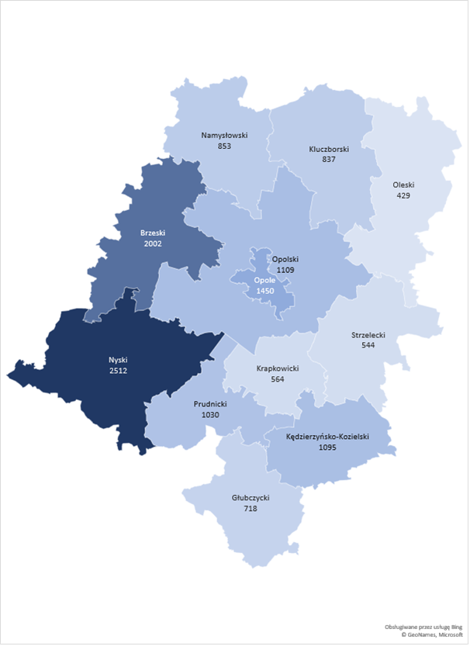
Source: own study based on data from the SL database.

The largest numbers of people covered by support were recorded in the districts of Nysa (2,512 people) and Brzeg (2,002 people), followed by the city of Opole (1,450 people), and the districts of Opole (1,109 people) and Kędzierzyn-Koźle (1,095 people). This means that the support was generally directed to the districts with the highest number of the unemployed (Nysa and Brzeg). It should be noted, however, that support – slightly less intensive than that presented in the statistics – was directed to the following districts: Prudnik (1,030 people), Namysłów (853 people), and Kluczbork (837 people). Relatively low support was directed to the Głubczyce district, despite a high unemployment rate recorded there in 2015, i.e. at the time of the first recruitments to the Operational Programme for the Opole Province.
Both in the light of national studies and regional analyses, the level of entrepreneurship of the inhabitants of the Opole Province is relatively low. The Polish Agency for Enterprise Development research shows that the region is in the group of 8 provinces with the lowest levels of entrepreneurship. In 2015, at the time of announcing the first recruitments for the Operational Programme for the Opole Province for 2014-2020, the number of national economy entities in the Opole Province per 10 thousand inhabitants was 962, compared to the average for Poland of 1,004. The Opole Province was also characterised by a lower entrepreneurship rate, measured by the number of entities entered in the REGON statistical register per the number of inhabitants, than the average for Poland. In rural areas, this ratio was even lower and was 62.0% of the average for the entire province. Moreover, the number of newly registered entities per 10 thousand inhabitants was 67.6 with intra-regional differences in this respect. The highest value of this ratio was recorded in the Opole district (111.7), followed by the districts of Brzeg (77.9), Namysłów (74.6), and Nysa (70.7). The lowest values of this ratio were recorded in the districts of Strzelce (39.4), Krapkowice (49.2), and Głubczyce (55.7).
The spatial distribution of support for setting up a business presented in the figures, clearly shows that stimulating the development of entrepreneurship by granting subsidies took place to the greatest extent in the Nysa district (400 people), the city of Opole (348 people), the Brzeg district (318 people), and the Opole district (296 people). On the other hand, the smallest number of people received funds for this purpose in the districts of Prudnik (93 people), Głubczyce (98 people), and Krapkowice (104 people).
Stimulating the development of entrepreneurship by granting loans took place primarily in the districts of Nysa (10 people), Strzelce (6 people), and the city of Opole (5 people).
Taking into account the situation on the labour market in Opole at that time, it should be concluded that the assumptions adopted for Measures 7.1 and 7.3 relatively adequately directed the intensity and power of the distribution of support in the Opole Province, because this type of support was directed to only two districts with relatively low entrepreneurship rates and high unemployment rates (Nysa and Brzeg). It should be noted, however, that support, much lower than it would appear from the entrepreneurship development ratios, was directed to the remaining districts with high unemployment rates in 2015, at the time of the launch of the Operational Programme for the Opole Province.

Figure 3. The number of people covered by support under Measures 7.1 and 7.3 who received subsidies for setting up a business in the Opole Province districts in 2016-2019 | Figure 4. The number of people covered by support under Measures 7.1 and 7.3 who received loans for setting up a business in the Opole Province districts in 2018-2019
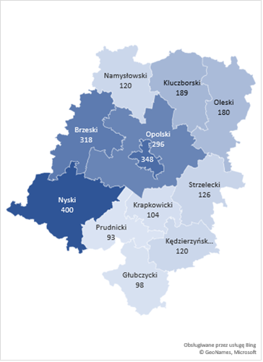 | 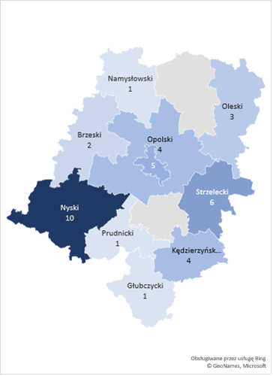
Source: own study based on data from the SL database. | Source: own study based on data from the SL database.

Target groups of support beneficiaries
According to the detailed description of the target groups under PA VII, the criteria for selecting project participants include, first of all, the status on the labour market, sex, age, disability, and the level of qualifications. The criteria for selecting final beneficiaries of support were, therefore, based on a set of characteristics of people included in the group defined as disadvantaged and corresponded to the findings of Diagnosis of Challenges, Needs, and Capacities of Areas/Sectors Covered by the Operational Programme for the Opole Province for 2014-2020, which indicated that at the time of launching the Programme, the group of all unemployed people registered in the Opole Province included a significant number of people in a disadvantaged situation on the labour market.
As shown in the chart below, the group of the unemployed covered by Measures 7.1, 7.2, 7.3 was distributed as follows: the long-term unemployed – 30.7%; the unemployed – 62.8%; the economically inactive – 6.0%. Thus, in the analysed period, the support was primarily used by people who had remained unemployed for less than 12 months, followed by the long-term unemployed and, to the least extent, economically inactive people.
Therefore, it should be stated that in terms of the status on the labour market, the structure of support beneficiaries under particular Measures corresponds to the structure of the unemployed, the long-term unemployed, and unemployed people encountering the greatest barriers to taking up and maintaining employment on the regional labour market.
Chart 2. Structure of support beneficiaries under Measures 7.1, 7.2 and 7.3 in terms of their status on the labour market
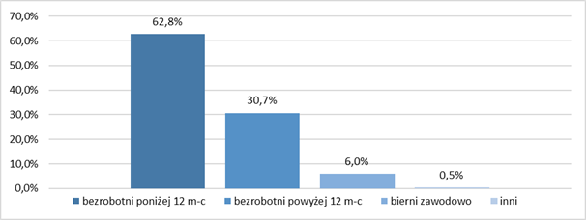
unemployed for less than 12 months unemployed for more than 12 months economically inactive other

Source: own study based on data from the SL database.
Nevertheless, based on the findings of qualitative research, it should be stated that, in the light of the available analyses and statistics, when asked for their opinions, the experts emphasised, among others, a definite need to continue support for economically inactive people (Measure 7.2).
(...) when analysing labour market statistics, entering this higher level, not the implementation one, we say that economically inactive people still require support. Statistics show that if there are about 6% of unemployed people in the economically active population, this is this rate, more or less at the moment, there are 3 or 4 times more economically inactive people in the region. This is what statistics tell us [U3].
The empirical research conducted in the region clearly indicates lower economic activity of women compared to men, a statistically higher unemployment rate among women, lower average age of economic deactivation, lower entrepreneurship, more frequent part-time employment, and a higher share of order contracts. In the structure of the registered unemployed, there is also a high percentage of women who have not taken up employment after giving birth.
In the light of the obtained data, women’s share in the structure of the support beneficiaries under Measures 7.1, 7.2, 7.3 was 55.6%. Therefore, it should be stated that the sex structure of people supported under the Programme corresponded to the general findings that sex largely determines the social position on the labour market, and the situation of women in this respect is particularly unfavourable.
Chart 3. Structure of support beneficiaries under Measures 7.1, 7.2 and 7.3 by sex
{0>
woman man
Source: own study based on data from the SL database
Age is another important determinant of employment. Age is particularly important, because the problem of being unemployed often affects people from specific age groups, e.g. young people or seniors. As indicated in the Diagnosis of Challenges, Needs and Capacities of the Areas/Sectors Covered by the Operational Programme for the Opole Province for 2014-2020, 30.0% of all registered unemployed in the Opole region were over 50 years old. Another large group comprised people under the age of 30, covered by support under the OP Knowledge Education Development. Considering the group of beneficiaries of support under PA VII of the Operational Programme for the Opole Province, it should be noted that it was dominated by people aged 35-49, constituting 48.6% of the total. The percentage of young people (30-34 years old) was not very high and amounted to 28.0%, so was the percentage of people over 50 years old – 19.5%. The structure of support beneficiaries by age corresponded to a sufficient extent to the characteristics of disadvantaged groups on the regional labour market.

Chart 4. Structure of support beneficiaries under Measures 7.1, 7.2 and 7.3 by age

30-34 years 35-49 years 50-59 years 60-64 years 65 and more years
Source: own study based on data from the SL database
The Opole region is also characterised by a low level of education of its inhabitants, which is why the issue of education is of particular importance there. The highest employment rate is reported for people with tertiary education, the lowest one for people with lower secondary and even lower education, and the majority of unemployed people do not have professional qualifications. As indicated in the Diagnosis of Challenges, Needs and Capacities of the Areas/Sectors Covered by the Operational Programme for the Opole Province for 2014-2020, “every third unemployed person in the region has no professional qualifications, and every fifth person has no professional experience” .
In the target group of beneficiaries of support under PA VII, a high percentage of people had upper secondary (56.6%) and primary (14.6%) education, probably without specific professional qualifications or with low qualifications. The high percentage of people with tertiary education (19.2%) whose situation on the labour market prompted them to take advantage of support, and whose share in the structure of the unemployed increased from 11.0% in 2014 to 12.2% in 2019, is disturbing. Taking into account the individual needs of the support beneficiaries, related to acquiring, supplementing, and improving qualifications, the need for permanent learning, and the demand for qualified employees on the Opole labour market, the selection of the support participants was adequate.
Chart 5. Structure of support beneficiaries under Measures 7.1, 7.2 and 7.3 by education

pre-primary (ISCED 0) lower secondary (ISCED 2)
post-secondary non-tertiary education (ISCED 4) primary (ISCED 1)
tertiary (ISCED 5-8) upper secondary (ISCED 3)

Source: own study based on data from the SL database
At the same time – as shown by qualitative research – it should be remembered that the proper identification of target groups should take into account the current phenomena that are of importance to the labour market. According to the competition proponents, it is crucial that the competent authorities consider the current needs of the labour market, e.g. in the context of such problems as depopulation or the need for further development of entrepreneurship in the region (and now, above all, the pandemic). Temporary “keeping” by subsidies (under Measure 7.3) the unemployed who will, indeed, set up a business only to wind it up after a short period, is not, in their opinion, the solution to the problem. It is necessary to consider extending the target group and increasing funds for this purpose:
(...) we are facing depopulation and a problem with keeping unemployed people, who set up a company only to wind it up soon, this is not the solution. That's my opinion. However, if we focus on the development of entrepreneurship, for all inhabitants of the Opole region, there is a greater chance that a student will not leave after graduation, but will think about starting a company, that someone, e.g. dismissed from work, will not leave, but will consider starting a business, and, of course, money for starting a business cannot be at the present level [K15].
The research also reveals considerable scepticism of the competition proponents as to the expected effectiveness of developing entrepreneurship in the region based on the target group narrowed down to, for example, the long-term unemployed:
(…) it is a misunderstanding to encourage a long-term unemployed to start a business”. [K17]; “You cannot, just like that, turn an unemployed person who is, for example, long-term unemployed, into a brilliant entrepreneur. Such a person must have certain characteristics (...). Projects under 7.3 should be primarily for people who are willing, have a concept, are creative, sometimes have really great predispositions, high skills, but they do not have this something that is necessary to start their own business, so it is enough to work with these people a little bit. People who choose to be long-term unemployed, even if they start their own business, this business is just for the indicator [K18].
Analyses of the labour market needs should verify further relevance of, among others, such identified target groups as: the unemployed/economically inactive people over 50, unemployed women, inhabitants of rural areas or marginalised urban areas, especially in the context of the social consequences of the pandemic. Future activities in these and other difficult areas will require very intensive work, perhaps often focused on social support rather than encouraging employment:
These are difficult groups, firstly, these people have already turned 30 (which is a definition and demarcation line for the purposes of the Regional Operational Programme), secondly (...) people from the most difficult groups, such as 50+, such as women, such as people from rural areas or those from marginalised urban areas, such people, unfortunately, require a lot of work to be introduced onto the open labour market. They require rather social than employment encouraging support [U2].
Summing up: taking into account the characteristics of the social situation of the unemployed in the Opole Province, the adequacy of the selection of target groups covered by support provided under PA VII of the Operational Programme for the Opole Province to the situation on the labour market in Opole at that time should be assessed as high. Thus, as regards general issues regarding support adequacy, it should be stated that:
- firstly: the intensity of the support offered corresponded to the spatial differences in the unemployment level, i.e. it was directed to those local labour markets where the greatest needs in this regard were identified (high numbers of people without work: unemployed, long-term unemployed, and economically inactive), with a slower increase in the number of jobs, insufficient to the existing needs (districts of Prudnik, Nysa and Głubczyce);
- secondly: the characteristics of the social and demographic and social situation (sex, age and education) of people covered by the support corresponded to the characteristics of people in a particularly difficult situation on the regional labour market, i.e. members of disadvantaged groups (women, the disabled, the long-term unemployed), and it was them who received the support, as they were constituted significant subgroups among the unemployed participating in the support, as evidenced also by the findings of qualitative research;
- thirdly: the Opole labour market also struggled with a shortage of qualified employees, and targeting support mainly at people without specific professional qualifications or with low qualifications increased the prospects for meeting employers’ needs, while reducing the “gap” between demand and supply on the labour market;
- fourthly: the demographic crisis, enhanced migrations, and depopulation processes in the Opole labour market where accompanied by intensive processes of declining and aging of labour resources, therefore, it was crucial to target the support to the age group with the highest economic activity, that can and should work, i.e. people between 30 and 50 years of age, which was done by providing support primarily to people in this age category. The support was also directed, though to a lesser extent, to people over the age of 50, whose share in the structure of the unemployed was relatively high, and who should remain economically active due to not being eligible for retirement benefits.
The quantitative and qualitative analysis of the research findings allows for drawing the following conclusions:
Due to the persistently high percentage of unemployed people over 50 years of age, it is necessary to extend the measures supporting this group under the Operational Programme for the Opole Province for 2021-2027. It needs to be considered that due to the economic crisis caused by COVID-19, people aged 50+ may be more exposed to loss of employment, having much lower chances of resuming employment than people from other age categories. Their economic activation is complex, but necessary, especially from the perspective of the demographic constraints on the regional labour market.
The percentage of unemployed and economically inactive women remains at a high level (increasing during the implementation of the Operational Programme for the Opole Province for 2014-2020). The effects of the forecast crisis caused by COVID-19 will be particularly acute for women (e.g. due to the significant share of women in the employment structure in industries most affected by the crisis, e.g. retailing, HoReCa).

Spatial distribution of support in the future financial framework
The analysis and forecast of the spatial distribution of support presented in this chapter were based on the situation on the labour market in 2014-2019. For obvious reasons, it was not possible to take into account the situation on local labour markets resulting from the COVID-19 pandemic. Therefore, the presented forecast and the summarising commentary in this chapter should be read in the context of the processes described in the chapter Situation of the pandemic and its impact on the labour market. Therefore, in the next financial framework under the Operational Programme for the Opole Province for 2021-2027, it may be necessary to adjust the spatial distribution of support due to the currently unknown situation as regards unemployment and entrepreneurship in particular districts.
Considering the situation on the Opole labour market in terms of the unemployment rate, it should be stated that there has been an improvement in this respect. During the current implementation period of the Operational Programme for the Opole Province for 2014-2020, there was a significant decrease in the unemployment rate from 11.8% in 2014 to 5.8% in 2019.
Table 3. Unemployment rate: total and by districts of the Opole Province in 2004-2019
District | Years
 | 2014 | 2015 | 2016 | 2017 | 2018 | 2019
Brzeg | 17.2 | 13.8 | 12.6 | 10.4 | 8.9 | 7.7
Głubczyce | 16.7 | 14.1 | 13.4 | 11.1 | 9.5 | 8.9
Kędzierzyn-Koźle | 12.3 | 11.8 | 10.2 | 9.1 | 8.1 | 7.3
Kluczbork | 12.3 | 10.7 | 9.6 | 8.1 | 7.6 | 7.1
Krapkowice | 8.6 | 7.9 | 6.8 | 5.5 | 5.4 | 5.4
Namysłów | 17.0 | 12.4 | 11.6 | 9.1 | 7.8 | 8.0
Nysa | 16.8 | 14.3 | 12.0 | 9.4 | 7.8 | 7.2
Olesno | 8.6 | 7.4 | 6.5 | 4.9 | 4.1 | 4.0
Opole | 11.7 | 10.2 | 9.1 | 7.8 | 6.4 | 5.5
Prudnik | 17.8 | 15.2 | 13.5 | 10.1 | 9.9 | 8.9
Strzelce | 8.2 | 7.4 | 6.6 | 5.6 | 5.1 | 5.1
city of Opole | 6.0 | 5.3 | 4.9 | 3.9 | 3.2 | 2.7
OPOLE PROVINCE | 11.8 | 10.1 | 9.0 | 7.3 | 6.3 | 5.8
Source: own study based on the Local Data Bank of Statistics Poland
The spatial analysis of the above data shows, however, that there was no significant change in the spatial distribution of unemployment on the local labour markets in the discussed period. With the exception of the Nysa district, both in 2014 and 2019, the highest unemployment rates were recorded in the districts of Głubczyce (16.7 and 8.9), Prudnik (17.8 and 8.9), Namysłów (17.0 and 8.0), and Brzeg (17.2 and 7.7).
According to the developed forecast, the trend observed in 2014-2019 will not change significantly in the new programming period 2021-2027. The unemployment rate in the region will gradually decrease to 4.9% in 2021 and approximately 3.0% in 2027.
Table 4. Forecast unemployment rate: total and by districts of the Opole Province in 2020-2027
District | Years
 | 2020 | 2021 | 2022 | 2023 | 2024 | 2025 | 2026 | 2027
Brzeg | 7.03 | 6.42 | 5.86 | 5.35 | 4.88 | 4.46 | 4.07 | 3.71
Głubczyce | 8.36 | 7.85 | 7.37 | 6.93 | 6.50 | 6.11 | 5.74 | 5.39
Kędzierzyn-Koźle | 6.94 | 6.59 | 6.26 | 5.95 | 5.66 | 5.37 | 5.11 | 4.85
Kluczbork | 6.54 | 6.03 | 5.55 | 5.11 | 4.71 | 4.34 | 4.00 | 3.68
Krapkowice | 5.07 | 4.76 | 4.46 | 4.19 | 3.93 | 3.69 | 3.46 | 3.25
Namysłów | 7.34 | 6.73 | 6.18 | 5.67 | 5.20 | 4.77 | 4.38 | 4.02
Nysa | 6.52 | 5.90 | 5.35 | 4.84 | 4.38 | 3.97 | 3.59 | 3.26
Olesno | 3.71 | 3.45 | 3.20 | 2.97 | 2.76 | 2.56 | 2.38 | 2.21
Opole | 5.07 | 4.68 | 4.32 | 3.98 | 3.67 | 3.39 | 3.12 | 2.88
Prudnik | 8.44 | 8.01 | 7.60 | 7.21 | 6.84 | 6.49 | 6.16 | 5.84
Strzelce | 4.72 | 4.36 | 4.03 | 3.73 | 3.45 | 3.19 | 2.95 | 2.73
city of Opole | 2.48 | 2.27 | 2.08 | 1.91 | 1.75 | 1.61 | 1.47 | 1.35
OPOLE PROVINCE | 5.34 | 4.92 | 4.53 | 4.17 | 3.84 | 3.53 | 3.25 | 3.00
Source: own study based on the Local Data Bank of Statistics Poland
The spatial forecast also shows that although the intra-regional differences in the situation on local labour markets will be maintained, there will be some change as regards districts requiring support. In 2021, the highest unemployment rates will be recorded in the following districts: Prudnik (8.0%), Głubczyce (7.8%), Namysłów (6.7%), and Kędzierzyn-Koźle (6.6%), that, according to the forecast, will record the highest unemployment also in 2027. Due to the change in the situation in the new programming period, the spatial intensity of support should, therefore, be changed and directed primarily to those local labour markets that, according to the forecast, will record the highest unemployment rates.
When considering the statistical data regarding the level of entrepreneurship development in the Opole Province, it should be stated that the current situation in terms of the number of economic entities per 10,000 inhabitants is favourable. Compared to 2014, the number of newly registered entities increased to reach 74.42 in 2019. A significant increase in the value of this ratio YoY was recorded in the following districts: Namysłów (5.0%), Olesno (4.3%), Opole (3.5%), Kluczbork (3.4%), Głubczyce (3.2%), and Nysa (2.9%). A slight improvement was recorded in the districts of Strzelce (0.4%) and Prudnik (0.2%). Declines in this respect were recorded in the districts of Kędzierzyn-Koźle (-0.8%), Opole (-0.5%) as well as Brzeg and Krapkowice ( -0.1%).
Table 5. Number of newly registered entities per 10 thousand inhabitants: total and by districts of the Opole Province in 2014-2019
District | Years
 | 2014 | 2015 | 2016 | 2017 | 2018 | 2019
Brzeg | 82.69 | 77.86 | 72.49 | 76.14 | 80.53 | 82.26
Głubczyce | 57.55 | 55.66 | 50.38 | 57.13 | 65.82 | 67.43
Kędzierzyn-Koźle | 57.28 | 62.83 | 50.44 | 49.88 | 55.88 | 54.98
Kluczbork | 57.03 | 58.46 | 50.57 | 54.99 | 66.83 | 67.50
Krapkowice | 50.27 | 49.23 | 42.41 | 46.09 | 49.11 | 50.10
Namysłów | 76.39 | 74.62 | 67.44 | 74.28 | 93.94 | 97.49
Nysa | 70.30 | 70.66 | 60.56 | 72.56 | 79.37 | 81.23
Olesno | 62.86 | 56.04 | 55.76 | 60.45 | 74.77 | 77.66
Opole | 65.31 | 63.51 | 61.58 | 64.88 | 74.00 | 77.51
Prudnik | 54.59 | 56.43 | 53.83 | 43.05 | 54.39 | 55.20
Strzelce | 45.12 | 39.37 | 46.89 | 39.67 | 44.73 | 46.03
city of Opole | 110.06 | 111.66 | 110.68 | 102.93 | 105.67 | 107.58
OPOLE PROVINCE | 68.45 | 67.63 | 63.05 | 65.20 | 72.84 | 74.42
Source: own study based on the Local Data Bank of Statistics Poland
In the new programming period 2021-2027, entrepreneurship development is forecast to remain at a similar level. The number of economic entities will gradually increase to reach 77.67 in 2021 and 88.32 in 2027.
Although the intra-regional differences in the situation on local labour markets will prevail, there will be some changes as regards districts requiring support. In 2021, the lowest value of the ratio concerned will be recorded in the Strzelce district (48.7), followed by the districts of Krapkowice (52.1) and Kędzierzyn-Koźle (53.2), that, according to the forecast, will also be characterised by the lowest increase in the number of companies in 2027. Due to the change in the intra-regional situation regarding entrepreneurship development in the Opole Province in the new programming period, there should be a change in the spatial intensity of support to direct it, first of all, to those local labour markets that, according to the forecast, will be characterised by the lowest increase in the number of companies.
Table 6. Forecast of the number of newly registered entities per 10,000 inhabitants: total and by districts of the Opole Province in 2020-2027
District | Years
 | 2020 | 2021 | 2022 | 2023 | 2024 | 2025 | 2026 | 2027
Brzeg | 84.03 | 85.83 | 87.67 | 89.55 | 91.48 | 93.44 | 95.45 | 97.49
Głubczyce | 69.08 | 70.77 | 72.49 | 74.27 | 76.08 | 77.94 | 79.85 | 81.80
Kędzierzyn-Koźle | 54.08 | 53.21 | 52.35 | 51.50 | 50.66 | 49.84 | 49.04 | 48.24
Kluczbork | 68.18 | 68.87 | 69.56 | 70.26 | 70.97 | 71.68 | 72.40 | 73.13
Krapkowice | 51.11 | 52.14 | 53.19 | 54.26 | 55.36 | 56.47 | 57.61 | 58.78
Namysłów | 101.17 | 104.99 | 108.95 | 113.07 | 117.34 | 121.77 | 126.37 | 131.14
Nysa | 83.14 | 85.08 | 87.07 | 89.11 | 91.20 | 93.34 | 95.52 | 97.76
Olesno | 80.68 | 83.81 | 87.06 | 90.43 | 93.94 | 97.58 | 101.36 | 105.30
Opole | 81.19 | 85.05 | 89.09 | 93.32 | 97.76 | 102.40 | 107.26 | 112.36
Prudnik | 56.03 | 56.87 | 57.72 | 58.58 | 59.46 | 60.35 | 61.25 | 62.17
Strzelce | 47.36 | 48.74 | 50.15 | 51.60 | 53.10 | 54.64 | 56.22 | 57.85
city of Opole | 109.53 | 111.51 | 113.53 | 115.59 | 117.68 | 119.81 | 121.98 | 124.19
OPOLE PROVINCE | 76.03 | 77.67 | 79.35 | 81.07 | 82.83 | 84.62 | 86.45 | 88.32
Source: own study based on the Local Data Bank of Statistics Poland

Beneficiaries of support in the future financial framework
The analysis and forecast of support beneficiaries presented in this chapter were based on the situation on the labour market in 2014-2019. For obvious reasons, it was not possible to take into account the potential increase in the number of the unemployed and economically inactive people caused by the COVID-19 pandemic, or other potential beneficiaries of support (e.g. the total number of working people, immigrants, people returning from abroad, etc.). Therefore, the presented forecast, as well as the summarising commentary included in this chapter, should be read in the context of the processes described in the chapter entitled Pandemic situation and its impact on the labour market. Therefore, in the next project framework under the Operational Programme for the Opole Province for 2021-2027, it is necessary to flexibly approach the strength and structure of target groups.
During the implementation of the Operational Programme for the Opole Province for 2014-2020, the group of potential beneficiaries of support in the region was systematically decreasing. The number of the unemployed decreased from 42,361 in 2014 to 20,948 in 2019, and that of the long-term unemployed – from 15,656 to 7,207.
Table 7. Numbers of the unemployed and the long-term unemployed: total and by districts of the Opole Province in 2014-2019
District | Unemployed |  |  |  |  |  | Long-term unemployed
 | Years |  |  |  |  |  | Years
 | 2014 | 2015 | 2016 | 2017 | 2018 | 2019 | 2014 | 2015 | 2016 | 2017 | 2018 | 2019
Brzeg | 5,055 | 4,016 | 3,638 | 2,909 | 2,479 | 2,156 | 2,209 | 1,364 | 1,391 | 1,113 | 796 | 656
Głubczyce | 2730 | 2,266 | 2,129 | 1,729 | 1,472 | 1,379 | 1,176 | 860 | 847 | 802 | 668 | 542
Kędzierzyn-Koźle | 4,099 | 3,921 | 3,449 | 3,058 | 2,705 | 2,476 | 1,621 | 1,412 | 1,530 | 1,353 | 1,172 | 1,026
Kluczbork | 2,626 | 2,240 | 2,018 | 1,699 | 1,561 | 1,475 | 961 | 831 | 775 | 691 | 569 | 593
Krapkowice | 2,340 | 2,116 | 1,822 | 1,493 | 1,435 | 1,457 | 822 | 792 | 751 | 660 | 600 | 599
Namysłów | 2,308 | 1,638 | 1,563 | 1,261 | 1,026 | 1,067 | 971 | 616 | 518 | 499 | 373 | 396
Nysa | 7,234 | 6,037 | 5,027 | 3,840 | 3,250 | 2,981 | 1,805 | 1,614 | 1,497 | 1,071 | 906 | 883
Olesno | 2,048 | 1,777 | 1,587 | 1,188 | 1,027 | 1,006 | 716 | 616 | 608 | 514 | 402 | 378
Opole | 4,525 | 3,934 | 3,611 | 2,767 | 2,226 | 1,926 | 1,854 | 1,458 | 1,410 | 1,147 | 886 | 569
Prudnik | 3,237 | 2,689 | 2,388 | 1,757 | 1,655 | 1,495 | 1,378 | 1,075 | 984 | 662 | 508 | 493
Strzelce | 1,958 | 1,836 | 1,658 | 1,384 | 1,273 | 1,300 | 543 | 499 | 476 | 417 | 403 | 423
city of Opole | 4,201 | 3,733 | 3,529 | 2,981 | 2,554 | 2,230 | 1,600 | 1,322 | 1,304 | 1,213 | 953 | 649
OPOLE PROVINCE | 42,361 | 36,203 | 32,419 | 26,066 | 22,663 | 20,948 | 15,656 | 12,459 | 12,091 | 10,142 | 8,236 | 7,207
Source: own study based on the Local Data Bank of Statistics Poland
According to the forecasts the identified trend will continue in the coming years. In 2021-2027, the number of the unemployed in the region will drop from 19,317 to 11,086. At the end of the analysed period, the largest number of the unemployed will be recorded in the Kędzierzyn-Koźle district (1,600), the city of Opole (1,235) as well as the districts of Nysa (1,172) and Opole (975).
Table 8. Forecast of the number of the unemployed: total and by districts of the Opole Province in 2020-2027
District | Years
 | 2020 | 2021 | 2022 | 2023 | 2024 | 2025 | 2026 | 2027
Brzeg | 1,945 | 1,754 | 1,582 | 1,427 | 1,287 | 1,160 | 1,047 | 944
Głubczyce | 1,279 | 1,186 | 1,100 | 1,020 | 946 | 877 | 813 | 754
Kędzierzyn-Koźle | 2,344 | 2,220 | 2,102 | 1,990 | 1,884 | 1,784 | 1,689 | 1,600
Kluczbork | 1,349 | 1,234 | 1,128 | 1,032 | 944 | 863 | 790 | 722
Krapkowice | 1,383 | 1,313 | 1,247 | 1,184 | 1,124 | 1,067 | 1,013 | 962
Namysłów | 968 | 878 | 797 | 723 | 656 | 596 | 540 | 490
Nysa | 2,653 | 2,361 | 2,101 | 1,869 | 1,664 | 1,480 | 1,317 | 1172
Olesno | 937 | 873 | 814 | 758 | 707 | 658 | 614 | 572
Opole | 1,769 | 1,624 | 1,492 | 1,370 | 1,258 | 1,156 | 1,061 | 975
Prudnik | 1,400 | 1,311 | 1,228 | 1,151 | 1,078 | 1,009 | 945 | 885
Strzelce | 1,219 | 1,142 | 1,071 | 1,004 | 941 | 882 | 827 | 775
city of Opole | 2,071 | 1,924 | 1,787 | 1,660 | 1,542 | 1,432 | 1,330 | 1,235
OPOLE PROVINCE | 19,317 | 17,820 | 16,449 | 15,188 | 14,031 | 12,964 | 11,986 | 11,086
Source: own study based on the Local Data Bank of Statistics Poland
Similar trends were observed in the number of the long-term unemployed that will decrease from 6,530 to 3,355 in 2021-2027. In 2027, the largest number of the long-term unemployed will be recorded in the districts of Kędzierzyn-Koźle (600), Krapkowice (418), Kluczbork (329), and Nysa (309).
Table 9. Forecast of the number of the long-term unemployed: total and by districts of the Opole Province in 2020-2027
District | Years
 | 2020 | 2021 | 2022 | 2023 | 2024 | 2025 | 2026 | 2027
Brzeg | 574 | 502 | 440 | 385 | 337 | 295 | 258 | 226
Głubczyce | 497 | 455 | 417 | 382 | 350 | 321 | 294 | 270
Kędzierzyn-Koźle | 960 | 897 | 839 | 785 | 734 | 686 | 642 | 600
Kluczbork | 551 | 512 | 475 | 442 | 410 | 381 | 354 | 329
Krapkowice | 573 | 548 | 524 | 501 | 479 | 458 | 438 | 418
Namysłów | 351 | 312 | 277 | 246 | 218 | 193 | 172 | 152
Nysa | 774 | 679 | 595 | 522 | 458 | 401 | 352 | 309
Olesno | 347 | 318 | 292 | 267 | 245 | 225 | 206 | 189
Opole | 499 | 438 | 385 | 338 | 296 | 260 | 228 | 201
Prudnik | 442 | 397 | 356 | 319 | 287 | 257 | 231 | 207
Strzelce | 386 | 353 | 322 | 294 | 268 | 245 | 224 | 204
city of Opole | 576 | 511 | 454 | 403 | 357 | 317 | 281 | 250
OPOLE PROVINCE | 6,530 | 5,922 | 5,376 | 4,884 | 4,439 | 4,039 | 3,680 | 3,355
Source: own study based on the Local Data Bank of Statistics Poland
Although the number of the unemployed and the long-term unemployed in the Opole Province will systematically decrease over the analysed period, it should be emphasised that unemployment will not cease to be a serious social problem there, as evidenced by the findings of conducted research, that clearly emphasise the unvarying needs of the Opole labour market, determined by growing demographic problems. Enhanced migrations (domestic and foreign), the deteriorating demographic situation (in 2018, the ratio for the province was the lowest in Poland and amounted to 61.2%, compared to the average for Poland of 65.1%), and the progressing aging of the population that depletes labour and human capital resources, which is particularly visible in rural areas and in the southern part of the province. Moreover, the observed depopulation processes are enhanced by the “auxiliary employee’s market” that persists in the region. The lack of attractive job offers for highly qualified staff causes their increased outflow to other, more attractive, labour markets, which is not offset by the inflow of new, highly qualified employees. Looking through the prism of the “gap” between the demand and supply of labour, immigrants, repatriates and returnees seem to be an important category of people requiring support:
There are many migrants who come back, they are still unregistered, in the process of returning, and they cannot be expected them to get registered, because not everyone wants to register with an office [...] they prefer to be passive [K6].
It should also be noted that according to statistical data, the structure of groups defined as disadvantaged is changing unfavourably in the total number of the unemployed. The share of women has increased by 1.3 pp., that of youth up to 25 years old – by 0.1 pp., that of people without qualifications – by 0.5 pp., and that of people with disabilities – by 0.1 pp..
(...) we are left with people who are in the most difficult situation on the labour market. Something that was not known in 2012, at the stage of programming, when the market realities were completely different [...] On the other hand, employers’ demand is changing, the structure of the unemployed and economically inactive people is changing, i.e. the most active people have been absorbed by the labour market, and we have been left with a group on the verge of social exclusion and occupational mobility [U8].
The research findings show that due to the set of demographic and social characteristics (sex, age, disability, place of residence, and other personal circumstances), these groups still require intensified support, not only in terms of returning onto or entering the labour market, but also integration through other forms:
But there are other things, there are social integration clubs and centres that reintegrate these people (…). Because the today’s market is absorbent and various companies are looking for many employees. Here, the integration of these people takes place rather through other forms, activation centres, social integration clubs [K12].
Particular attention in terms of improving the situation on the labour market should also be paid to people who are economically inactive, especially women, as their share in this group in 2015-2017 decreased by only 1.4 pp. to finally stabilise in the province at 44.3%.
Low qualifications or the lack of qualifications of the workforce is undoubtedly a weakness of the Opole labour market, as these people do not meet the needs reported by employers. Significant attention should, therefore, be paid to young people without qualifications, with low qualifications or qualifications that do not match the requirements of employers and the needs of the labour market. The structure of the unemployed includes a significant share of poorly educated people, with no profession and work experience. As shown by the findings of research, such situation leads to economic inactivity, long-term dependence on social assistance, taking up work in the shadow economy, and other difficulties on the labour market.
Activation of the disabled is another challenge that requires continued support under the Operational Programme for the Opole Province. This is particularly important given that employers’ interest in their employment is not only not high (in 2018, only 2.0% of all job offers in the Opole Province were addressed to people with disabilities), but is even decreasing (37.9% decrease in 2017-2018). According to the participants of qualitative surveys, the decline in the unemployment level was often related to the problem of support adaptation to emerging new needs:
[…] when it comes to people with disabilities, mostly people with mental impairments were left. If such a person is sent for an internship, the employer will have a grudge. These people need a different path, a different procedure or a specialist project, with more money and some guardian, advisor or assistant who will guide them differently [P18].
The next group includes people who are employed but have an unstable situation on the labour market. In the Opole region, it was common to employ people under civil law contracts, with remuneration often around the minimum level (in 2018, there were 17,119 such employees). Therefore, people in this group should be supported in improving their skills and qualifications, because a change in this area will enable them to start work under employment contracts and will result in an increase in their remuneration.
The selection of support forms in another issue. Advantageous and adequate forms used during the implementation of the Operational Programme for the Opole Province for 2014-2020, such as: internships/traineeships, courses/training, equipping/further equipping the workplace, should be supplemented with other, less conventional, method (coaching, crafting, support groups, job trainer), which could be used by people with a complicated and difficult personal, family or ill health. As for support for groups of immigrants, returnees, and repatriates, it should include both the processes of adaptation, raising or supplementing qualifications, and a system of incentives and preferences in starting a business, as well as relocation allowances.
The quantitative and qualitative analysis of the research findings allows for drawing the following conclusions:
The improvement in the situation on the labour market and the decrease in the number of unemployed and long-term unemployed people in the period before the COVID-19 pandemic resulted in a decrease in the population of end beneficiaries of support and were a major source of risks for recruiting target groups for projects provided for in the Operational Programme for the Opole Province for 2021-2027. It was, therefore, important to avoid these risks and expand the group of support beneficiaries.
The current course of the pandemic indicates that the forecast economic crisis caused by COVID-19 will significantly deteriorate the situation on the Opole labour market, which will probably lead to a significant increase in unemployment (in the pessimistic scenario, the unemployment rate in Poland is forecast to double). Therefore, it is still advisable to expand the group of support beneficiaries, as well as to include in target groups people who lose their jobs due to the crisis (people who lose their jobs for reasons attributable to the workplace, or are forced to liquidate or suspend their business).
Thus the group of the unemployed will be even more internally diversified – apart from the low-qualified unemployed, this group will include people with specific professional qualifications (e.g. hairdressers, cooks, waitpersons, trip specialists) and often experience in running their own business. In the face of the crisis caused by COVID-19, expansion of the group of support beneficiaries to include in target groups people who lose their jobs due to the crisis (people who lose their jobs for reasons attributable to the workplace, or are forced to liquidate or suspend their business) will allow for extensive intervention on the labour market by labour offices. Therefore, the anti-crisis measures taken in the region should continue to account for both a wide group of support beneficiaries, while extending and diversifying support forms. Nevertheless, too detailed guidelines for the implementation of labour market projects in 2014-2020 with the European Social Fund prevent the MA/IB from being able to flexibly and adequately respond to the existing and forecast situation on the labour market.
Demographic processes related to the migration outflow and a low birth-rate are more intense in the Opole region than in Poland in general. Depopulation is the main development problem of the Opole Province, hence the need to take measures to counter its further depopulation. The forecast economic crisis caused by the pandemic will intensify the migration and re-emigration processes. Therefore, it is necessary to use instruments that can convince people to live in the Opole region and prevent re-emigration, whose effectiveness can be measured.
The beneficiaries of economic activation projects implemented by commercial entities (under Measure 7.2 of the Operational Programme for the Opole Province for 2014-2020) feel the need to develop closer forms of communication, discussion, and formal communication with institutions announcing competitions.

Assessment of the effectiveness of support forms
In this subchapter, the degree of the effectiveness of support forms provided for in Measures 7.1, 7.2 and 7.3 was assessed. When analysing the issue in question, particular focus was on the following aspects:
- Has the support allowed the beneficiaries to gain or increase qualifications, competences or skills enabling them to find and start a job and to effectively adapt to the changing situation on the labour market?
- Have the beneficiaries improved their situation as a result of support received, i.e. have they started a job or set up a business?
- Has the offered support changed the attitudes of its beneficiaries, in particular in terms of migration trends and occupational mobility?
- Has the support provided enabled for educating employees whose qualifications, competences or skills correspond to the development needs of enterprises operating in the regional specialisation areas?
- Have companies been established as a result of the support provided, whole business profiles have strengthened the potential of regional specialisations of the Opole Province?

Competences, qualifications and skills acquired as a result of participation in the support
The research carried out in the Opole Province in 2017 showed difficulties faced by entrepreneurs in recruiting various types of employees (specialists, service workers and sales assistants, workers and craftsmen). On the other hand, analyses in the area of monitoring scarce and redundant occupations carried out in the region showed the unfavourable occupational structure of the unemployed, as most of them had professional qualifications, if any, related to professions defined as redundant. In response to this situation, a number of forms of support were launched under Priority Axis VII, aimed at identifying the capacities and stimulate economic activity of people in a particularly difficult situation on the labour market, and thus increase their chances of successful adaptation to the changing situation on the labour market situation and finding employment.
Training courses
Research shows that training courses attended by the respondents involved, above all, supplementary training for professional qualifications, including acquisition of new competences (64.4%), and training for the acquisition of new/other professional qualifications (57.7%). The remaining types of training improved software skills (37.5%), soft skills, such as self-presentation and stress management (26.0%), and communication in foreign languages (16.3%), i.e. skills to which employers attach increasing importance, and which definitely increase the chances to find a job by unemployed people. Some of the training courses also focused on developing in their participants job seeking skills (nearly 27.0%).
As shown by empirical research, people belonging to target support beneficiary groups very often are not aware of their capacities. Therefore, in order to improve their level of economic activity, they need counselling that increases their self-confidence and raises their self-esteem in terms of their own chances on the labour market, therefore all measures carried out under PA VII should be considered important in terms of increasing chances for taking up employment by non-working people.
Chart 6. Types of training courses offered to support beneficiaries

Training in communication in foreign languages
Training in soft skills (e.g. self-presentation, stress management)
Training in job seeking skills
Training in software skills
Training for the acquisition of new/other professional qualifications
Supplementary training for professional qualifications, including acquisition of new competences
Source: own study based on data from the CATIs, n=104
Over the analysed period, a total of 608 training courses were conducted under Measures 7.1 and 7.2, including the vast majority under Measure 7.1 (521) (Measure 7.2 – only 87). As for their thematic scopes, Measure 7.1 offered a much more extensive choice, as the training courses were addressed to 65 professional groups (Measure 7.2 – only 24).
Table 10. Groups of professions (beneficiaries of support) covered by training courses conducted under Measure 7.1 in the Opole Province in 2015-2019
Occupation groups by classification of professions developed for the purposes of the “Occupational Barometer” survey | Number of training courses carried out in the Opole Province in 2015-2019 | Percentage of training courses carried out in the Opole Province in 2015-2019
truck and tractor drivers | 72 | 13.8%
earthmoving equipment operators and mechanics | 54 | 10.4%
Welders | 40 | 7.7%
warehouse workers | 40 | 7.7%
bus drivers | 39 | 7.5%
Beautician | 24 | 4.6%
buyers and suppliers | 24 | 4.6%
electricians, electromechanics and wiremen | 19 | 3.6%
operators of lifting and transport equipment | 13 | 2.5%
physical security workers | 12 | 2.3%
metal cutting machine operators | 11 | 2.1%
sales assistants and cashiers | 9 | 1.7%
physiotherapists and masseurs | 8 | 1.5%
facility administrators, porters, janitors and caretakers | 8 | 1.5%
metal structure fitters | 7 | 1.3%
farmers and breeders | 7 | 1.3%
HS management and recruitment specialists | 7 | 1.3%
earthmoving equipment operators and mechanics | 6 | 1.2%
construction installation fitters | 6 | 1.2%
accounting and bookkeeping employees | 6 | 1.2%
rail transportation workers | 6 | 1.2%
psychologists and psychotherapists | 6 | 1.2%
tailors and clothing production workers | 5 | 1.0%
Babysitters | 5 | 1.0%
caregivers for the elderly or the disabled | 5 | 1.0%
animal handling workers | 5 | 1.0%
driving instructors | 4 | 0.8%
bricklayers and plasterers | 4 | 0.8%
construction workers | 4 | 0.8%
independent accountants | 4 | 0.8%
graphic designers | 3 | 0.6%
recreation and sport instructors | 3 | 0.6%
Cooks | 3 | 0.6%
database designers and administrators, programmers | 3 | 0.6%
forestry workers | 3 | 0.6%
woodworkers and carpenters | 3 | 0.6%
Upholsterers | 3 | 0.6%
mechanical technicians | 3 | 0.6%
BVLOS operators | 3 | 0.6%
Pavers | 2 | 0.4%
motor vehicle technician | 2 | 0.4%
Florists | 2 | 0.4%
waitpersons and bartenders | 2 | 0.4%
foreign language teachers | 2 | 0.4%
operators of lifting and transport equipment | 2 | 0.4%
industrial designers | 2 | 0.4%
real estate specialists | 2 | 0.4%
website administrators | 1 | 0.2%
analysts, testers and operators of ICT systems | 1 | 0.2%
car tinsmiths and painters | 1 | 0.2%
Confectioners | 1 | 0.2%
Hairdressers | 1 | 0.2%
miners and operators of mining machinery and equipment | 1 | 0.2%
car painters | 1 | 0.2%
medical equipment operators | 1 | 0.2%
other education specialists | 1 | 0.2%
administrative and office workers | 1 | 0.2%
physical workers in production and elementary occupations | 1 | 0.2%
Metalworkers | 1 | 0.2%
employees od uniformed services | 1 | 0.2%
sales representatives | 1 | 0.2%
secretaries and assistants | 1 | 0.2%
public administration specialists | 1 | 0.2%
financial specialists | 1 | 0.2%
Locksmiths | 1 | 0.2%
Total | 521 | 100.0%
Source: own study based on data the data provided by the Employer and the data derived from the study “Occupational Barometer” developed by the Ministry of Labour and Social Policy
Table 11. Groups of professions (beneficiaries of support) covered by training courses conducted under Measure 7.2 in the Opole Province in 2015-2019
Occupation groups by classification of professions developed for the purposes of the “Occupational Barometer” survey | Number of training courses carried out in the Opole Province in 2015-2019 | Percentage of training courses carried out in the Opole Province in 2015-2019
caregivers for the elderly or the disabled | 15 | 17.2%
Welders | 11 | 12.6%
logisticians and freight forwarding agents | 11 | 12.6%
administrative and office workers | 7 | 8.1%
metal cutting machine operators | 5 | 5.8%
warehouse workers | 4 | 4.6%
electricians, electromechanics and wiremen | 3 | 3.5%
truck and tractor drivers | 3 | 3.5%
earthmoving equipment operators and mechanics | 3 | 3.5%
accounting and bookkeeping employees | 3 | 3.5%
workers doing finishing works in construction | 3 | 3.5%
receptionists and registrars | 3 | 3.5%
artists, interior decorators and heritage conservationists | 2 | 2.3%
travel agency employees and tour operators | 2 | 2.3%
food processing workers | 2 | 2.3%
sales assistants and cashiers | 2 | 2.3%
construction installation fitters | 1 | 1.2%
bricklayers and plasterers | 1 | 1.2%
kindergarten teachers | 1 | 1.2%
sales representatives | 1 | 1.2%
construction workers | 1 | 1.2%
independent accountants | 1 | 1.2%
secretaries and assistants | 1 | 1.2%
buyers and suppliers | 1 | 1.2%
Total | 87 | 100.0%
Source: own study based on data the data provided by the Employer and the data derived from the study “Occupational Barometer” developed by the Ministry of Labour and Social Policy
Research on labour demand carried out in the region indicated that Opole employers most often looked for industrial workers and craftsmen (32.9%), mainly construction workers (15.8%), electricians and electronic engineers (5.6%) , metalworkers, plant and machinery mechanics (5.3%), and food processing, woodworking, and textile manufacturing workers (4.9%). This group was followed by service and sales workers (15.8%), including sales assistants (8.6%), personal services workers (6.6%) and specialists (15.5%) in the area of economics and management (4.3%), law, social affairs and culture (3.6%), as well as physics, mathematics, technical sciences, and health (3.0%). Then came technicians and other associate professions (12.8%), i.e. associate professionals in healthcare as well as business and administration (3.3%), and in the field of law, social affairs, and culture (3.0%), followed by plant and machinery operators (8.2%), including mainly drivers and equipment operators (7.2%). On the other hand, the least demand was for office workers and workers performing elementary occupations (6.3%).
Despite the fact that both the number and scope of the training courses were varied, the comparison of their subject matter with the demand for specific types of occupations indicates that the selection of the training topics was adequate and corresponded to the demand for work observed in the Opole Province, offering qualifications in scarce occupations sought by employers, and thus increasing the chances for finding work by their beneficiaries.
Chart 7. The topics of the conducted trainings courses and the demand for professions in the Opole Province in 2015-2019

Measure 7.1 Mesure 7.2 Total for Measures 7.1 and 7.2
scarce profession profession with a supply and demand equilibrium redundant profession demand difficult to determine
Source: own study based on data the data provided by the Employer, the reports on the monitoring of scarce and redundant professions in the districts of the Opole Province, and the “Occupational Barometer” study developed by the Ministry of Labour and Social Policy
The importance of acquiring competences, qualifications, and skills has also been manifested in qualitative research. Experts emphasise a positive qualitative change in terms of the overall, desired impact of the support provided under the Measures concerned on the improvement in qualifications and competences or acquisition of new ones. Although, as they claim, the training courses offered and carried out currently are characterised by a less impressive quantitative ratio (approx. 40-45%) than before, when a lot of training courses were carried out, mainly in the group, they bring greater benefits and are more effective in terms of raising qualifications because:
(...) here our approach was that it was up to the unemployed, we do not force them to participate in training, only those who actually want to take up specific work for which specific qualifications are needed (at least half of our people have C, C + E (type of driving license – ed.) Everything is up to the unemployed person only [P48].
It seems that in such circumstances, and perhaps especially in such circumstances, the most important thing should be to acquire real (not fictitious) qualifications, professional competences, which requires longer training, in a professional training company (in line with the Guidelines for the Labour Market), in which the education process ends with an examination and obtaining a relevant diploma (such an examination sometimes may be simply failed) [K60]. As regards the importance and confirmation of the quality of the qualifications obtained, postulates are raised to extend the forms of support to include postgraduate studies:
“These are certified training courses, they must be certified. So in the case of welding, certification of the Welding Institute is obviously required to confirm that this training is adequate and one can start working afterwards” [U15].
“And here we should give these competences of adults who have already worked in the past, which we will slightly adapt to the changing labour market. However, it is very rare for us to retrain a person, through there are exceptions, but it rarely happens, from a completely different industry to one that requires completely different foundations” [U15];
“we want postgraduate studies, that we are now starting to introduce into the programme, to be possible; for 7.2 already. Some people also need postgraduate studies and we have such requests from various sources and it would be good if they could do such studies. It is one of the forms of support” [U37].
Internships and traineeships as well as equipping or further equipping of workstations
Besides the willingness and motivation to take up work, determinants of the extent of support effectiveness also include sectors and industries in which companies organising internships and traineeships or equipping or further equipping workstations operate, as the adequate selection of these entities increases support beneficiaries’ chances to find permanent employment, while their wrong selection may make support ineffective. It turns out – which is also confirmed by qualitative research – a clear emphasis has been rightly put on it for some time.
We are now talking about people who must also have these digital skills – we do not have to call them digital, just competences and predispositions – they need to be raised, in addition to vocational training, high-quality internships, under good supervision by employers, we are starting to watch this very closely – these cannot be just any internships, as an internship is also a form of training [U8].
The Opole Province is dominated by private service and commercial companies and public administration, healthcare, and education entities.
Research findings indicate that the selection of the industry structure of companies where internships and traineeships took place, and where workstations were equipped or further equipped, was adequate and corresponded to this structure. The internships and traineeships took place mainly in the private sector (74.0%), where the service sector was one of the most popular (30.8%), followed by commerce (12.0%), and construction (8.4%). As for the public sector, internships were most often carried out in public administration (12.0%), healthcare (8.4%), and education (6.0%) entities.
Chart 8. Types of companies where the support beneficiaries participated in internships/traineeships  services services and trade  production and trade trade  production  Source: own study based on data from the CATIs, n=250 | Chart 9. Sectors in which the companies where the support beneficiaries participated in internships/traineeships operate  Private Public  Source: own study based on data from the CATIs, n=250
Chart 10. Industries in which the companies where the support beneficiaries participated in internships/traineeships operate

Other services | Public administration | Trade and repairs | Construction | HoReCa | Industrial processing | Healthcare and social assistance | Education | Financial intermediation | Transport, warehousing and communications | Management of commercial real estate | Production of electricity, gas and water and provision thereof
Source: own study based on data from the CATI survey, n=250
Support aimed at equipping or further equipping workstations was similarly targeted and concerned mainly the private sector (94.4%), in which the service sector (66.7%) and trade (22.2%) were the most popular. In the public sector, workstations were equipped or further equipped most often in companies operating in healthcare and social assistance.
Chart 11. Types of companies where workstations were equipped or further equipped  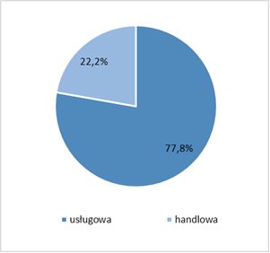  services trade  Source: own study based on data from the CATIs, n=18 | Chart 12. Sector structure of companies where workstations were equipped or further equipped  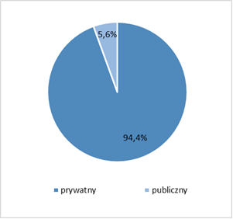  private public  Source: own study based on data from the CATIs, n=18
Chart 13. Industry structure of companies where workstations were equipped or further equipped

Other services | Trade and repairs | HoReCa | Healthcare and social assistance

Source: own study based on data from the CATIs, n=18

When making a summary assessment of the effectiveness of the support provided, it should be stated that among the registered unemployed in the Opole Province there was a large group of people without professional qualifications (32.1%) and with low professional qualifications, therefore the training courses and internships/traineeships carried out were largely effective tools to meet the needs of the Opole labour market, resulting from the demand for specific professions and related qualifications and skills.
It should be noted, however, that despite the fact that their implementation responded to the needs of support beneficiaries, there were too few of those forms that effectively contribute to reducing personality deficits of support beneficiaries In order to improve the disadvantaged groups’ position on the labour market, it is worth increasing the number of support forms and broadening their thematic scope to include those that contribute to building self-esteem and strengthen self-confidence on the labour market. The importance of the adequate definition of the training subject, that in order to effectively raise the qualifications of the trainees should result from cooperation with a psychologist and career counsellor, was emphasised also by the proponents. Therefore, it should be stated that, first of all, training in “soft skills” is of significant importance for finding a job:
(…) the subject (of training – ed.) should result from cooperation with a psychologist and career counsellor. It should be so, but it is often the case that participants do not know and then a career counsellor, psychologist, substantive team have to make recognition. I am not talking about a group of such project, full-time participants…. We have to extend the form of support for project participants to include soft and digital skills [K128].
The quantitative and qualitative analysis of the research findings allows for drawing the following conclusions:
High effectiveness of support is noted, especially as part of the Measures related to setting up a business (in Operational Programme for the Opole Province for 2014-2020, Measure 7.3), if it is addressed to people who are highly motivated, creative, have ideas, predispositions, and specific competences. Difficulties relate to the long-term unemployed applying for support, especially in terms of an adequate psychological diagnosis, important for the development of an individual pathway to get out of unemployment, as well as to providing long-term psychological support.

Cannibalisation of products and services in the Programme
As evidenced by the authors of the study “Mid-Term Evaluation of the Material Progress in the Operational Programme for the Opole Province for 2014-2020 for the Purposes of a Mid-Term Review, Including the Fulfilment of the Provisions of the Implementation Frameworks and Reserve”, products and services offered under Measures 7.1, 7.2 and 7.3 compete with each other in terms of support provided, which is referred to as „cannibalisation” of products and services in the Programme. This conclusion is confirmed by the results of conducted research. The most popular forms of support offered under Measure 7.1 included counselling (31.6%), internship/traineeship (27.4%), and job placement (27.2%). As for Measure 7.2, these were consultancy (39.2%), training courses (23.0%), job placement (18.6%), and internship/traineeship (14.3%). Under Measure 7.3, the most popular support forms included consulting (29.8%), training courses (28.7%), and other forms (23.8%), including legal advice, consulting services, and industry advice. Thus, the portfolio of support instruments offered under the Measures concerned is very similar to each other when it comes to some forms of support, and their frequency of use is similar as well. Therefore, it should be stated that the above-mentioned Measures compete with each other to a significant extent and are one of the indicators of the continued existence of cannibalisation of products and services provided for in the Programme.
Chart 14. Popularity of the forms of support provided in the Opole Province districts under Measure 7.1 in 2015-2019  consultancy  internship/traineeship  job placement  training course  subsidies for setting up a business  equipping or further equipping of workstations  sheltered employment  reimbursement of the costs of commuting, accommodation  other  Source: own study based on data from the SL database | Chart 15. Popularity of the forms of support provided in the Opole Province districts under Measure 7.2 in 2015-2019  consultancy  training course  job placement  internship/traineeship  reimbursement of the costs of commuting, accommodation  other  professional improvement  Source: own study based on data from the SL database

Chart 16. Popularity of the forms of support provided in the Opole Province districts under Measure 7.3 in 2015-2019

consultancy
training course
other
subsidy for setting up a business
reimbursement of the costs of commuting, accommodation
loan for setting up a business
care of a child of up to 3 years of age/reimbursement of the costs of caring of children of up to 7 years of age or another dependent person
Source: own study based on data from the SL database
Simultaneous offering of the same forms of support in a given area to the same target group is another dimension of the cannibalisation process. This situation translates into difficulties in recruitment to particular projects, because the same forms of support are addressed to target groups characterised by the same characteristics of their social position as well as demographic and social characteristics. The distribution of the characteristics of the social position of the support beneficiaries under Measures 7.1, 7.2, 7.3, such as: status on the labour market, sex, age, and education, prove the existence of cannibalisation in terms of selecting target groups for projects. The analysis shows that the forms of support provided for under particular Measures are aimed at target groups that are largely identical in terms of structural characteristics.
Chart 17. Structure of support beneficiaries by their status on the labour market under Measures 7.1 and 7.2 and in total  Measure 7.1 Measure 7.2 Total for Measures 7.1 and 7.2  people unemployed for up to 12 months  people unemployed for more than 12 months  economically inactive people  Source: own study based on data from the SL database | Chart 18. Structure of beneficiaries of subsidies and loans for setting up a business by their status on the labour market under Measures 7.1 and 7.3 and in total  Measure 7.1 Measure 7.3 Total for Measures 7.1 and 7.3  people unemployed for up to 12 months  people unemployed for more than 12 months  economically inactive people  Source: own study based on data from the SL database

Chart 19. Structure of support beneficiaries by sex under Measures 7.1 and 7.2 and in total
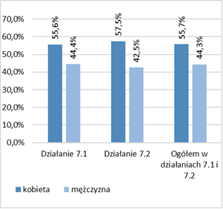

Measure 7.1 Measure 7.2 Total for Measures 7.1 and 7.2

woman man

Source: own study based on data from the SL database | Chart 20. Structure of beneficiaries of subsidies and loans for setting up a business by sex under Measures 7.1 and 7.3 and in total  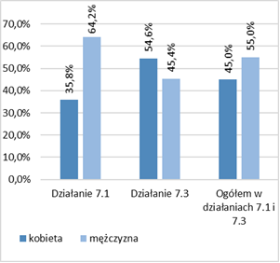  Measure 7.1 Measure 7.3 Total for Measures 7.1 and 7.3  woman MAN

Source: own study based on data from the SL database

Chart 21. Structure of support beneficiaries by age under Measures 7.1 and 7.2 and in total  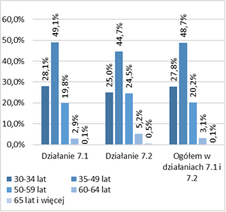  Measure 7.1 Measure 7.2 Total for Measures 7.1 and 7.2  30-34 years 35-49 years  50-59 years 60-64 years  65 and more years  Source: own study based on data from the SL database | Chart 22. Structure of beneficiaries of subsidies and loans for setting up a business by age under Measures 7.1 and 7.3 and in total  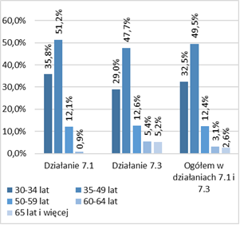  Measure 7.1 Measure 7.3 Total for Measures 7.1 and 7.3  30-34 years 35-49 years  50-59 years 60-64 years  65 and more years  Source: own study based on data from the SL database
Chart 23. Structure of support beneficiaries by education under Measures 7.1 and 7.2 and in total
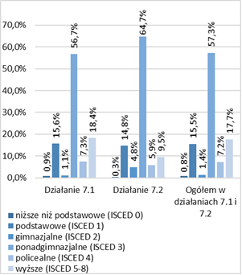

Measure 7.1 Measure 7.2 Total for Measures 7.1 and 7.2

pre-primary (ISCED 0)
primary (ISCED 1)
lower secondary (ISCED 2)
upper secondary (ISCED 3)
post-secondary not tertiary (ISCED 4)
tertiary (ISCED 5-8)
Source: own study based on data from the SL database

Chart 24. Structure of beneficiaries of subsidies and loans for setting up a business by education under Measures 7.1 and 7.3 and in total
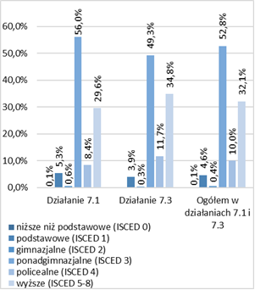

Measure 7.1 Measure 7.3 Total for Measures 7.1 and 7.3

pre-primary (ISCED 0)
primary (ISCED 1)
lower secondary (ISCED 2)
upper secondary (ISCED 3)
post-secondary not tertiary (ISCED 4)
tertiary (ISCED 5-8)
Source: own study based on data from the SL database
Another problem related to offering the same forms of support was highlighted in the opinion expressed by an expert from the Provincial Labour Office in Opole that, as an institution, places great emphasis on the quality of support. Negative effects of cannibalisation include differences in the quality of support offered in a systemic and competitive manner. The overall assessment of support offered by various entities is more favourable for tasks carried out “systemically” by labour offices than in the case of other (commercial) providers offering the same forms of support:
Under it [Measure 7.1 ed.] there are greater difficulties in recruiting enterprises to provide high-quality internships (to support beneficiaries) and internships there are sometimes shorter than those offered by labour offices. Internships organised by our offices last at least 3 months. Internships last usually from 3 to 6 months, and here (commercial institutions ed.) it is very common that these internships take 1 or 1.5 month, which is inadequate” [U30]; "(...) we have set such conditions as well as both area and effectiveness ones, combining forms of support from recruitment and consulting, internships and training, dedicated in one professional area, then we required effects; and, unfortunately, the beneficiaries, i.e. commercial institutions, most often did not cope with it well [U2].
Similar support instruments under the Measures, very similar frequency of their use and addressing the same forms of support to target groups that are largely identical in terms of their structural characteristics would require drawing a demarcation line between Measures 7.1 and 7.2 to eliminate cannibalisation and its effects. Nevertheless, this solution was not approved by the beneficiaries of the two Measures in the discussion carried out during the Expert Panel.

Impact of participation in support on taking up work
According to analyses, it should be concluded that the support offered under Measures 7.1 and 7.2 had a significant impact on the situation of its beneficiaries on the labour market. Under Measure 7.1, the largest number of people who took up work after they had been granted support was in the districts of Nysa (1,383) and Brzeg (991), the city of Opole (757), and in the Opole district (686), in where the highest number of unemployed was registered in December 2014. As part of Measure 7.2, the greatest number of people who took up work after they had been granted support was in the districts of Nysa (87), Brzeg (32), and Namysłów (24).

Figure 5. The number of people who took up work after they had been granted support under Measure 7.1 in the Opole Province districts in 2015-2019 (completed projects) | Figure 6. The percentage of people who took up work after they had been granted support under Measure 7.1 in the Opole Province districts in 2015-2019 (completed projects)
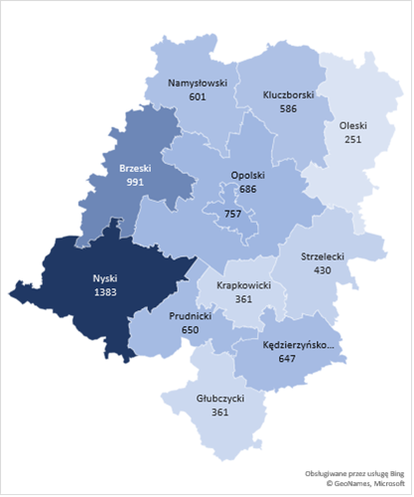 | 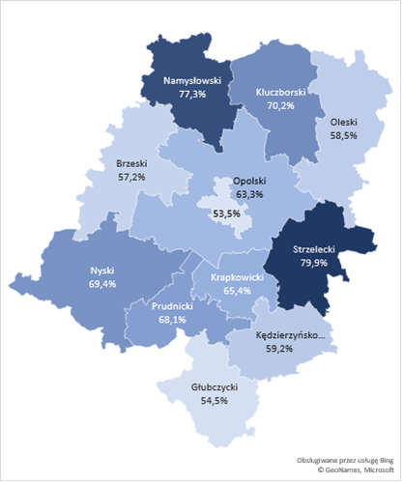
Source: own study based on data from the SL database | Source: own study based on data from the SL database

Figure 7. The number of people who did not take up work after they had been granted support under Measure 7.1 in the Opole Province districts in 2015-2019 (completed projects) | Figure 8. The percentage of people who did not take up work after they had been granted support under Measure 7.1 in the Opole Province districts in 2015-2019 (completed projects)
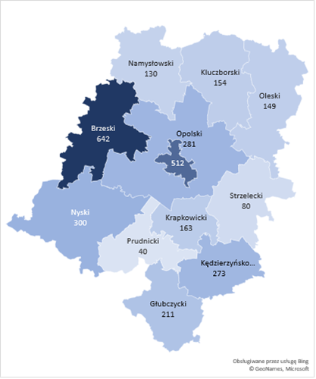 | 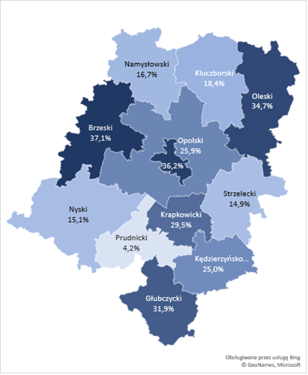
Source: own study based on data from the SL database | Source: own study based on data from the SL database

Figure 9. The number of people in a different situation on the labour market after being granted support under Measure 7.1 in the Opole Province districts in 2015-2019 (completed projects) | Figure 10. The percentage of people in a different situation on the labour market after being granted support under Measure 7.1 in the Opole Province districts in 2015-2019 (completed projects)
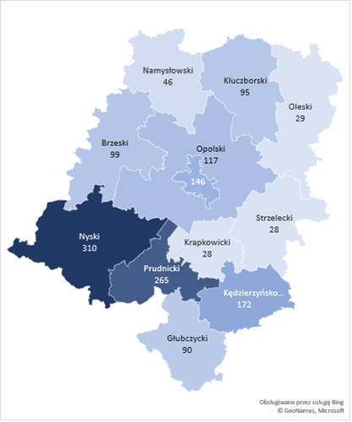 | 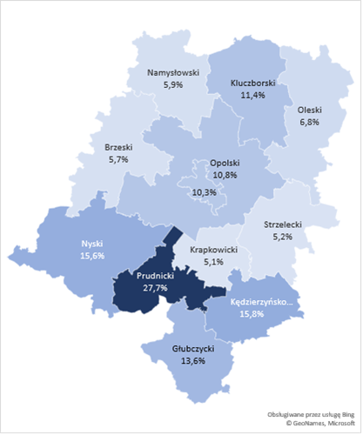
Source: own study based on data from the SL database | Source: own study based on data from the SL database

Figure 11. The number of people who took up work after they had been granted support under Measure 7.2 in the Opole Province districts in 2015-2019 (completed projects) | Figure 12. The percentage of people who took up work after they had been granted support under Measure 7.2 in the Opole Province districts in 2015-2019 (completed projects)
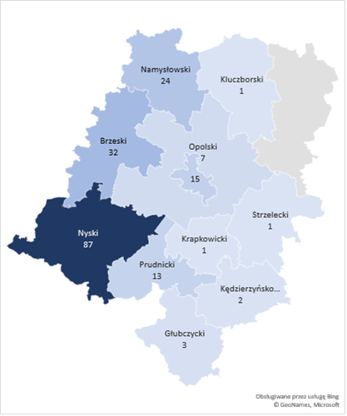 | 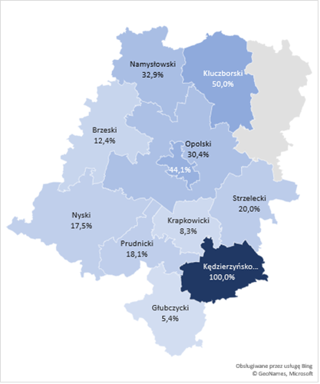
Source: own study based on data from the SL database | Source: own study based on data from the SL database

Figure 13. The number of people who did not take up work after they had been granted support under Measure 7.2 in the Opole Province districts in 2015-2019 (completed projects) | Figure 14. The percentage of people who did not take up work after they had been granted support under Measure 7.2 in the Opole Province districts in 2015-2019 (completed projects)
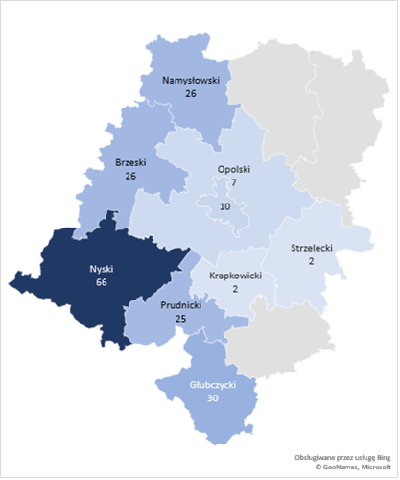 | 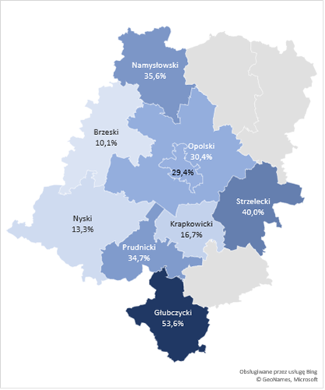
Source: own study based on data from the SL database | Source: own study based on data from the SL database

Figure 15. The number of people in a different situation on the labour market after being granted support under Measure 7.2 in the Opole Province districts in 2015-2019 (completed projects) | Figure 16. The percentage of people in a different situation on the labour market after being granted support under Measure 7.2 in the Opole Province districts in 2015-2019 (completed projects)
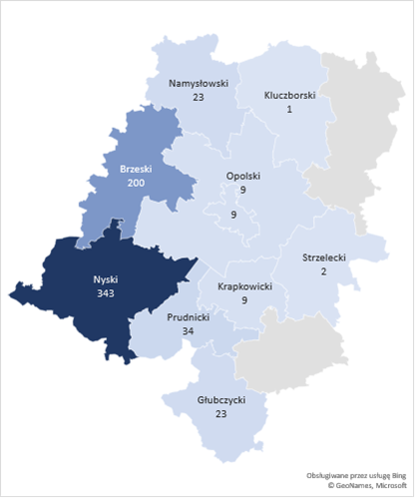 | 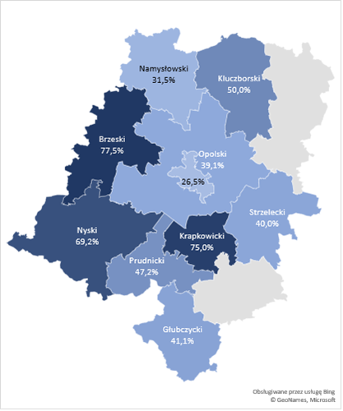
Source: own study based on data from the SL database | Source: own study based on data from the SL database

Internships/traineeships
The high effectiveness of the Measures was confirmed also by the findings of CATIs. Having completed the internship/traineeship, most of the respondents (60.4%) were employed in the companies where they completed them, while the others started to intensively look for a job (32.8%) or started running their own business (2.0%). A similar number (1.6%) found and started a job already during the internship. Only a small number of people started further education (0.4%) after completing their participation in the project. Thus, the majority of the respondents (64.0%) successfully changed their situation on the labour market by taking up economic activity after completing an internship or traineeship.
Chart 25. The situation of support beneficiaries on the labour market following completion of an internship/traineeship
{0>
I have taken up further education but I was not looking for a job
Other
During the internship, I found and started a different job
I have set up a business
I have neither taken up further education nor have been looking for a job
I have started looking for a job
I have been employed in the company where I completed the internship

Source: own study based on data from CATIs, n=250
The positive assessment of the internships/internships expressed by the support beneficiaries was correlated with the positive assessment of the beneficiaries, participants in the qualitative research:
“[internships] are quite a nice form, successful in around 60.0% in our case. At least 60 people work afterwards, they have an employment contract for a minimum of 3 months, for the part-time required” [P4]. “(...) we do not force them, but these people ask for internships themselves, because we know – we are introducing such a positive trend from the very beginning – that after this internship people find employment and very few people come back to us” [P6].
According to FGI participants, the overall assessment of the effectiveness of the internships offered is positive, but the accomplishment of the adopted goal always depends on a specific situation. For example, the period of short 3-month employment after an internship is more effective in various places/districts, while in the case of a longer period of employment it is clearly lower:
We are talking about this short period of 3 months. In this case the effectiveness is high – around 80.0%, more or less, but it is very high. On the other hand, the long-term effectiveness drops to 40.0% [P41].
Training courses
According to the research findings, the effectiveness of training courses in changing the professional situation was also high. After their completion, half (51.0%) of the respondents were employed, including more than one-third under employment contracts (38.5%), and the others (12.5%) – under civil law contracts. About one-third (29.8%) started looking for a job, others started their own business (12.5%) or took up further education and looked for a job (1.0%). Therefore, the vast majority of those who had completed training courses became active on the labour market (63.5%), while only a small group remained unemployed, as 5.8% did not show any activity in this regard.
Chart 26. The situation of support beneficiaries on the labour market following completion training courses

I have taken up further education and have been looking for a job
I have neither taken up further education nor have been looking for a job
I have set up a business
I have been employed under a civil law contract (contract of mandate/contract for performance of a specific task)
I have started looking for a job
I have been employed under an employment contract

Source: own study based on data from CATIs, n=104
According to the research findings, it should be stated that both forms of support – internships/traineeships and training courses – were characterised by a similar, high degree of effectiveness, because after their completion, most of the respondents became economically active, thus changing their the situation on the labour market. It should also be noted that the effectiveness of internships/traineeships resulted from direct contacts with a potential employer and the possibility of presenting oneself, one’s qualifications and skills directly in the work environment. As for training courses, these enabled their participants to obtain new professional competences and new professional qualifications or enhance or complement those already possessed. Other advantages included acquisition of soft skills and the ability to communicate in foreign languages, increasing the attractiveness of non-working people as future employees. The overall effectiveness of the applied forms of support was also due to the specific characteristics of these forms of support, as they enable project participants to enter the labour market, which has a number of advantages: playing new social roles, leading a new lifestyle of a working person, developing a number of psychological features (activity, responsibility, self-organisation), as well as reducing the feeling of deprivation and exclusion at the level on an individual. All of them bring the expected results, provided that the support beneficiary is not characterised by “learned helplessness”. In turn, from the perspective of the needs of the labour market, the effectiveness of these forms of support manifests itself in the ability to use the capacities of support beneficiaries and reduce a number of social problems caused by unemployment (especially long-term unemployment).

Impact of participation in support on occupational mobility
Research shows that support offered under Measures 7.1 and 7.2 affected the occupational mobility of support beneficiaries to a varying degree.
In the case of participants of internships and traineeships, the trend of “migration reluctance” or “reluctance to occupational mobility” was the most apparent, because according to their declarations, the vast majority of the beneficiaries of this form of support (69.9%) would not be willing to move to another place, even if they found an attractive offer.
Chart 27. Change of the place of residence of support beneficiaries in order to take up work (internships/traineeships)  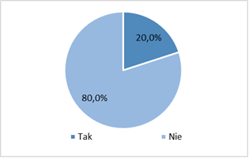  Yes No  Source: own study based on data from CATIs, n=250 | Chart 28. Propensity to occupational mobility of support beneficiaries in the event of receiving an attractive job offer (internships/traineeships)  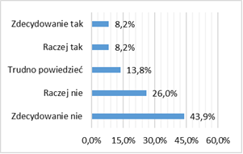  Definitely yes  Rather yes  Hard to say  Rather not  Definitely not  Source: own study based on data from CATIs, n=196
Occupational mobility manifested itself to a greater extent among people participating in training courses. While it is true that over half of the project participants (55.8%) did not change their place of residence when taking up a job, a significant group (44.2%) moved to another location. The distribution of responses to the question about the propensity to change the place of residence in connection with receiving an attractive job offer, proves, however, low “propensity to occupational mobility” in this group and acting somehow under compulsion. The vast majority of support beneficiaries (71.2%) declared that they would not have changed their place of residence, even if they had found an attractive job offer somewhere else.
Chart 29. Change of the place of residence of support beneficiaries in order to take up work (training courses)  Yes No  Source: own study based on data from CATIs, n=104 | Chart 30. Propensity to occupational mobility of support beneficiaries in the event of receiving an attractive job offer (training course)  Definitely yes  Rather yes  Hard to say  Rather not  Definitely not  Source: own study based on data from CATIs, n=90

Those members of the group for whom workstations were equipped or further equipped did not face the need to move to another location to take up work, and thus changed their place of residence in connection with taking up employment to the least extent (13.3%). Despite this fact, it was this group that revealed the highest “propensity to occupational mobility”. More than half of the respondents declared that they would have moved to another location if they had found an attractive job offer.
Chart 31. Change of the place of residence of support beneficiaries in order to take up work (equipping or further equipping of workstations)  {0>  Yes No  Source: own study based on data from CATIs, n=15 | Chart 32. Propensity to occupational mobility of support beneficiaries in the event of receiving an attractive job offer (equipping or further equipping of workstations)  Definitely yes  Rather yes  Hard to say  Rather not  Definitely not  Source: own study based on data from CATIs, n=16
Participation in the support forms discussed did not significantly affect reported reluctance towards occupational mobility (related to the possibility of obtaining an attractive and well-paid job). The persistence of this attitude was demonstrated, first of all, by people participating in internships and traineeships (71.6%), and to a lesser extent by those for whom their workstations had been equipped or further equipped (44.4%), followed by those who had participated in training courses (37.5%).
Chart 33. Impact of participation in an internship/traineeship on the propensity to occupational mobility  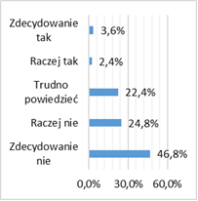  Definitely yes  Rather yes  Hard to say  Rather not  Definitely not  Source: own study based on data from CATIs, n=250 | Chart 34. Impact of equipping or further equipping the workstation on the propensity to occupational mobility  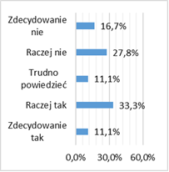  Definitely yes  Rather yes  Hard to say  Rather not  Definitely not

Source: own study based on data from CATIs, n=18 | Chart 35. Impact of participation in training courses on the propensity to occupational mobility  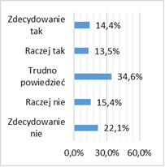  Definitely yes  Rather yes  Hard to say  Rather not  Definitely not  Source: own study based on data from CATIs, n=104

In view of the above, it should be concluded that the change in the attitudes in the surveyed group in terms of occupational mobility related to the search for an attractive and well-paid job was not high, which was undoubtedly influenced by the effectiveness of the support received by the respondents, that enabled them to start work in the place of residence or in its vicinity, thus lowering propensity to occupational mobility.

Impact of participation in support on building the capacity of regional specialisations
Another analysed issue focused on the impact of the forms of support offered under Measures 7.1, 7.2 and 7.3 on building and strengthening the capacity of regional specialisations set out in the Regional Innovation Strategy in force until 2020.
The issues of staff education and stimulating the key directions of entrepreneurship development in the region were clearly emphasised by experts who repeatedly emphasised in discussions that support offered under the specified Measures should be provided in such a way as to release the pro-economic potential in the region to the greatest possible extent.
(...) we should, through our actions, release such intellectual and development potential to make this superstructure grow here [B23].
As shown above, the industry structure of the companies where internships and traineeships were held, and workstations were equipped or further equipped, corresponded to the regional specialisations set out in the Regional Innovation Strategy by 2020 to a relatively limited extent. In the private sector, the discussed forms of support were implemented primarily in the service, commercial, and construction industries, while in the public sector – in administration, healthcare, and education.
When analysing the subject matter of the training courses offered, it should be stated that for building the potential of regional specialisations those training courses were important that enabled the acquisition of or improvement in qualifications in the following groups of professions:
Regional specialisations
- “Sustainable construction and wood technologies”: earthmoving equipment operators and mechanics; operators of lifting and transport equipment; industrial designers.
- “Technologies of the machinery and metal industries”: operators of metal cutting machines, miners and operators of mining plant and machinery;
- “Energy industry technologies (including renewable energy sources, energy efficiency improvement)”: electricians, electromechanics, and wiremen;
- “Agri-food technologies”: food processing workers.
Potential regional specialisations
- “Health and environmental protection processes and products”: caregivers for the elderly and the disabled, psychologists and psychotherapists, physiotherapists and masseurs, recreation and sport instructors, medical equipment operators;
- “Spatially integrated regional tourist product”: travel agency employees and tour operators.
Summing up, it should be stated that the forms of support offered under Measures 7.1 and 7.2 corresponded, though to a limited extent, to the development needs of enterprises operating in the area of the regional specialisations, as they made it possible to educate employees and increase their qualifications, competences or skills in occupational groups related to the leading industries in the region.
Businesses
The correspondence of the profiles of the businesses set up with the areas of regional specialisation was another aspect of the effectiveness of the support provided under PA VII. An analysis accounting for the regional specialisations set out in the Regional Innovation Strategy by 2020 showed that the vast majority of the businesses set up as part of the support offered (73.8%) corresponded to the areas of regional specialisations of the Opole Province.
Chart 36. Correspondence of the profiles of the businesses set up with the areas of the regional specialisations of the Opole Province
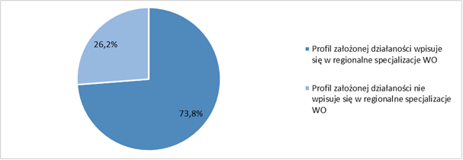
Profile of the established business corresponds to the regional specialisation of the Opole Province
Profile of the established business does not correspond to the regional specialisation of the Opole Province
Source: own study based on data from the SL database
The profiles of the businesses set up were related mainly to the construction industry (38.0%) that is part of “Sustainable construction and wood technologies”, followed by those in the area of “Technologies of the machine and metal industries” (4.8%), and in other areas such as: “Energy industry technologies (including renewable energy sources, improvement of energy efficiency)” and “Agri-food technologies”.
New companies offering tourist services (5.0%) and those offering medical and rehabilitation services (3.9%) fit into the group of potential regional specialisations, such as: “Health and environmental protection processes and products” and “Spatially integrated regional tourist product”.
Table 12. The most frequently set up businesses by industry and the regional specialisations
Construction industry and mineral industry with construction services | 38,0%
Trade | 21,7%
Light industry | 7,6%
Wood and paper industry, including furniture manufacture | 7,2%
Tourist services | 5,0%
Machine and electromechanical industry | 4,9%
Medical and rehabilitation services | 3,9%
Education services | 3,9%
Metal and metallurgical industry | 3,2%
Financial services | 1,8%
Agri-food industry | 1,1%
Chemical industry | 1,0%
Transport and logistics | 0,9%
Total | 100,0%
Source: own study based on data from the SL database
The importance of building smart regional specialisations and the creation of new companies and thus also new jobs as part of these specialisations for the development of the Opole region was emphasised in particular by FGI participants, who during the group discussion repeatedly pointed out that the persistent shortage in this area makes it impossible to effectively prevent young people seeking work in neighbouring metropolises from leaving the Opole region. Their position in this regard is reflected in the following exemplary statements:
(…) in a less urbanised area, with lower entrepreneurship, worse entrepreneurship indicators (we are talking about rural areas, we are talking about depopulation in our region, let us not forget about it), these are the challenges for us. Good-quality jobs, in regions with a high rate of attracting external investors, the structure of funds absorption is also different, i.e. where there is more technology, smart specialisation involvement, where there is a wider choice of a career path, there are also greater chances for employment. In some areas, we have traditional professions to perform, we do not have so many of these professions yet, there are of course gems, but there are not yet enough such companies that would make young people stay in our region and not look for a job in Wrocław or Warsaw [U19].
The quantitative and qualitative analysis of the research findings allows for drawing the following conclusions:
The high rate of changes on the national and regional labour markets observed in recent years, makes it impossible to precisely predict the processes in the long term (e.g. in terms of the demand for specific types of professions), which makes it difficult to plan economic activation measures. This problem is additionally exacerbated by the constantly changing proportions of various support beneficiaries in the structure of the target group. All this requires much greater flexibility in the selection of adequate forms of support.
The importance of greater flexibility on the labour market grows in the conditions of negative economic shocks, as it facilitates taking anti-crisis adaptation measures. Thus, greater flexibility in the selection of forms of economic activation will also be substantiated in the case of the economic crisis caused by COVID-19. In the near term, it will be important for raising qualifications in industries that are key in the time of crisis (e.g. employees working in healthcare, food production and distribution, as well as professional drivers, warehouse workers, and couriers). In the longer term, it will be beneficial from the perspective of the current needs of the economy, and thus eliminating the structural mismatch on the labour market.

Assessment of the effectiveness of support forms
In this subchapter, an assessment of the degree of the effectiveness of the forms of support provided under Measures 7.1, 7.2 and 7.3 was made. When analysing the issue in question, particular focus was on the following aspects:
- What was the cost-effectiveness of the support forms?
- What was the employment effectiveness of the support forms?

Effectiveness of the forms of support in terms of economic activation
When analysing the amounts “invested” under Measures 7.1 and 7.2 in particular districts, it should be stated that the highest amounts of support were directed to the most needy local labour markets, i.e. where the number of unemployed people, including the long-term unemployed, was the highest. The amounts “invested” under both Measures ranged between PLN 3,109,636 (the Olesno district) and PLN 26,896,201 (the Nysa district).
Figure 17. Amounts “invested” under Measures 7.1 and 7.2 in the Opole Province districts in 2015-2019
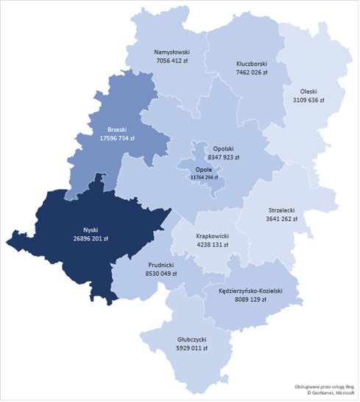
Source: own study based on data from the SL database
When analysing the unit costs of economic activation of the support participants, it should be noted that under Measure 7.1, these ranged from PLN 6,455 (the Brzeg district) to PLN 8,911 (the Kluczbork district). As for Measure 7.2, these costs ranged from PLN 13,000 (the district of the city of Opole) to PLN 23,764 (the Brzeg district).

Figure 18. Amount under Measure 7.1 per participant in the Opole Province districts in 2015-2019 | Figure 19. Amount under Measure 7.2 per participant in the Opole Province districts in 2017-2019
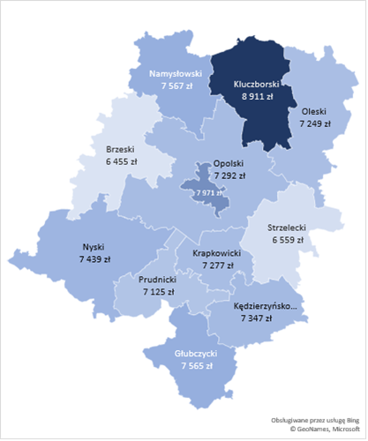 | 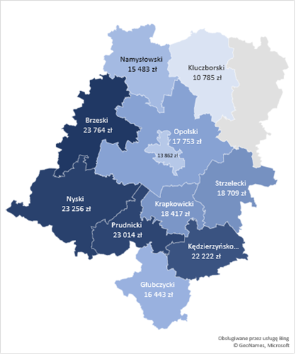
Source: own study based on data from the SL database | Source: own study based on data from the SL database

When analysing the effectiveness of support under Measure 7.1 in absolute numbers, i.e. looking at it through the prism of the number of people who have returned onto the labour market as a result of the support received, the highest effectiveness was recorded in the Nysa district where 1,689 people started work after having been provided with support, followed by the Brzeg district, where 1,266 people returned onto the labour market. Considering it, however, in terms of the ratio of people who took up work having been provided with support to people who did not take up work having been provided with support, it should be noted that the situation in this respect is most favourable in the districts of Prudnik and Strzelce.
Table 13. People who took up work and people who did not take up work having been supported under Measure 7.1 in the Opole Province districts in 2015-20197.1
District | People who took up work |  |  |  |  | Total | People who did not take up work |  |  |  |  | Total
 | Years |  |  |  |  |  | Years
 | 2015 | 2016 | 2017 | 2018 | 2019 |  | 2015 | 2016 | 2017 | 2018 | 2019
Brzeg | 250 | 246 | 279 | 340 | 151 | 1,266 | 209 | 98 | 99 | 139 | 106 | 651
Głubczyce | 114 | 118 | 116 | 95 | 38 | 481 | 47 | 66 | 38 | 47 | 33 | 231
Kędzierzyn-Koźle | 206 | 218 | 171 | 138 | 81 | 814 | 123 | 107 | 41 | 20 | 3 | 294
Kluczbork | 127 | 119 | 169 | 198 | 125 | 738 | 23 | 42 | 36 | 33 | 39 | 173
Krapkowice | 88 | 115 | 95 | 87 | 71 | 456 | 62 | 34 | 28 | 23 | 18 | 165
Namysłów | 127 | 119 | 178 | 149 | 83 | 656 | 31 | 18 | 35 | 27 | 20 | 131
Nysa | 511 | 397 | 361 | 296 | 124 | 1,689 | 84 | 75 | 72 | 40 | 45 | 316
Olesno | 91 | 80 | 71 | 75 | 35 | 352 | 41 | 46 | 37 | 21 | 11 | 156
city of Opole | 226 | 202 | 239 | 237 | 109 | 1,013 | 163 | 155 | 111 | 78 | 57 | 564
Opole | 195 | 199 | 194 | 219 | 112 | 919 | 88 | 73 | 48 | 50 | 35 | 294
Prudnik | 170 | 158 | 147 | 162 | 98 | 735 | 3 | 9 | 5 | 9 | 15 | 41
Strzelce | 105 | 114 | 93 | 126 | 96 | 534 | 29 | 18 | 10 | 19 | 7 | 83
Total | 2,210 | 2,085 | 2,113 | 2,122 | 1,123 | 9,653 | 903 | 741 | 560 | 506 | 389 | 3,099
Source: own study based on data from the SL database
When comparing the absolute numbers in the case of Measure 7.2, it should be noted that the highest effectiveness of the support was recorded in the Nysa district, where the number of support beneficiaries who took up employment was the highest (95) (in the other districts, the numbers of people who took up work were much lower). It was also the district where the ratio of people who took up work having been provided with support to people who did not take up work in spite of this support was the most favourable.
Table 14. Number of people who took up work having been supported under Measure 7.2 in the Opole Province districts in 2017-2019
District | People who took up work |  |  | Total | People who did not take up work |  |  | Total
 | Years |  |  |  | Years
 | 2017 | 2018 | 2019 |  | 2017 | 2018 | 2019
Brzeg | 37 | 0 | 0 | 37 | 29 | 0 | 0 | 29
Głubczyce | 3 | 0 | 0 | 3 | 30 | 0 | 0 | 30
Kędzierzyn-Koźle | 2 | 0 | 0 | 2 | 0 | 0 | 0 | 0
Kluczbork | 1 | 0 | 0 | 1 | 0 | 0 | 0 | 0
Krapkowice | 2 | 0 | 0 | 2 | 2 | 0 | 0 | 2
Namysłów | 28 | 0 | 0 | 28 | 27 | 0 | 0 | 27
Nysa | 95 | 0 | 0 | 95 | 74 | 0 | 0 | 74
Olesno | 0 | 0 | 0 | 0 | 0 | 0 | 0 | 0
city of Opole | 15 | 0 | 0 | 15 | 13 | 0 | 0 | 13
Opole | 7 | 0 | 0 | 7 | 8 | 0 | 0 | 8
Prudnik | 15 | 0 | 0 | 15 | 27 | 0 | 0 | 27
Strzelce | 2 | 0 | 0 | 2 | 2 | 0 | 0 | 2
Total | 207 | 0 | 0 | 207 | 212 | 0 | 0 | 212
Source: own study based on data from the SL database
It is also worth noting that the support effectiveness measured by the number of people who took up work having been provided with support relative to the number of people who did not take up work in spite of this support was higher for Measure 7.1 than Measure 7.2. As shown by the research findings, having received support under Measure 7.1, three-fourths of people in each district on average took up work and only one-fourth of them were still unemployed. The opposite situation was observed when it comes to Measure 7.2, in which, after having receiving support, on average slightly more than half of people returned onto the labour market in each of the districts.
A comparison of the average cost of economic activation of support beneficiaries between Measure 7.1 and Measure 7.2 shows that this cost under Measure 7.1 was slightly above PLN 6,000, while under Measure 7.2, it was around PLN 17,000.
Chart 37. Average cost of economic activation of support beneficiaries under Measures 7.1 and 7.2
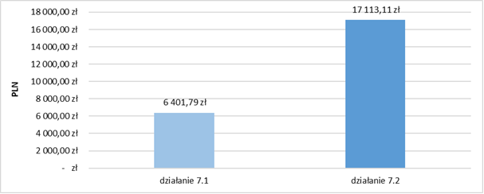
……………………………………………………………….PLN 6,401.79 PLN 17,113.11
Measure 7.1 Measure 7.2
W pozostałych liczbach na wykresie należy wykreślić “zł” i zmienić przecinki na kropki, a spacje na przecinki
Source: own study based on data from project co-financing agreements and the SL database
It can be, therefore, concluded that the differences between the amounts of support under the two Measures did not positively affect the level of support effectiveness. However, according to analyses of the statements of the competition proponents, the possible optimisation of costs, i.e. their reduction, could result in the gradual disappearance of companies that would like and would be able to carry out their tasks on the labour market:
If nowadays the policy of optimising these costs aimed at their lowering, I predict very low beneficiaries’ willingness to implement these projects in the future [K76].
It should also be noted that the assessment of cost-effectiveness should account also for the diverse thematic scope of the forms of support implemented under both Measures.
We have such projects under 7/2 in which we engine drivers. The employment effectiveness is very high. These are high-cost projects, because these licences are expensive.
As well as the fact that high differences in the average costs of economic activation between the two Measures result from the fact that in the case of Measure 7.2 the entire organisational part of the project and all indirect costs related to it are borne (as opposed to district labour offices implementing projects under Measure 7.1) by the competition implementers. The specific characteristics of the operation of both types of support providing entities are, therefore, different, as labour offices, being public institution, are obliged by the provisions of the Act. In this sense, the obviousness of the discussed cost differentiation results from comparing a state (budgetary) institution, on the one hand, and the profit-oriented entity, on the other. The differences between the competition and non-competition project procedure are clearly visible in internships:
We should remember that unlike competition project, projects implemented by labour offices do not include administrative costs, while it is not said that district labour offices do not bear these costs. They do. They have up to 3% from the Labour Fund, so outside projects and they have such funds (...). And yet another factor: district labour offices have unit rates resulting from the act, or these internships, set at a low level, while in the competition procedure, the rates were much higher, because these internships were at the level of even PLN 1,700. This is a fundamental difference [U36].
The problem of gross differentiation in the amounts of internship scholarships was raised by non-competition project proponent who observed that potential participants of various projects calculated whether joining them would be beneficial and profitable. Resignation from participation in, e.g. internships implemented as part of projects under Measure 7.1 by district labour offices is associated, according to beneficiaries, with their clearly lower profitability, as they notice that there are other more profitable offers of similar forms of support implemented by other entities or institutions (for example under ESF projects). This issue is raised in the following statement:
Some people resign from internships because of the money offered in spite of the fact they actually have to work like others [P3].
The downside of this 7.1 project is that we, as labour offices, have to operate in accordance with our act. We have nothing else, like “something extra”, while many other institutions that are just getting started submit some ESF projects, use tools that have nothing to do with our act and, for example, an unemployed person may take part in the same internship, in the same form and in the same institution under our referral for PLN 1,000, while they can do the same for much more money under an ESF project implemented by another institution (the same internship, the same scholarship but not regulated by the act), so in the case of internships, this is a problem that will keep growing [P4].
Analysing the cost-effectiveness based on various evaluations (including ministerial ones), the Provincial Labour Office emphasises that the expenses on internships, training and related administrative costs, and guiding the unemployed are not one-off expenses, but they remain at a constant, stable level:
(...) we have approximately the average cost assumed in the programme for activation measures of about 10,000. Here, as a result of a grant and transitional support, about 30,000, but the effectiveness is very high and then these people do not come back (...) [U34].
Under Measures 7.1 and 7.2, beneficiaries used several forms of support at the same time. The maximum number of forms of support per participant was high; the highest under Measure 7.2 (13) and slightly lower under Measure 7.1 (9). The minimum number of forms of support per one participant under both Measures was 1. In general, the Measures differed slightly in terms of the most frequent number of forms of support per one participant – 2 under Measure 7.1 and 4 under Measure 7.2.
Chart 38. Number of forms of support per participant under Measures 7.1 and 7.2
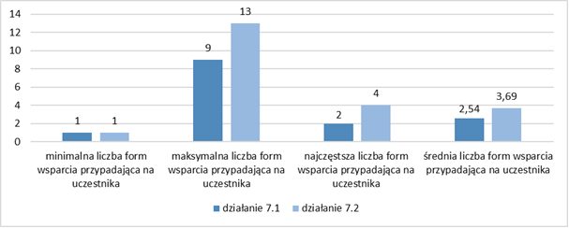
minimum number of support forms per participant | maximum number of support forms per participant | the most common number of support form per participant | average number of support forms per participant
Measure 7.1 Measure 7.2
Source: own study based on data from the SL database
The effectiveness of the support provided, measured by the percentage of working people depending on the number of forms of support, indicates that participation in two or three forms of support is the most effective for taking up employment. Therefore, it can be concluded that the use of several forms of support was highly conducive to the high effectiveness of the support provided.
Chart 39. Percentage of working and non-working people depending on the number of forms of support provided
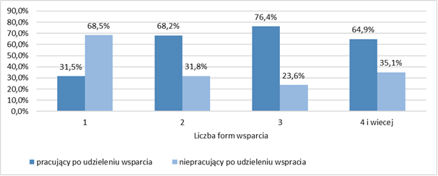

4 and more
Number of support forms
people working after having been granted support people not working after having been granted support
Source: own study based on data from the SL database
The quantitative and qualitative analysis of the research findings allows for drawing the following conclusions:
Despite the high popularity and effectiveness of support in the form of internships for unemployed and economically inactive people, the current amount of internship grants is no longer attractive, especially when various benefits are available (e.g. 500+), which is a frequent reason for resignation from support. At the same time, there is a difference between the amount of internship grants provided as part of measures pursued by district labour offices and that offered by commercial entities (in the Operational Programme for the Opole Province 2014-20, Measures 7.1 and 7.2), resulting from the statutory constraints binding on district labour offices). Significantly lower grants offered by district labour offices are not attractive compared to those offered under measures carried out by commercial entities.

Effectiveness of the forms of support in self-employment
When analysing the amounts “invested” under Measures 7.1 and 7.3 for self-employment in particular districts, it should be stated that the highest amounts of support were directed to the most needy local labour markets. The spatial distribution of the amounts indicates that the largest amounts of funds were allocated to the Nysa district (PLN 9,106,662), followed by the district of the city of Opole (PLN 7,747,837) and the Opole district (PLN 6,537,441).
Figure 20. Amounts of support under Measures 7.1 and 7.3 for setting up a business in the Opole Province districts in 2015-2019
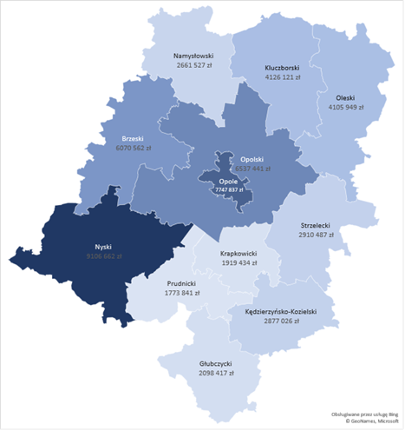
Source: own study based on data from the SL database

Figure 21. Amounts of support under Measure 7.1 for setting up a business in the Opole Province districts in 2015-2019 | Figure 22. Amounts of support under Measure 7.3 for setting up a business in the Opole Province districts in 2015-2019
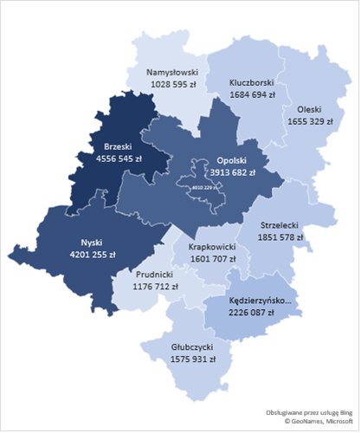 | 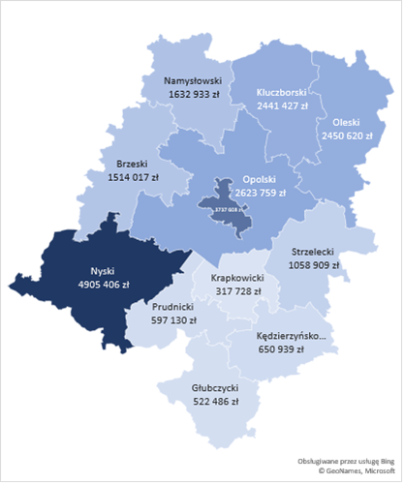
Source: own study based on data from the SL database | Source: own study based on data from the SL database

Under Measure 7.1, the highest amounts were allocated to the districts of Brzeg (PLN 4,556,545), Nysa (PLN 4,201,255), and Opole (PLN 3,913,682). As for Measure 7.3, the highest amounts were allocated to the districts of Nysa (PLN 4,905,406), the city of Opole, and Opole (PLN 2,623,759).
People who benefited from the funds most often set up companies in construction, trade in and repair of motor vehicles, and industrial processing, which corresponds to the industry structure of companies operating in the Opole Province.
Table 15. The most frequently set up businesses by industry
Construction | 25.7%
Industrial processing | 14.8%
Wholesale and retailing; repair of motor vehicles, including motorcycles | 16.0%
Professional, scientific and technical activities | 11.0%
Other services | 9.3%
Administrative and support services | 6.8%
Healthcare and social assistance | 3.5%
Education | 2.8%
Arts, entertainment and recreation | 2.5%
Accommodation and food service | 2.4%
Information and communication | 1.8%
Financial and insurance services | 1.3%
Real estate management | 0.8%
Agriculture, forestry, hunting and fishing | 0.7%
Transport and warehouse management | 0.5%
Water supply; sewerage and waste management and remediation services | 0.1%
Total | 100.0%
Source: own study based on data from the SL database
When analysing the findings of quantitative research, it should be emphasised that the structure of the established companies is dominated by services (68.6%), trade (11.8%), and mixed activities. The least frequently established businesses include production companies, i.e. ones that shape the potential and stimulate the development of the region to the greatest extent. This type of companies would therefore require a preferential approach with respect to support in the new programming period.
Chart 40. Types of companies established as a result of received support
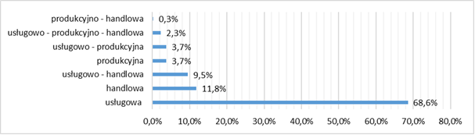
production and trade
services, production and trade
services and production
production
services and trade
trade
services
Source: own study based on data from CATIs, n=347
One of the basic problems related to the effectiveness of the discussed form of support is continuation of the operation of established companies after the mandatory period of running a business, as success in this respect gives hope for a permanent change in the status of the unemployed on the labour market.
When analysing the results of surveys, it should be stated that over half (66.0%) of the respondents still run their businesses set up as a result of the support provided under Measures 7.1 or 7.3, including a large group of companies (39.0%) for which the mandatory period of running a business has already expired. About one-third (34.0%) of support beneficiaries has suspended or dissolved their business, and 27.1% of them still run the business because the mandatory period of running it has not expired yet.
Chart 41. Status of established businesses
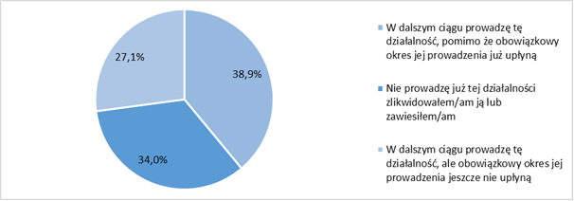
I continue to run this business, in spite of the fact that the mandatory period of its maintenance has already expired

I do not run this business any more – I have closed or suspended it

I continue to run this business, but the mandatory period of its maintenance has not expired yet

Source: own study based on data from CATIs, n=347
The findings of the survey correspond to the opinions of experts obtained as a result of the qualitative research:
Earlier surveys showed an approx. 70.0% business survival rate after this year [U34].
They are also confirmed in analyses of existing data, which show that in the discussed period more than half of the beneficiaries of support (64.5%) were active on the market after the mandatory period of running a business. Other businesses were dissolved (18.2%) or suspended (16.4%).
Table 16. The status of companies after the mandatory period of operation
Section in the Polish Classification of Activities | Percentage |  |  |  |  | Number |  |  |  |  | Average time of running a business in months
 | Active | Suspended | Deleted | No data | Total | Active | Suspended | Deleted | No data | Total
A | 40.0% | 13.3% | 46.7% | 0.0% | 100.0% | 6 | 2 | 7 |  | 15 | 17
C | 61.5% | 18.2% | 19.4% | 1.0% | 100.0% | 193 | 57 | 61 | 3 | 314 | 20
E | 0.0% | 50.0% | 50.0% | 0.0% | 100.0% | 0 | 1 | 1 |  | 2 | 19
F | 77.9% | 11.5% | 9.7% | 0.8% | 100.0% | 385 | 57 | 48 | 4 | 494 | 23
G | 56.0% | 18.4% | 25.0% | 0.6% | 100.0% | 204 | 67 | 91 | 2 | 364 | 21
H | 70.0% | 20.0% | 10.0% | 0.0% | 100.0% | 7 | 2 | 1 | 0 | 10 | 23
I | 61.8% | 12.7% | 23.6% | 1.8% | 100.0% | 34 | 7 | 13 | 1 | 55 | 16
J | 69.4% | 19.4% | 8.3% | 2.8% | 100.0% | 25 | 7 | 3 | 1 | 36 | 14
K | 73.3% | 3.3% | 23.3% | 0.0% | 100.0% | 22 | 1 | 7 | 0 | 30 | 20
L | 68.4% | 21.1% | 10.5% | 0.0% | 100.0% | 13 | 4 | 2 | 0 | 19 | 19
M | 70.5% | 16.6% | 11.6% | 1.2% | 100.0% | 170 | 40 | 28 | 3 | 241 | 21
N | 38.9% | 22.9% | 37.6% | 0.6% | 100.0% | 61 | 36 | 59 | 1 | 157 | 16
P | 64.5% | 19.4% | 14.5% | 1.6% | 100.0% | 40 | 12 | 9 | 1 | 62 | 24
Q | 69.7% | 13.2% | 15.8% | 1.3% | 100.0% | 53 | 10 | 12 | 1 | 76 | 19
R | 62.3% | 17.0% | 20.8% | 0.0% | 100.0% | 33 | 9 | 11 | 0 | 53 | 16
S | 62.8% | 18.9% | 17.3% | 1.1% | 100.0% | 120 | 36 | 33 | 2 | 191 | 20
Total | 64.5% | 16.4% | 18.2% | 0.9% | 100.0% | 1,366 | 348 | 386 | 19 | 2,119 | 20
Source: own study based on data from the SL database and the CEIDG databases
It is also worth noting that the business conducted is the sole source of income for the vast majority of the respondents (88.8%). Others receive additional income from rent or lease, receive a disability or retirement pension, or an alimony or scholarship.
Chart 42. Income sources of people running a business
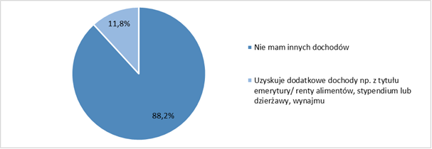

I have no other income
I have additional income, e.g. retirement/disability pension, alimony, scholarship, lease or rental
Source: own study based on data from CATIs, n=229
Most of the respondents who dissolved or suspended their company work full-time (58.5%); the others are looking for a job (22.0%), are economically inactive (7.6%) or unemployed, but are not looking for a job (7.6%).
Chart 43. The current labour market status of people who have benefited from co-financing to set up a business
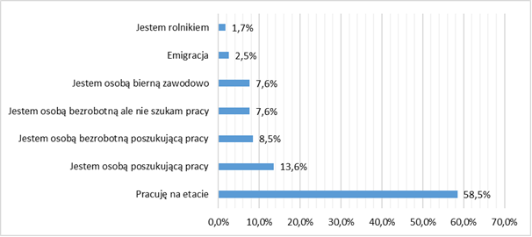
I am a farmer
Emigration
I am an economically inactive person
I am an unemployed person, but I am not looking for a job
I am an unemployed person looking for a job
I am a job seeker
I work full-time

Source: own study based on data from CATIs, n=118
Business suspension or dissolution was most often due to the excessive burden of social security premiums (50.8%), unprofitability of running a business (44.1%), less often due to family situation (23.7%) or poor health (14.4%), while for a small group of respondents (10.2%), it was a seasonal business.
Figure 44. Reasons for business dissolution/suspension
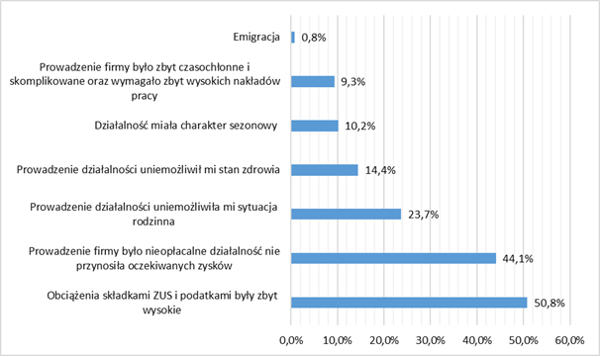
Emigration
Running this business was too much time-consuming and complicated, and it required too much labour
The business was a seasonal one
I was unable to run this business due to ill health
I was unable to run this business due to my family situation
Running this business was unprofitable, as it did not bring the expected profit
The burden with social insurance premiums and taxes was too high

Source: own study based on data from CATIs, n=118
In order to identify the factors that have the greatest impact on the survival of established companies after the mandatory period of their operation, it was verified which characteristics increase the probability of their survival, e.g. sex, age, having a specific education, status on the labour market or experience in running a business.

Chart 45. Probability of survival/suspension/dissolution of a business set up as a result of subsidies granted under Measures 7.1 and 7.3 (statistically significant areas in at least one probit function)
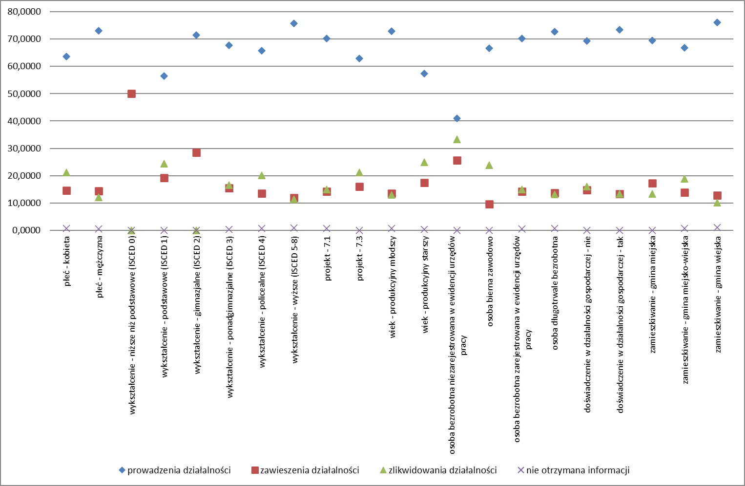
sex – woman | sex – man | education – pre-primary (ISCED 0) | education – primary (ISCED 1) | education – lower secondary (ISCED 2) | education – upper secondary (ISCED 3) | education – post-secondary non-tertiary (ISCED 4) | education –tertiary (ISCED 5-8) | project – 7.1 | project – 7.3 | age – working younger | age – working older | unemployed person not registered with a labour office | economically inactive person | unemployed person registered with a labour office | long-term unemployed person | experience in running a business – no | experience in running a business – yes | place of residence – municipality | place of residence – urban-rural area | place of residence – commune

running a business suspension of a business dissolution of a business no information

Source: own study based on data from the SL database and the CEIDG databases
As for the socio-demographic characteristics, the highest probability value was estimated for the education variable. The survival rate of entities established by people with tertiary education was 75.8%. The group of people with tertiary education was also characterised by the lowest rate of dissolution or suspension of the established company (24.2%). Sex was the second most important characteristics. The company survival rate among men was 73.1% and that among women – 63.6%. Age was another important factor. The company survival rate among the younger working age group was 72.9%, while in the older working age group, it was 57.4%. The place of residence also had a significant impact. The highest business survival rate (76.1%) was recorded among people living in rural communes.
The most important characteristics determining the position of the support beneficiaries on the labour market included the registration with the district labour office and the status on the labour market. The highest probability of company dissolution was recorded in the group of people who were not registered with the district labour office (59.0%) and were economically inactive (33.3%).
Despite slight differences, the probability of success in running a business was also dependent on previous experience in running a business held by a support beneficiary. In the group of people who had already tried their hand in business, this index value was 70.15%, while among people who did not have such experience, it was 69.3%. The survival of the established companies depended also on the Measures under which a potential future entrepreneur received support. The company survival rate for Measure 7.1 was 70.1%, while that for Measure 7.3 – 62.8%
The findings can be summarised as follows:
- Women are characterised by 9.5% lower probability of the company survival than men.
- The probability of the company survival decreases by 25.8% for people with pre-primary education – ISCED 0, primary education – ISCED 1 (19.4%), lower secondary education – ISCED 2 (4.4%), upper secondary education – ISCED 3 (8.2%), and post-secondary non-tertiary education – ISCED 4 (10.1%) compared to people with tertiary education – ISCED 5-8.
- The probability of the company survival decreases by 15.5% for people who are of older working age compared to people of younger working age.
- The probability of the company survival decreases by 29.2% for people who are not registered with the district labour office compared to those who are registered.
- The probability of the company survival decreases by 6.0% for the economically inactive people and people who have been unemployed for less than 12 months (2.5%) compared to the long-term unemployed.
- The probability of the company survival decreases by 7.3% for people who received support under Measure 7.3 compared to people who received support under Measure 7.1.
- The probability of the company survival decreases by 4.2% for people who have no experience in running a business compared to people with experience in this regard.
- The probability of the company survival decreases by 6.7% for people who live in municipalities and by 9.4% for people who live in urban-rural areas as compared to people living in communes.
Therefore, people with the greatest chance of maintaining the established business are: men with tertiary education, at younger working age, living in a commune, with experience in running a business, registered with the district labour office, having the status of a long-term unemployed person, who have received a subsidy for setting up a business.

Employment efficiency of companies established as a result of co-financing
When analysing the research findings, it should be stated that the employment efficiency of the established companies is not high. Most of them are sole proprietorships (68.1%) based on self-employment. Only a small group of entrepreneurs (31.0%) created additional jobs: 1 job (21.0%); up to 10 jobs (10.0%), and in few cases more than 10 jobs (0.9%).
Chart 46. Number of jobs created in the company since its inception
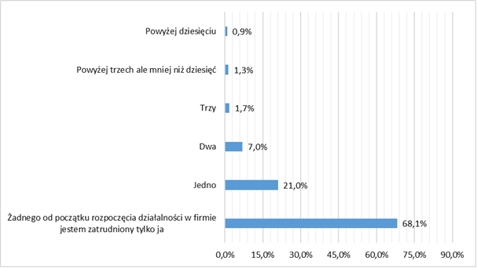

more than ten
more than three but fewer than ten
three
two
one
none – ever since I set up my business I have been its sole employee

Source: own study based on data from CATIs, n=229
Employees of the established companies work under all types of contracts, most often for a fixed period (49.2%) and for an indefinite period (25.4%), most of them full-time (80.9%). This means that people setting up companies and hiring employees tend to enhance the unfavourable tendencies on the labour market related to low job security, preferring fixed-term contracts and civil law contracts as a form of employment (25.4%).
Chart 47. Types of contracts under which employees are hired  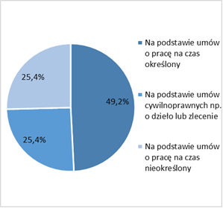  Under contracts for a fixed term  Under civil law contracts, e.g. contracts for a specific task or mandate contracts  Under contracts for an indefinite term  Source: own study based on data from CATIs, n=63 | Chart 48. Working time  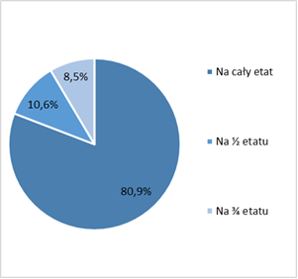  Full time  Half time  Three-fourths of the FTE  Source: own study based on data from CATIs, n=47
Their remuneration is most often equal to the national average (33.3%) or is slightly lower (27.0%).
Chart 49. Average remuneration of employees
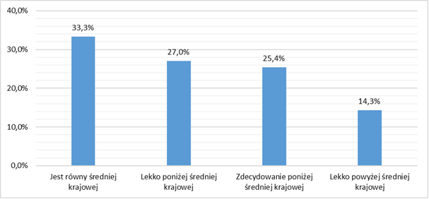
Equal to the national average Slightly below the national average Much less than the national average Slightly above the national average

Source: own study based on data from CATIs, n=63
Generally, companies have no problem with maintaining the jobs they have created (75.3%). Only 24.7% of them had to liquidate jobs, most often within a year of their creation.
Chart 50. Maintaining jobs created in companies  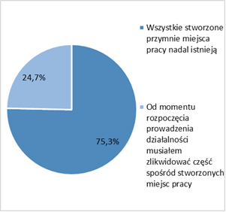  All jobs created by me still exist  Since I set up a business, I have had to liquidate part of jobs created by me  Source: own study based on data from CATIs, n=73 | Chart 51. Average time until liquidation of jobs created in companies  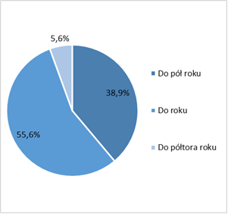  Up to half a year  Up to a year  Up to one year and a half  Source: own study based on data from CATIs, n=73
After liquidation of previously created jobs, respondents in more than half of the companies work in them alone (55.6%) or employ maximum 1 person (44.4%).
Chart 52. Number of liquidated jobs  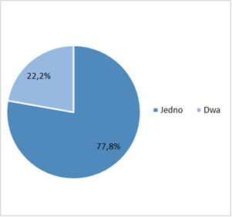  One Two  Source: own study based on data from CATIs, n=18 | Chart 53. Number of people currently employed  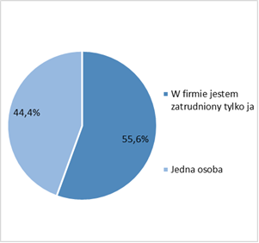  I am the only employee in the company  One person  Source: own study based on data from CATIs, n=18

Assessment of the usefulness of support forms
In this subchapter, an assessment of the degree of the usefulness of the forms of support provided under Measures 7.1, 7.2 and 7.3 was made. When analysing the issue in question, particular focus was on the following aspects:
- What reasons/factors made the participants join particular forms of support?
- How do the beneficiaries assess the usefulness of particular forms of support?
- What problems did the people who participated in the support offered encounter?

Usefulness of support instruments in terms of economic activation
Internships and traineeships
The usefulness of the support obtained under Measure 7.1 through internships/traineeships was assessed as high. The assessment of the knowledge/skills acquired through participation in these forms of support was positive, mainly in terms of: expanding knowledge and acquiring new skills (64.0%) and deepening knowledge (17.6%). A small group (7.6%) claimed that “everything I learned was new to me”.
The usefulness of the acquired knowledge/skills on the labour market was assessed positively as well: over one-third of the respondents assessed it as very high or high (37.2%), while 31.2% of the respondents assessed it as moderate. Only a small group of support beneficiaries (12.8%) expressed a negative opinion saying that they had not learned anything new, while 13.2% described the knowledge/skills acquired during internships as completely useless. Overall, the percentage of people dissatisfied with the support received was not high (26.0%).
Chart 54. Assessment of the knowledge/skills acquired through internships/traineeships  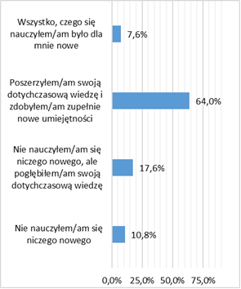  Everything I learned was new to me  I expanded my knowledge and acquired completely new skills  I did not learn anything new, but I expanded my knowledge  I did not learn anything new  Source: own study based on data from CATIs, n=250 | Chart 55. Assessment of the degree of the usefulness of skills/qualifications acquired through internships/traineeships  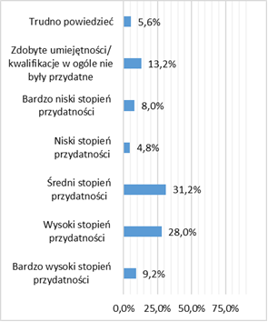  Hard to say  The skills/qualifications I have acquired are not useful at all  Very low usefulness  Low usefulness  Moderate usefulness  High usefulness  Very high usefulness  Source: own study based on data from CATIs, n=250
Almost all respondents (95.2%) did not mention any difficulties or problems while participating in internships/traineeships. A small group that mentioned them indicated the following problems limiting the usefulness of this form of support: the incompetence of the people running them (2.0%) and the uncomfortable conditions in which they were conducted (1.6%), as well as an inconvenient timeframe of the internship (0.8 %), and, occasionally, inconsistence of the duties performed during the internship/traineeship with the knowledge they had (0.8%). Definitely less often (in few cases), the respondents mentioned such usefulness limitations as: lack of the necessary equipment (0.4%), no buddy (0.4%), no study plan, ignorance about the tasks performed (0.4%), and too much theoretical information and too little practical knowledge (0.4%).
Chart 56. Difficulties and problems that occurred during participation in the internship/traineeship
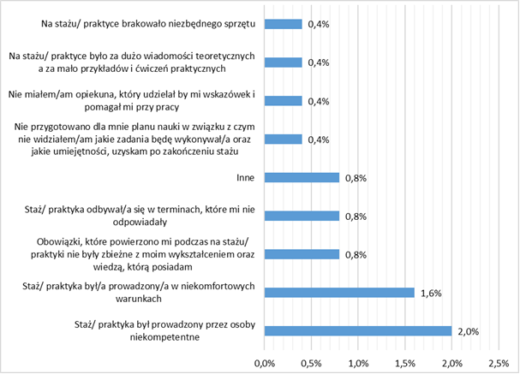
Lack of the necessary equipment

Too much theoretical information and too few examples and practical exercises

No buddy to guide and help with work

I did not have any study plan prepared, thus I did not know what tasks I would perform and what skills I would gain upon completion of the internship

Other

Inconvenient timeframe of the internship/traineeship

The duties I was entrusted with during the internship/traineeship did not correspond to my education and knowledge

Uncomfortable conditions during the internship/traineeship

The internship/traineeship was run by incompetent people

Source: own study based on data from CATIs, n=250
Slightly different difficulties and problems related to this form of support were identified by the participants of qualitative surveys. As shown by the statement below, internships are often used by employers only to take advantage of „free labour” related to the repeated admission of interns without the intention of employing them under a contract after the end of the internship period:
“(...) employers cheat us a bit, as for half a year they have a man whom they have chosen by themselves and are satisfied with him or her all the time, because for 6 months there have been no signals that something is wrong with this person. But when it comes to the point that they have to settle this internship and hire that person, this person is no longer good. And we have such cases”[P4]. “The employer prefers to hire an employee working for free than to hire a given person, so they assume in advance that they will not create a job anyway, but such a person will be useful for them for 6 months, being able to do such basic, simple things. And then they try to prove that this man is not fit for this job anymore” [P5].
Another problem is the conscious absenteeism of interns justified by a sick leave, which, in the opinion of the respondents, is – at least to some extent – related to the interns’ awareness that they will be paid their grants during the sickness period anyway.
Training courses
The assumptions of the Operational Programme for the Opole Province for 2014-2020 regarding interventions in the area of the regional labour market concerned, among others, support in the creation of high-quality jobs, both through affecting employers and improving skills and qualifications of job seekers. This was to be achieved, primarily, through vocational training courses as part of which unemployed people could gain new/other qualifications or supplement the existing ones, or acquire new or additional professional competences, as well as acquire or improve their skills of communicating in foreign languages and software skills.
The analysis of the research findings showed that the usefulness of this type of support was assessed as high. In all types of training courses (except for training in communicating in foreign languages), the following assessment prevailed – everything I learned was new to me. In the case of training for the acquisition of new/other professional qualifications, such assessment was expressed by the majority of the respondents (71.7%), a similar opinion, also in the vast majority, was expressed by the participants of training in soft skills (69.2%) and over half of the participants of training in job seeking skills (59.3%), as well as supplementary training for professional qualifications, including acquisition of new competences (51.5%). On the other hand, the participants of the training in software skills use pointed out both new skills (47.4%) and broadening the existing knowledge (44.7%). The latter assessment definitely prevailed among the participants of training courses developing the skills of communicating in foreign languages (78.9%). Dissatisfaction with the low usefulness of the support received was expressed only by a small group of the participants (from 1.5% to 5.3%).
Chart 57. Assessment of knowledge/skills acquired through participation in training courses
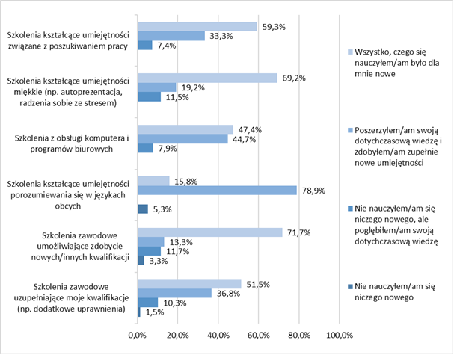
Training in job seeking skills | Everything I learned was new to me
Training in soft skills (e.g. self-presentation, stress management)

Training in software skills | I expanded my knowledge and acquired completely new skills
Training in communication in foreign languages | I did not learn anything new but I expanded my knowledge
Training for the acquisition of new/other professional qualifications
Supplementary training for professional qualifications, including acquisition of new competences | I did not learn anything new

Source: own study based on data from CATIs, n=104
In more than half of the cases the skills and qualifications acquired during the training courses were rates as very useful or useful on the labour market (53.8%). Their moderate usefulness was indicated much less frequently (36.5%), and the least often low or very low usefulness (8.6%) was indicated. Approximately 1.0% of the participants indicated a complete lack of their usefulness.
Chart 58. Assessment of the degree of the usefulness on the labour market of skills/qualifications acquired through training courses
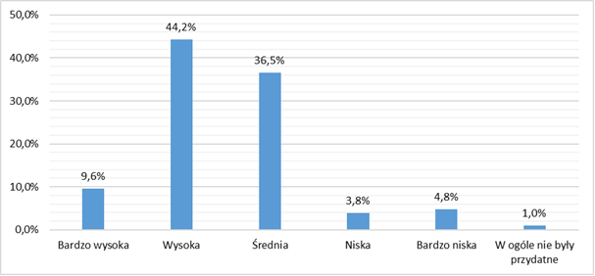
Very high High Moderate Low Very law Not useful at all

Source: own study based on data from CATIs, n=104
Most of the respondents (65.4%) did not indicate any difficulties while participating in the training courses. The major barriers and difficulties indicated by the remaining group of the support beneficiaries concerned the duration of the training courses (20.2%) and the prevalence of theoretical classes over practical ones (17.3%). A smaller group (11.5%) considered their thematic scope too narrow. Approximately 5.0% of the participants pointed to organisational issues related to the choice of the timeframe, while 3.8% of them considered the individuals running the training courses incompetent. In few cases (1.0%), attention was drawn to the lack of equipment and the wrong choice of topics.
Chart 59. The greatest barriers/difficulties encountered during the training courses
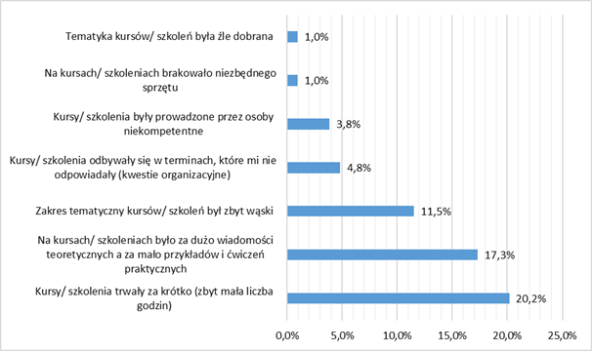
Inadequate thematic scope

Lack of necessary equipment

Incompetent trainers

Inconvenient timeframe (organisational issues)

Too narrow thematic scope

Too much theoretical information and too few examples and practical exercises

Too short duration (too few classes)

Source: own study based on data from CATIs, n=104

Usefulness of support instruments in terms of self-employment
The support offered under Measures 7.1 and 7.3 can be assessed as useful, as the amount of funds received by the applicants for setting up a business was, in their opinion, sufficient to start a business (74.7%); the opposite opinion was expressed by a definite minority of the respondents (25.3%). The support was fully sufficient for one-third of its beneficiaries (32.0%), because they were able to buy all products and services and covered all the fees necessary to start a business, while 42.7% of them claimed that this amount could be higher, because it enabled to buy only most of the products and services and covered only most of the fees necessary to start a business.
Chart 60. Assessment of the amount of co-financing received for setting up a business
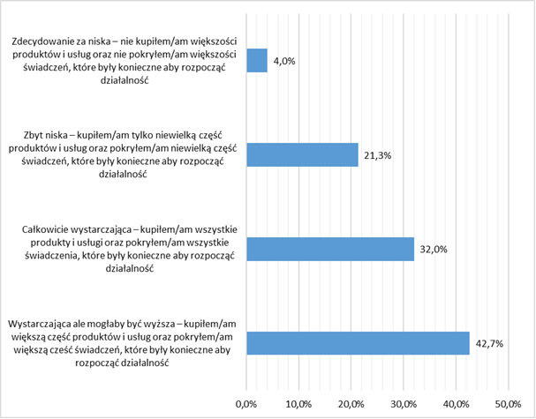

Definitely too small – I did not purchase most of the products and services nor did I pay most of the fees necessary to set up a business

Too small – I purchased only small part of the products and services and paid a small part of the fees necessary to set up a business
Fully sufficient - I purchased all the products and services and paid all the fees necessary to set up a business

Sufficient but could have been higher - I purchased most of the products and services and paid most of the fees necessary to set up a business

Source: own study based on data from CATIs, n=347
Over half of the respondents (62.8%) assessed that the financial support received was adequate to their needs, as they could spend it on purchasing products and services and covering fees related to starting a business, but only over one-third (34.6%) of the support beneficiaries could satisfy all their needs, others (28.2%) were unable to fully satisfy them. On the other hand, a similar group, over one-third (37.2%), of the support beneficiaries were unable to meet their needs, because the funds received were sufficient to purchase only some products and services and to cover only some fees (31.1%), while 6.1% of the support beneficiaries were unable to purchase most of products and services and cover most of fees with the funds received.
Chart 61. Assessment of the adequacy of funds received for financing products and covering fees to the needs of support beneficiaries
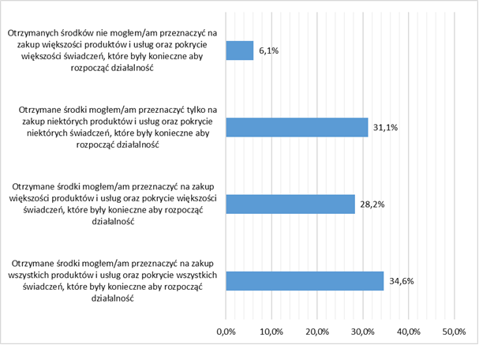

The funds received were insufficient to purchase most of the products and services and pay most of the fees necessary to set up a business

The funds received were sufficient to purchase only some of the products and services and pay some of the fees necessary to set up a business

The funds received were sufficient to purchase most of the products and services and pay most of the fees necessary to set up a business

The funds received were sufficient to purchase all the products and services and pay all the fees necessary to set up a business

Source: own study based on data from CATIs, n=347
The findings are confirmed by qualitative research. According to experts, there are many people in a difficult situation among those interested in financial support, in particular micro-loans (approx. 80.0%). These people highly appreciate their usefulness. Such an assessment results, among others, from a low interest rate on micro-loans (only 0.1%), that is also fixed. There is also a grace period in the repayment period, during which one can pay only small interest for the first 6 or 12 months. Micro-loans are perceived by the support beneficiaries as an opportunity to obtain very cheap financing. What they find as a problem, however, is the inability to increase the amount of support after signing the contract, or to obtain another, additional micro-loan during the term of the contract:
I have repeatedly heard from our clients who had already operated for six months or a year, that it is a pity that they cannot increase the amount of the loan taken or take another one, as this would help them to develop, that they would like to take advantage of some more help [F15].
Support in the form of grants or loans for setting up a business obtained under Measures 7.1 and 7.3 was enhanced by non-returnable financial aid paid monthly for a period of 6-12 months and intended for covering fees related to setting up and running a business. When analysing the usefulness of this form of support, it should be noted that only a small percentage (3.7%) of the respondents took advantage of it and, according to most of them (61.5%), it was not sufficient to cover the fees associated with setting up and running a business.
Chart 62. Assessment of the amount of non-returnable financial aid received
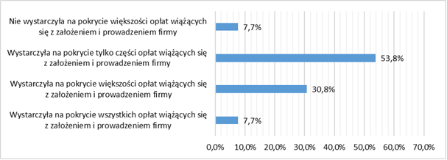
Insufficient to pay most of the fees related to setting up a business

Sufficient to pay only part of the fees related to setting up a business

Sufficient to pay most of the fees related to setting up a business

Sufficient to pay all the fees related to setting up a business

Source: own study based on data from CATIs, n=13
As pointed out by experts, the usefulness of forms of support in terms of self-employment is enhanced primarily by counselling and training aimed at transferring the knowledge and skills necessary to start and run a business (e.g. by obtaining legal assistance or consultations and advice on the effective use of the funds received) and strengthening competences of people applying for subsidies/loans for setting up a business:
(...) we put a strong emphasis on making them very competent in running a business and there is a bit of such advisory work, because not every person can run a business, because not everyone has such predispositions. So what is important in such projects is to recruit such people (...); people who observe various evaluations do not re-enter the register of the unemployed to a large extent. This means that they get activated, even when they stop their business activity, at some time, after 2 or 3 years, because something has not worked out, they do return on the unemployed people market. The effect has been achieved [U10].
According to quantitative research, 31.7% of the respondents participated in this type of classes and almost all of them assessed them positively (90.0%), indicated mainly such benefits as: deepening knowledge (39.1%), expanding knowledge and gaining new skills (38.2%), and through an unambiguous assessment expressed in the phrase – “everything I learned was new to me” (12.7%).
Chart 63. Assessment of the usefulness of the classes in terms of the needs of people setting up a business
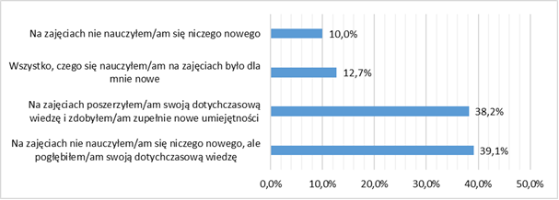
I did not learn anything new during the classes

All I learned during the classes was new to me

I expanded my knowledge and acquired completely new skills during the classes

I did not learn anything new during the classes, but I expanded my knowledge

Source: own study based on data from CATIs, n=110
Almost all respondents (83.6%) did not mention any difficulties while participating in the classes. Those who mentioned them (16.4%) indicated that the usefulness of this form of support was limited by: too much theoretical and too little practical knowledge (88.9%), too narrow thematic scope of the training (55.6%), too short duration and too few hours (44.4%), poorly chosen training topics (38.9%), and organisational issues (5.6%).
Chart 64. Barriers/difficulties encountered during the classes
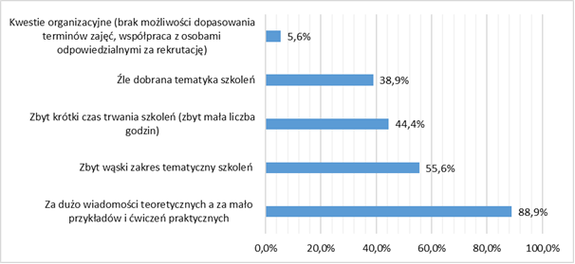
Organisational issues (lack of flexibility in the dates of the classes, cooperation with people responsible for recruitment)

Poorly chosen topics

Too short duration (too few hours)

Too narrow thematic scope

Too much theoretical information and too few examples and practical exercises

Source: own study based on data from CATIs, n=42
The quantitative and qualitative analysis of the research findings allows for drawing the following conclusions:
The diagnosed obstacle in increasing the absorption of funds in the form of both returnable and non-returnable support instruments is the observed insufficient flexibility in terms of their allocation. Intervention in terms of support in the form of returnable financial instruments under the Operational Programme for the Opole Province for 2014-2020 was limited due to two criteria: the age barrier (over 30) and the unemployed person status.
Research shows a growing interest in returnable financial support in the form of micro-loans. This relatively new instrument operating on the Opole labour market (for 2 years) would definitely increase the absorption capacity if it were directed to people younger than the ones provided for in the Operational Programme for the Opole Province for 2014-2020 under Measure 7.3. The age limit constrained the potential effectiveness of this support, given not only great interest in it but also “economic readiness” among people under 30 years of age.
In the case of support in the form of non-returnable financial instruments, their effectiveness is limited by the lack of the ability to differentiate co-financing rates in the applicable methodology, which often prevents the launch of promising business plans. Greater flexibility in granting financial support will also be beneficial in the situation of the forecast economic crisis caused by COVID-19, especially for unemployed people with experience in running a business.

Assessment of the durability of support effects
In this subchapter, an assessment of the degree of the durability of the effects of support provided under Measures 7.1, 7.2 and 7.3 was made. When analysing the issue in question, particular focus was on the following aspects:
- Have the support beneficiaries maintained the employment (self-employment) gained as a result of participation in the support?
- For what reasons do the people who have received support do not work or do not run a business?
- Do the people who have participated in the support plan to invest in their further professional development or the development of the companies they have established?

Durability of the effects of support in terms of economic activation
Internships and traineeships
Despite the fact that, as experts point out, there are some problems with some employers when it comes to employment of a given person after a 3-month internship [P4), the findings of quantitative research show that having obtained support in the form of an internship/traineeship, the vast majority of respondents (70.8%) are economically active. Most of them work in a different company than the one where they completed their internship/traineeship (49.6%), definitely fewer in the same company where they completed their traineeship/traineeship despite the fact that the period of obligatory employment has already elapsed (18.0%), and only a small percentage (2.0%) of them work in the company where they completed their internship/traineeship, because the period of obligatory employment has not expired yet. A small percentage of the respondents (1.2%) run their own business.
Chart 65. Current labour market situation of the people who have participated in internships and traineeships
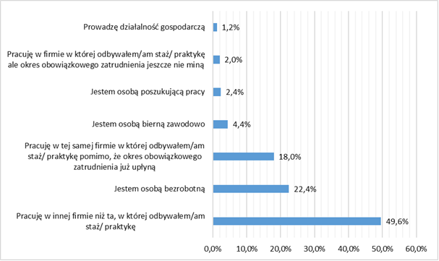

I run a business

I work in the company where I have completed an internship/traineeship, but the mandatory period of employment has not ended yet

I am a job seeker

I am an economically inactive person

I work in the company where I have completed an internship/traineeship, despite the fact that the mandatory period of employment has already ended

I am an unemployed person

I work in a company other than the one where I have completed an internship/traineeship

Source: own study based on data from CATIs, n=250
A small number of the respondents (29.2%) are unemployed. Those who do not have a job, despite participating in the support, justify it with, first of all: personal situation (31.5%), lack of job offers in the area (27.4%), ill health(20.5%) , lack of jobs in their profession (16.4%), the age barrier (15.1%), lack of attractive job offers on the labour market (12.3%). Other reasons mentioned much less frequently include: lack of professional experience (2.7%) and inability to successfully look for a job (2.7%), lack of relevant qualifications (1.4%), and fear of losing social benefits (1.4%).
Chart 66. Reasons for unemployment among the people who have participated in internships/traineeships
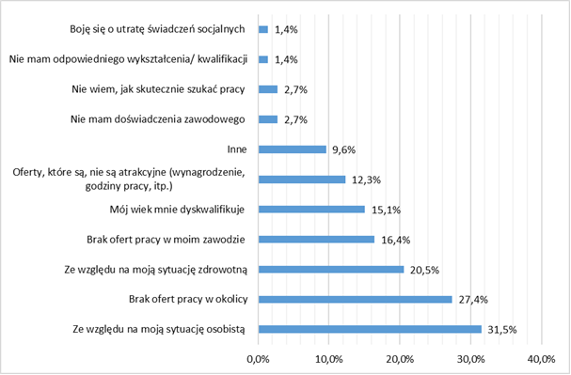
I am concerned about losing my social benefits

I do not have the adequate education/qualifications

I do not know how to look for a job effectively

I have no professional experience

Other

Available offers are unattractive (salary, working hours, etc.)

My age disqualifies me

No offers in my profession

Due to ill health

No offers in the vicinity

Due to my personal situation

Source: own study based on data from CATIs, n=73
At the time of the launch of the Operational Programme for the Opole Province for 2014-2020, statistical data on the situation on the regional labour market indicated disturbing processes and phenomena, such as mass employment of people under civil law and fixed-term contracts, too often combined with the provision of the national minimum wage. As the observed regularities not only do not build work security, but are also a factor encouraging internal and foreign migrations, the durability of the effects of the support received as part of internships and traineeships can also be assessed by analysing its impact on improving the level of work security in terms of the employment form.
The research findings show that after completing internships and traineeships, the vast majority of the respondents are employed under employment contracts (89.8%), most of which (61.6%) are contracts for an indefinite period and a minority for a fixed period (28.2 %). Only a small percentage of the support beneficiaries work under civil law contracts (6.2%) or are self-employed (3.4%). Considering the above, it can be concluded that the current form of employment of support beneficiaries has been undoubtedly affected by their participation in internships and traineeships, and thus the durability of their effects can be assessed as high and contributing to the improvement in the level of work security.
Chart 67. Current form of employment of the participants of internships and traineeships
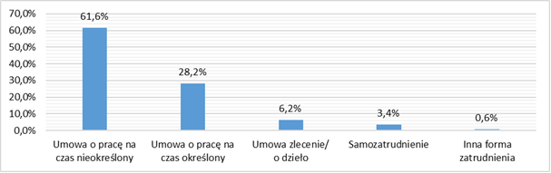
Employment contract for an indefinite term
Employment contract for a definite term
Mandate contract/contract for a specific task
Self-employment
Other form of employment
Source: own study based on data from CATIs, n=177
The durability of the support effects is also evidenced by the assessment of a large group of respondents (40.1%), stating that without participation in internships and traineeships, they would not have had a chance to get their current job. At this point, however, it is worth noting that a similar group (34.5%) does not notice a clear relationship between participation in the support and their current situation on the labour market.
Chart 68. Assessment of the impact of participation in an internship/traineeship on getting the current job
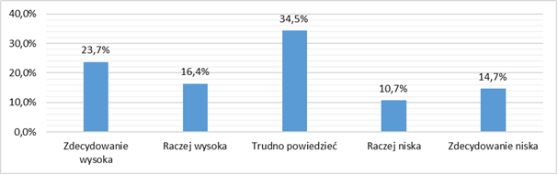
Definitely high Rather high Hard to say Rather low Definitely low
Source: own study based on data from CATIs, n=177
The durability of the effects of support is also evidenced by the assessment of the impact of participation in an internship or traineeship on further professional development. Although the assessments in this respect were varied and one-third of the respondents (34.5%) were not able to clearly assess this impact, it was rated high and very highly by 29.4% of the respondents, and moderate by 21.5%. Therefore, in general, over half of the support beneficiaries noticed the positive impact of participation in an internship/traineeship and its usefulness in terms of further professional development.
Chart 69. Assessment of the impact of participation in an internship/internship on further professional development
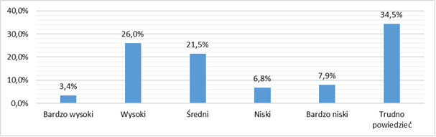
Very high High Moderate Low Very low Hard to say
Source: own study based on data from CATIs, n=177
Permanent effects of the support also include a change in the attitudes of its beneficiaries, manifested in their continued improvement of professional qualifications. The situation in the Opole region is not very good in this respect, because the rates of participation in lifelong learning are low and lower than the average for Poland. The current state of affairs is confirmed by the research findings, showing that since the end of the internship or traineeship, most of the respondents (68.4%) have not participated in other forms of improving professional qualifications, justifying it most often with the lack of a relevant thematic offer (31, 0%) or having sufficient skills (22.2%). The remaining smaller group of the respondents believed that further improvement in their qualifications would not help them change their current position on the labour market (19.9%), or indicated their personal situation (14.0%) as one of the reasons preventing their further education.
Chart 70. Reasons for not participating in other forms of improving professional qualifications, e.g. training courses
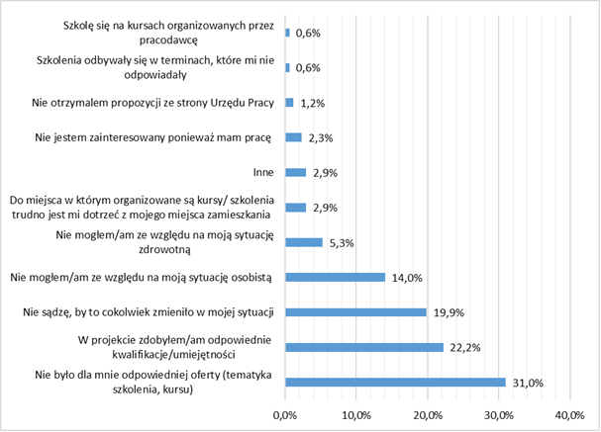
I participate in training courses organised by the employer

The timeframe of the training courses was not convenient for me

I have not received an offer from the labour office

I am not interested, because I have a job

Other

It is difficult for me to get to the venue on the training courses from my place of residence

I was unable due to ill health

I was unable due to my personal situation

I do not think this could change anything in my situation

I acquired relevant qualifications/skills by participating in the project

There was no adequate offer for me (thematic scope of the training course)

Source: own study based on data from CATIs, n=171
Training courses
Just like in the case of internships and traineeships, the durability of the effects of training courses should also be assessed positively. As indicated by the research findings, after completion of participation in this form of support, more than two-thirds of the respondents are economically active (69.2%), and only about one-third remain unemployed (30.8%). Therefore, it should be concluded that participation in the training courses offered contributes to a change in the economic activity of the support beneficiaries and positively influences their situation on the labour market.
Chart 71. Current labour market situation of the people who have participated in training courses
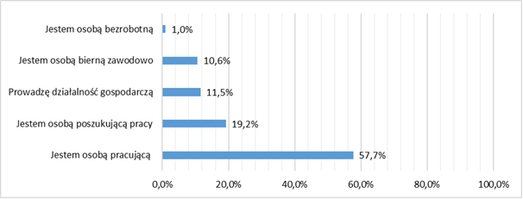
I am unemployed
I am economically inactive
I run a business
I am a job seeker
I have a job

Source: own study based on data from CATIs, n=104
The group of economically inactive participants of training courses indicate their personal (34.4%) and health (15.6%) situation as the key determinant of unemployment, followed by the lack of attractive offers on the labour market, understood primarily as unattractive salaries and inconvenient working hours (28.1%). Other, much less frequently mentioned reasons include the lack of offers in the area where the respondents live (9.4%), the lack of jobs in their profession (3.1%), and the lack of relevant education and qualifications (3.1%). Only a small part of the respondents do not work because they receive a disability or age pension (6.2%).
Chart 72. Reasons for unemployment among the people who have participated in training courses
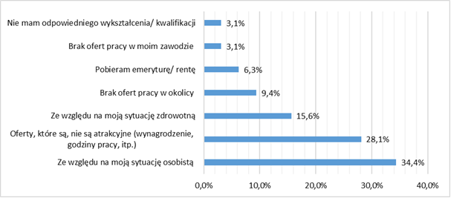
I do not have relevant education/qualifications
No job offers in my profession
I receive a retirement/disability pension
No job offers in the vicinity
Due to ill health
Available job offers are unattractive (salary, working hours, etc.)
Due to my personal situation
Source: own study based on data from CATIs, n=32

As in the case of internships and traineeships, the durability of the effects of support in the form of training courses can be assessed by analysing their impact on the improvement in work security. The research findings show that the vast majority of the participants of training courses (73.6%) are employed under an employment contract, including a significant part of them (40.3%) under contracts for an indefinite time, and only one-third (33.3%) under contracts for a definite time. Self-employment was indicated by 16.7%, and employment based on a civil law contract by 9.7% of the respondents. Considering the above, it can be concluded that the current form of employment of the support beneficiaries has been undoubtedly affected by their participation in training courses, and thus the durability of their effects can be assessed as relatively high and contributing to the improvement in the level of work security, thought to a slightly lesser extent than in the case of internships and traineeships.
Chart 73. Current form of employment of the participants of training courses
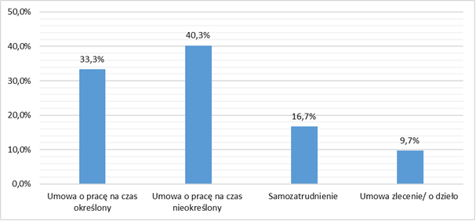
Employment contract for a fixed term
Employment contract for an indefinite term
Self-employment
Mandate contract/contract for a specific task
Source: own study based on data from CATIs, n=72
The durability of the effects of the support is also evidenced by the assessments of nearly one-third of the respondents, who believe that without participation in training courses, they would not have had a chance to get their current job (29.2%). It is worth noting, however, that a much larger group of the respondents (48.6%) than in the case of internships and traineeships, claim that regardless of the support received they would get their current job. On the other hand, 22.2% of the respondents do not unequivocally link the impact of the support received with their current professional situation.
Chart 74. Assessment of the impact of participation in a training course on getting the current job
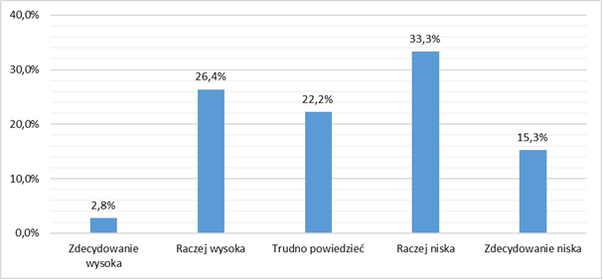
Definitely high Rather high Hard to say Rather low Definitely low
Source: own study based on data from CATIs, n=72
The positive and lasting impact of the support provided is also evidenced by the highly positive assessment of the impact of participation in training courses on further professional development. Most of the respondents (63.9%) rated this impact high or very high.
Chart 75. Assessment of the impact of participation in training courses on further professional development
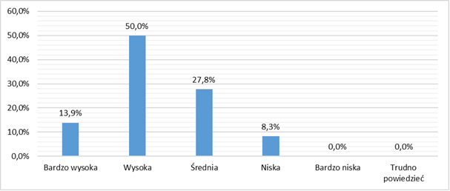
Very high High Moderate Low Very low Hard to say
Source: own study based on data from CATIs, n=72
As in the case of internships and traineeships, more than half of the respondents (60.6%) have not engaged in the further improvement in their professional qualifications since the completion of training courses. Most of them have not participated in other forms of the improvement in their professional qualifications as they believe that they have already acquired the relevant skills (63.5%). A smaller group of the respondents (17.5%) believe that further improvement in their qualifications will not change their current position on the labour market. The remaining percentage of the respondents indicated their personal (15.9%) or health (11.1%) situation as one of the reasons preventing their further education, and some of them (11.1%) did not find a relevant thematic offer.
Chart 76. Reasons for not participating in other forms of improving professional qualifications, e.g. internships or traineeships
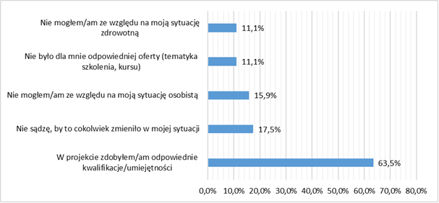
I was unable due to ill health

There was no adequate offer for me (thematic scope of the training course)

I was unable due to my personal situation

I do not think this could change anything in my situation

I acquired relevant qualifications/skills by participating in the project

Source: own study based on data from CATIs, n=63
Equipping or further equipping of workstations
The durability of jobs created as a result of reimbursement of the costs of equipping or further equipping workplaces should be described as moderate. While it is true that the vast majority of the people who have benefited from this form of support are still economically active (83.3%), only one-third of them work in the company where a workstation has been created for them. Other beneficiaries either work in another company (44.4%) or have decided to set up a business and are self-employed (5.6%).
Chart 77. Current labour market situation of the people who have benefited from support for equipping or further equipping workstations
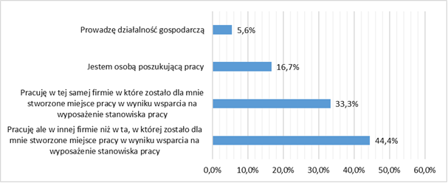

I run a business

I am a job seeker

I work in the company where a workstation was created for me with support for equipping a workstation

I work, but not in the company where a workstation was created for me with support for equipping a workstation

Source: own study based on data from CATIs, n=18
The respondents who currently do not work indicate mainly the following reasons: low salary, uncomfortable working conditions, and difficult relations with the company’s management. Since a good workplace is a value created by both the employee and the employer, such reasons may, on the one hand, prove the poor quality of some jobs created as a result of co-financing the workplace, and, on the other hand, the demanding attitude of some support beneficiaries.
Chart 78. Reasons for unemployment among the people who have benefited from support for equipping or further equipping workstations
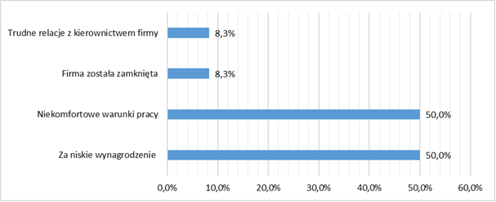
Difficult relations with the company’s management
The company has been closed
Uncomfortable working conditions
Too low salary
Source: own study based on data from CATIs, n=14
Considering the durability of the effects of the discussed form of support in terms of improving work security, it should be stated that it contributes to it to the least extent compared to the other analysed forms. Firstly, despite the fact that most beneficiaries of this form of support are employed under employment contracts (60%), including one-third of them working under contracts for an indefinite time, it is still a lower percentage than in the case of internships and traineeships or training courses. Secondly, although the purpose of this form of support was to create dedicated jobs in companies, a large part of the support beneficiaries have changed their workplace.
Chart 79. Current form of employment of the people who have benefited from support for equipping or further equipping workstations
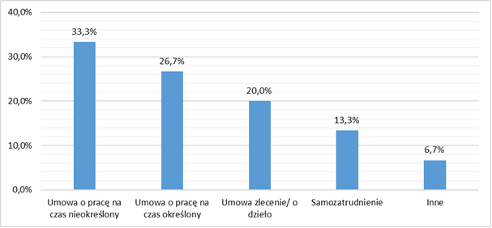
Employment contract for an indefinite term
Employment contract for a fixed term
Mandate contract/contract for a specific task
Self-employment
Other

Source: own study based on data from CATIs, n=15
As in the case of internships and traineeships, as well as training courses, most of the respondents believed that participation in this form of support was helpful and contributed to the improvement in their situation on the labour market. However, one-third of the respondents did not unequivocally link the impact of the support received with their current professional situation.
Chart 80. Assessment of the impact of support in equipping or further equipping the workstation on getting the current job
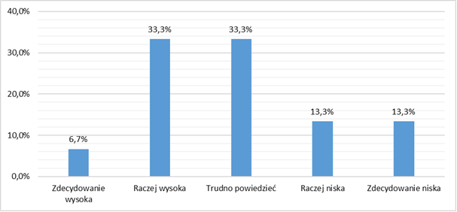
Definitely high Rather high Hard to say Rather low Definitely low

Source: own study based on data from CATIs, n=15
The positive and lasting impact of the support provided is also evidenced by the highly positive assessment of its impact on further professional development. Its usefulness was mentioned by the vast majority of the respondents, and 60% of them rated this impact as high or very high.
Chart 81. Assessment of the impact of participation in support for equipping or further equipping the workstation on further professional development
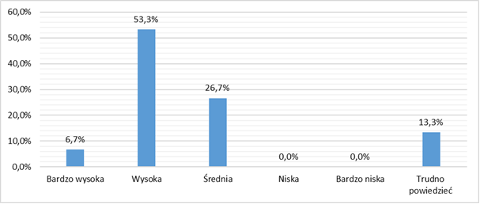
Very high High Moderate Low Very low Hard to say

Source: own study based on data from CATIs, n=15
The permanent effects of this form of support include also a higher percentage of respondents who continued to improve their professional qualifications than in the case of internships and traineeships as well as training courses (66.7%). Those who did not decide to continue their education justify it mainly by the lack of an adequate thematic offer (83%), while one-third of them believe that further improvement in qualifications will not change their current position on the labour market.
Chart 82. Reasons for not participating in other forms of improving professional qualifications, e.g. internships and traineeships or training courses
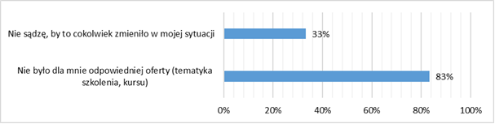
I do not think this could change anything in my situation

There was no adequate offer for me (thematic scope of the training course)

Source: own study based on data from CATIs, n=7

Durability of the effects of support in terms of in self-employment
In the face of the consequences of the COVID-19 pandemic, the future of the established companies can be predicted to a limited extent, as in recent days, many companies have suspended their operation and others have limited it significantly. There are, however, industries that are increasing employment. Detailed information in this respect, although to a very limited extent, due to the lack of “hard statistical data”, is presented in Chapter 4. The presented analyses should be read and interpreted in its context of this information.
The durability of the impact of the support provided is evidenced by the condition of the established companies after the mandatory period of running a business, including, in particular, their development plans for the future. As shown by the research findings, the situation of the vast majority of companies (86.4%) is assessed as good (63.3%) or very good (23.1%). Only 3.9% of the respondents (9 people) are afraid of having to close or suspend their business in the next 12 months
Chart 83. Assessment of the current situation of the company
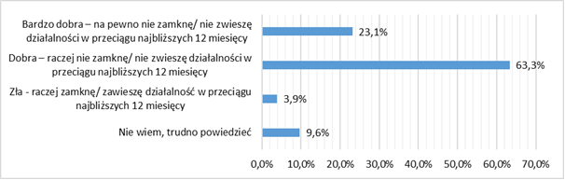
Very good – I will definitely not close/suspend my business within the next 12 months

Good – I will rather not close/suspend my business within the next 12 months

Poor – I will rather close/suspend my business within the next 12 months

I do not know, hard to say
Source: own study based on data from CATIs, n=229
Half of the respondents declare that they intend to develop the companies they have established. In this group, 61.8% of the respondents intend to invest in the purchase of equipment, machines or software, 21.8% of them plan to expand the territorial range of the company’s operations, and 20.9% of them plan to increase the number of goods produced or services rendered.
To finance development plans, most of the respondents (77.3%) plan to use external funds (loans or subsidies) and obtain them from public entities, e.g. from district labour offices (80.0%) or the Opole Centre for Economic Development (OCRG). The others (20.0%) intend to borrow funds from a bank or shadow banking entity (11.8%) or from family or friends (8.2%).
Chart 84. Plans related to the company’s development in the next 12 months  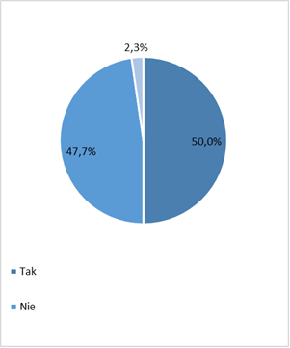  Yes  No  Source: own study based on data from CATIs, n=220 | Chart 85. Activities related to the company’s development plans within the next 12 months.  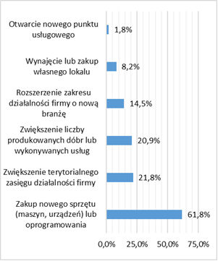  Opening a new service outlet  Rental or purchase of one’s own premises  Expanding the scope of operations with a new industry  Increasing the number of goods produced or services provided  Expansion of the territorial range of the company’s operations  Purchase of new equipment (machines, devices) or software  Source: own study based on data from CATIs, n=142

Chart 86. Plans related to the use of external funds, e.g. loans/subsidies, to finance the company’s development  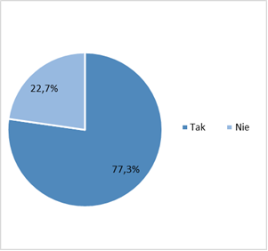  Yes No  Source: own study based on data from CATIs, n=110 | Chart 87. Sources of obtaining the largest part of funds for the company’s development  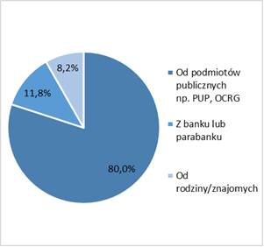  From public entities, e.g. district labour offices, Opole Centre for Economic Development (OCRG)  From a bank or shadow banking entity  From family/friends  Source: own study based on data from CATIs, n=85
Most of the entrepreneurs running their businesses do not intend to hire new employees (65.9%), while the others (34.1%) plan to employ new people: almost three-quarters (72.0%) of them intend to employ one person, almost a quarter (24.0%) intend to employ two people, and three or four people in few cases.
Chart 88. Plans regarding the employment of new people within the next 12 months  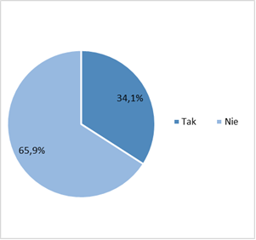  Yes No  Source: own study based on data from CATIs, n=220 | Chart 89. Number of new people planned to be employed  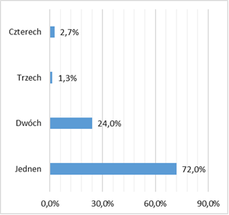  Four  Three  Two  One  Source: own study based on data from CATIs, n=75
In order to implement plans related to the employment of new people, most business owners (64.0%) plan to take advantage of support offered by public institutions, e.g. district labour offices.
Chart 90. Plans regarding the use of support offered by public institutions (e.g. district labour offices) to employ new people
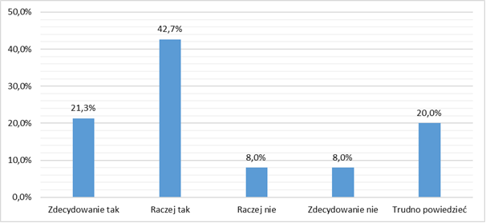
Definitely yes Rather yes Rather not Definitely not Hard to say
Source: own study based on data from CATIs, n=75
The vast majority of respondents (70.3%) do not intend to invest in their further professional development. On the other hand, more than half (53.5%) of them intend to raise the competences of their employees by investing in their further education and obtaining new professional competences by them.
Chart 91. Plans for increasing the competences of support beneficiaries through training, acquiring new professional competences  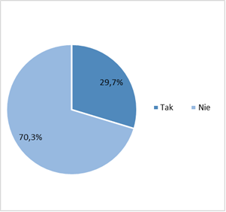  Yes No  Source: own study based on data from CATIs, n=229 | Chart 92. Plans for increasing the competences of one’s employees through further education and obtaining new professional competences by them  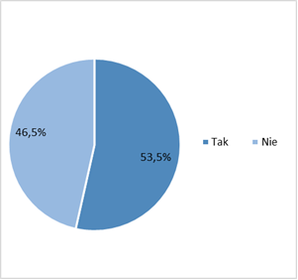  Yes No

Source: own study based on data from CATIs, n=114

TOTAL IMPACT OF SUPPORT EFFECTS
Principal component analysis (PCA) is mainly used to reduce the number of variables describing phenomena (their reduction), but also to find regularities (relationships) between the variables. Components are a linear combination of the variables considered. PCA analysis makes it possible to identify those initial (output) variables that have a large impact on the appearance (composition) of these components (forming a homogeneous group), i.e. those that are more important for explaining the problem subject to examination than the others. The principal component (with maximised variance) is then a representative of this group. Subsequent components (mutually uncorrelated) are defined in such a way as to maximise the variability that has not been explained by the previous component, so the successive components “explain” less and less.
The analysis was based on data presenting the amounts invested in projects implemented under Measures 7.1, 7.2 and, 7.3, the distribution of support beneficiaries by sex, age, education, and data showing their situation on the labour market: the registered unemployment rate, percentage of the long-term unemployed, as well as the number of newly registered entities per 10,000 residents.
As a result of the PCA analysis and based on the data characterising the effects of particular projects, three groups of districts were identified:
- group 1, the districts of Nysa, Olesno, Opole, Prudnik, and Strzelce, in which significant investment in projects under Measure 7.2 was observed, with populations with education levels 3 and 4 (moderately educated),
- group 2, the Opole district, where, relative to the rest of the province, proportionally more investment was made in projects under Measures 7.3 and 7.1, with a population with education levels from 5 to 8 (highly educated),
- group 3, the districts of Brzeg, Głubczyce, Kędzierzyn-Koźle, Kluczbork, Krapkowice, and Namysłów, where targeting the instruments at people with education levels from 0 to 2 (poorly educated) was the most important.
These groups also have different characteristics in terms of the labour market indicators. In group 1, a decrease in the unemployment rate was observed with a relatively small increase in the entrepreneurship rate, in group 2, i.e. in Opole, a relatively high rate of entrepreneurship was recorded, but the impact of this measure on the general characteristics of the labour market decreased, while in group 3, the unemployment rate, including long-term unemployment, increased.
Figure 23. Results of the grouping of PCA components, showing three types of areas of support through the assessed projects
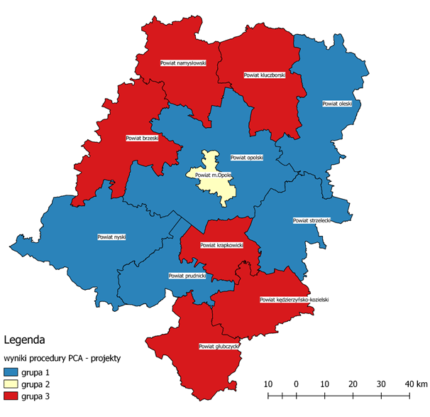
Key
results of the PCA procedure – projects
group 1
group 2
group 3
Source: own study
However, in terms of the analysis of trends that were observed on the labour market from 2015 to 2019 alone (without the effects of project implementation) and the PCA analysis used, the following groups of districts were identified:
- group 0, the districts of Nysa and Strzelce: in this group, there was a decrease in the unemployment rate, but the rate of entrepreneurship increase was not high, which affected, in particular, the long-term unemployed,
- group 1, the districts of Brzeg, Głubczyce, Kędzierzyn-Koźle, Kluczbork, Krapkowice, Namysłów, Olesno, Opole, and Prudnik, in which the level of the unemployment rate, despite the fact that this group is internally diversified, was generally still high, with the impact of the long-term unemployed staying at a similar level,
- group 2, the Opole district, where a significant reduction in the unemployment rate, also among the long-term unemployed, and an increase in the entrepreneurship ratio were observed (although the impact of the latter on the labour market in the entire province decreased year by year).
Figure 24. Results of the grouping of districts, showing the situation on the labour market in 2015-2019
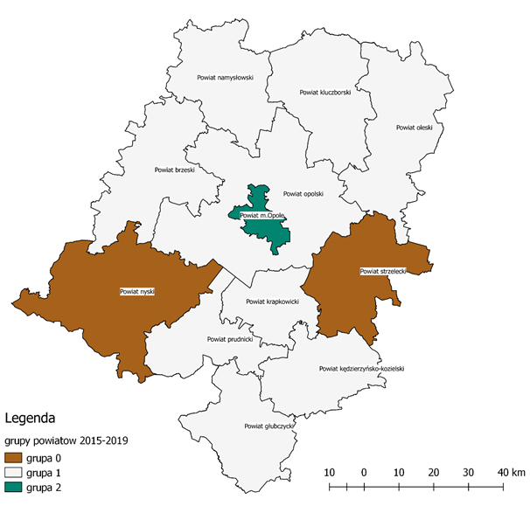
Key
groups of districts in 2015-2019
group 0
group 1
group 2
Source: own study
It can be assumed that the continuation of the existing trends on the labour market (until 2027) will lead to changes in the mutual similarity of the grouped districts and the development of:
- group 0, districts of Kędzierzyn-Koźle, Kluczbork, Krapkowice, and Strzelce, in which, assuming the continuation of the existing trends on the labour market, the unemployment rate will remain the highest in all the groups, with an increasing share of the long-term unemployed,
- group 1, the districts of Brzeg, Namysłów, Nysa, Olesno, Opole, and the city of Opole, with generally positive trends in changes on the labour market, in which the entrepreneurship rate will the most important characteristics,
- group 2, the districts of Głubczyce and Prudnik, where – if the existing trends continue – the share of the long-term unemployed will decrease, but the general unemployment rate will increase (which means greater rotation of the unemployed).

Figure 25. Results of the grouping of districts, showing the projected situation on the labour market in 2020-2027
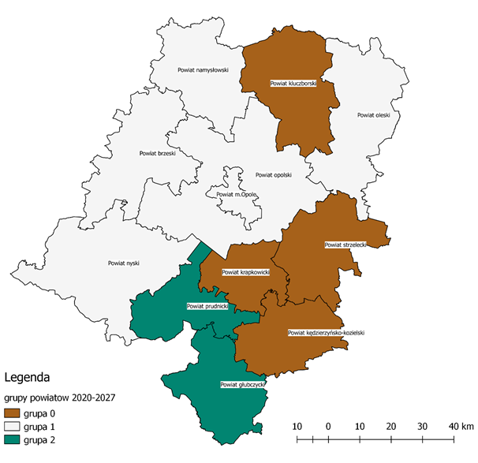
Key
groups of districts in 2020-2027
group 0
group 1
group 2

Source: own study
It should be emphasised at this point that the effects of the implementation of projects under Measures 7.1, 7.2 and 7.3 observed on the labour market in 2015-2019, are the result of the implementation of measures taken based on the situation on the market before that period and adapted to the changing situation. This is a normal situation, consistent with both the theory and practice of project implementation. The observed statistical data confirm significant changes on the labour market, and in this respect, the implemented Measures (7.1, 7.2 and 7.3) should be assessed positively. The value of the Cramér’s correlation coefficient V (which is one of the measures of dependency, determining the level of dependence between two qualitative variables or between a qualitative variable and a quantitative continuous variable) shows, however, that the assessed projects are only a selected element of the policy stimulating the creation and maintenance of new jobs.

Table 9 Values of Cramér’s V correlation coefficients for the identified groups of districts
Group | year 2019, group 0 | year 2019, group 1 | year 2019, group 2 | year 2027, group 0 | year 2027, group 1 | year 2027, group 2
PCA group 1 | 0.1527525232 | 0.0845154255 | 0.0735612358 | 0.0690065559 | 0.0487950036 | 0.021821789
PCA group 2 | 0.0389249472 | 0.1507556723 | 0.2886751346 | 0.0615457455 | 0.087038828 | 0.0389249472
PCA group 3 | 0.1290994449 | 0.087038828 | 0.087038828 | 0.1020620726 | 0 | 0
Source: own study
The impact of the described instruments, which is positive as shown by the data, is, however, slightly correlated with strictly local problems, which means that the policy pursued is at least supra-local. Moreover, in the light of the forecast until 2027, it is worth considering the changes, for at least two reasons: firstly, the analysis showed a diminishing impact of the effects of the measures carried out over time, and secondly, it showed quite significant changes in the configuration of the mutual similarity of the characteristics determining the conditions on the labour market by the districts of the Opole Province.

ASSESSMENT OF THE CORRECTNESS OF THE FORMULAS FOR THE IMPLEMENTATION OF INTERVENTIONS UNDER THE OPERATIONAL PROGRAMME FOR THE OPOLE PROVINCE FOR 2014-2020 AND THEIR ADEQUACY IN 2021-2027
Principles and assumptions of the Operational Programme for the Opole Province for 2014-2020, their correctness and adequacy for the Operational Programme for the Opole Province for 2021-2027.
The Operational Programme for the Opole Province for 2014-2020 accounted for the horizontal principles for its preparation and implementation involving the adoption of: a sustainable development model and a number of rules that have been introduced to prevent any discrimination related to sex, race, ethnic origin, religion or belief, disability, age, and sexual orientation. During the implementation of the Programme, the principle of non-discrimination, taking into account the needs of specific social groups and ensuring access to support for people from marginalised groups, prevailed. The provisions of the Convention on the Rights of Persons with Disabilities and the European Disability Strategy 2010-2020 were also taken into account. These rules are obvious, correct and up-to-date, and should continue to apply in the Operational Programme for the Opole Province for 2021-2027.
The document entitled Detailed Description of Priority Axes of the Operational Programme for the Opole Province for 2014-2020 provided for in the Description of Priority Axis VII – Competitive Labour Market, at the general level and at the level of Measures 7.1, 7.2 and 7.3 assumptions regarding the problems on the labour market regarding the implementation of projects in the area of economic activation and improvement in the situation of people on the labour market (7.1, 7.2), as well as assumptions regarding the implementation of projects in the area of support for entrepreneurship (7.3) in the region. It also specified the forms of assistance and identified target groups – final beneficiaries of support. Due to the new programming period and the COVID -19 pandemic, it is necessary to evaluate the validity of the adopted assumptions, forms of support, and the correctness of identifying target groups for the 2021-2027 timeframe.
The adopted assumptions, forms of assistance, and the selection of target groups – final beneficiaries of support should be related to the general picture of the labour market in the Opole Province presented in the draft of the Operational Programme for the Opole Province for 2021-2027. This picture results from strategic assumptions regarding the socio-economic situation in the region and the situation on the labour market before the COVID-19 pandemic, and thus it is not up-to-date and requires amendments. The outbreak of the pandemic and its social consequences will change its picture and will require taking into account both the current problems of the labour market and the individual problems of the target groups, which should become the basis for intervention and support provision.
Rationale: The pandemic situation and its possible impact on the labour market are presented in Chapter 4 of this Report – this section includes only its summary with a list of negative phenomena concerning the socio-economic situation in the Opole Province and its impact on the labour market. The situation on the regional labour market is likely to deteriorate to a significant extent. Still before the pandemic, the region was characterised by slow development of the service sector, whose share in the regional GDP structure was lower than the average for Poland, which applied in particular to non-market services (trade and repairs, HoReCa, information and communication, warehousing, financial and insurance services, and real estate services). In March this year, the pandemic resulted in a decline in employment in these branches. The current situation, with closed borders, transport suspension, and a drop in demand abroad, will surely significantly affect all sectors relying on exports. We do not know yet the extent of the economic and social consequences of the pandemic that will affect the development opportunities and the competitiveness of the region in the near future. It is highly probable that the picture of the Opole labour market will change in terms of the unemployment level (that will increase, perhaps even twice), because already in April this year, the unemployment rate in the Opole Province increased to 6.5%, and the number of unemployed people increased by 1.9 thousand. This process was also affected by migrations, i.e. the inflow of people working in Austria and Germany returning to Poland, which may intensify in the near future. Moreover, the percentage of people dismissed for reasons attributable to the workplace (more group layoffs) and that of the long-term unemployed are increasing. Due to the suspension of business operation, and perhaps even its liquidation, there will be a further change in the structure of the unemployed; apart from unemployed people with low qualifications, it will include people with specific professional qualifications and people with experience in running their own business. It will be very likely for the Opole labour market, as its enterprise structure is dominated by natural persons running a business (self-employment). The situation of disadvantaged groups (women, the disabled, people aged 50+, the long-term unemployed) will probably deteriorate, and entrepreneurs will be probably less willing to employ people from this group. The number of job offers, both in the public and private sectors, that already in March this year changed unfavourably, will also decrease. The existing spatial differentiation of the unemployment rate in the districts will prevail [in April this year, the highest unemployment rate was registered in the districts of Głubczyce (10.1%) and Nysa (8.7%)], so will the decrease in the demand for employees, which has been already recorded in 10 districts of the Opole Province. Under the most pessimistic scenario (i.e. if the epidemic is not controlled by the end of the year), the rise in unemployment may turn out to be much higher than that currently forecast. To put it briefly, the situation on the labour market is likely to deteriorate significantly.
Assessment of the correctness and adequacy of the assumptions and support forms adopted for Measures 7.1, 7.2 and 7.3 under the Operational Programme for the Opole Province for 2014-2020 in 2021-2027
Measures 7.1 and 7.2 under the Operational Programme for the Opole Province for 2014-2020 include the following general assumptions regarding interventions on the labour market: increasing employment opportunities for people in a particularly difficult situation on the labour market and improving the professional situation of people who do not have a stable position on the labour market due to low wages and the form of employment. Based on the research findings and the conducted analyses, it should be stated that they were correct and are still adequate.
Measure 7.3 includes the following assumption regarding interventions on the labour market: increasing the number of permanent jobs created with funds allocated for setting up a business. Based on the research findings and the conducted analyses, it should be stated that it was correct and is still adequate.
The Measures provide for the following forms of support.
Table 18. Types of projects and forms of support
Measure 7.1. Vocational activation of unemployed people implemented by district labour offices (forms of support): | Measure 7.2. Vocational activation of unemployed people: | Measure 7.3. Setting up a business:
Forms of support contributing to the economic activation of the unemployed:  - training,  - internships,  - professional preparation of adults,  - equipping and further equipping of workstations,  - intervention work,  - granting one-off funds for starting a business (legal assistance, consultations, and advice related to setting up a business),  - grant for creating a job in the form of telework,  - activation benefit for full-time employment after a break related to raising a child or taking care of a dependent person,  - co-financing of remuneration for employing an unemployed person who has turned 50. | Labour market services (identification of barriers to returning onto and entering the labour market, defining the career path, personalisation of support with the analysis of job offers, including:  - job placement,  - career guidance. | Returnable support for people intending to set up a business (one-time loan).
 | Economic activation programmes, including the professional reorientation of farmers:  - training,  - internships,  - equipping and further equipping of workstations,  - employment subsidies,  - relocation allowance (at least half-full-time employment, other gainful work or setting up a business activity outside the place of residence),  - support by a job coach in supported employment,  - volunteering (training and advisory support for a volunteer). | Non-returnable support (subsidy) for people intending to set up a business, involving:  - training services,  - counselling at the stage preceding setting up a business,  - granting a subsidy in a maximum amount of 6 average salaries,  - transitional support: specialist consultancy in the area of effective use of subsidies and running a business,  - non-returnable financial aid paid monthly for a period from 6 to 12 months from the date of setting up a business.
Popularisation and implementation of alternative and flexible forms of employment and methods of work organisation:
- grant for creating a job in the form of telework,
- subsidising part-time employment, working from home, rotating work, job sharing.
 | Forms of support aimed at increasing the qualifications and competences of beneficiaries, improving their situation on the labour market.
Source: own study
As shown by analyses, the current forms of support contributing to the economic activation of the unemployed, provided for in Measure 7.1, as well as the types of support provided under Measures 7.2 and 7.3, remain valid. In the next programming period of 2021-2027, the limits of support require changes in each Measure, which means that the amount of internship grants in competitive and non-competitive projects should be increased and standardised. The types of support provided for in Measure 7.3 also remain valid for the future programming period. On the other hand, the research and analysis findings indicate that changes are required in the limits of support and the method of providing support, consisting in:
- differentiation of financial support limits, i.e. the unit rate of the subsidy amount for setting up a business (based on the number of new jobs created (according to the formula: unit rate = job),
- in the case of financial support, it is desirable to introduce a subsidy and loan system, increasing the sustainability of businesses, through a two-stage financing system (subsidy for setting up a business, and then a loan to support the further development of the company),
- in connection with the COVID-19 pandemic, it is desirable in the case of subsidies to abolish the requirement to maintain the company for 12 months for people who have been forced to dissolve or suspend their business due to the economic crisis caused by COVID-19.
Assessment of the correctness and validity of the identification of target groups for Measures 7.1, 7.2 and 7.3 under the Operational Programme for the Opole Province for 2014-2020 in 2021-2027
In the Detailed Description of Priority Axes of the Operational Programme for the Opole Province for 2014-2020 in the Description of Priority Axis VII – Competitive Labour Market, the following target groups were identified as the final beneficiaries of support.
Table 19. Target groups of support beneficiaries under Measures 7.1, 7.2 and 7.3
Measure 7.1. Vocational activation of unemployed people implemented by district labour offices (forms of support): | Measure 7.2. Vocational activation of unemployed people: | Measure 7.3. Setting up a business:
Only unemployed people aged 30+ registered with district labour offices [...], especially people in a particularly difficult situation on the labour market, i.e.:  - women,  - people with disabilities,  - people aged 50+,  - long-term unemployed people,  - people with low qualifications,  - people having at least one child under the age of 6 or at least one child with disabilities under the age of 18,  - return migrants and immigrants. | 1. Unemployed jobseekers and economically inactive people 30+, including, in particular:  (a) women,  (b) people with disabilities,  (c) people aged 50+,  (d) long-term unemployed people,  (e) people with low qualifications,  (f) people having at least one child under the age of 6 or at least one child with disabilities under the age of 18,  (g) return migrants and immigrants.  2. working people aged 30+:  (a) employed under civil law contracts,  (b) employed under short-term contracts,  (c) people with low income (the so-called working poor),  (d) return migrants and immigrants,  (e) people giving up agriculture along with their families. | 1. Unemployed jobseekers and economically inactive people aged 30+, including, in particular:  (a) women,  (b) people with disabilities,  (c) people aged 50+,  (d) long-term unemployed people,  (e) people with low qualifications,  (f) people having at least one child under the age of 6 or at least one child with disabilities under the age of 18,  (g) return migrants and immigrants.
Source: own study
As for the identification of the target groups for the Measures, based on the findings of the research and analyses carried out as part of the project, it should be stated that it was done correctly. Nevertheless, the analyses and the estimated projected effects of the COVID-19 pandemic on the processes and problems of the regional labour market indicate that in the new financial framework of 2021-2027, changes will be required in the structure of the target group defined as the final beneficiary of support. It will be necessary to expand the group of support beneficiaries to include the following subgroups:
- people who have lost their jobs due to the economic crisis caused by the COVID-19 pandemic, including those who have experience in running a company closed due to the crisis (self-employed),
- people with higher professional qualifications (but requiring changes) than it was provided for in both Measures,
- secondary school and university graduates,
- people under the age of 30.
The proposed changes are substantiated by the conclusions resulting from the research and analyses carried out as part of this evaluation, included in the Report and in the recommendation table, as well as the forecasts effects of the COVID-19 pandemic on the labour market, presented in Chapter 4 hereof. Updating of the assumptions, forms of support, and the structure of target groups will allow for eliminating the structural mismatch on the labour market, by introducing a demand system as a universal principle, which in turn will allow for flexible and relatively quick response to the dynamically changing needs of the supply and demand sides of the labour market, especially in the case of key industries in the time of crisis. On the other hand, expanding the group of support beneficiaries will allow for a wide intervention on the labour market, including in the economic activation of people who have lost their jobs due to the economic crisis and migrants returning from abroad or from other regions of Poland as a result of job loss.
Assessment of the provisions of the Guidelines for the implementation of projects in the area of the labour market co-financed with the European Social Fund in 2014-2020 and proposed provisions for the 2021-2027 framework
The provisions of the Guidelines for the implementation of projects in the area of the labour market co-financed with the European Social Fund in 2014-2020 included: assumptions regarding the implementation of projects in the area of economic activation and improvement in the situation of people on the labour market; assumptions for the implementation of projects in the area of support for entrepreneurship, and assumptions for the implementation of projects in the field of care for children under 3 years of age or people with disabilities. The assessment concerned the following provisions containing assumptions directly related to the labour market:
- Assumptions regarding the implementation of projects in the area of economic activation and improvement in the situation of people on the labour market, which related to the following specific issues:
- the method of measuring employment effectiveness and professional effectiveness in the project,
- target groups of support beneficiaries,
- identification of the needs of project participants,
- conditions and procedures for granting particular forms of support by entities other than district labour offices.

- Assumptions regarding the implementation of projects in the area of support for entrepreneurship, which related to the following specific issues:
- target group,
- conditions and procedures for support provision,
- general conditions for the implementation of projects in the area of entrepreneurship support,
- conditions for the implementation of projects in the area of granting non-returnable support for setting up a business,
- conditions for running a business.
Assessment of the correctness and validity of the provisions
The answer to the question whether the provisions contained in the Guidelines... are correct and valid and do not cause barriers to the implementation of projects should refer to several specific problems regarding: the selection of target groups that benefited from the support offered under the Operational Programme for the Opole Province for 2014-2020, forms of support, i.e. types of assistance that could be granted under the Programme to the specified target groups, and limits of support/subsidy amounts/loans granted for setting up a business.
Given the COVID-19 pandemic, these assumptions are no longer valid, as currently the support does not cover those categories of people who will lose their jobs due to the pandemic or will be forced to suspend or dissolve the company and will require such support, which entails, first of all, the necessity to expand the target groups, and, secondly, broadening the forms of support and differentiating the limits of financial support (internship grants, subsidies, loans).
The findings of the conducted analyses show that, in principle, the provisions contained in Chapter 3 of the Guidelines... concerning the implementation of projects in the area of economic activation, were correct, as they made it possible to provide support to people in need, in the most difficult situation on the labour market, according to their specific needs. The detailed analyses presented in the Report, regarding the adequacy, effectiveness, usefulness, and durability of the support clearly confirm expectations in these respects. Nevertheless, the research findings showed that during the implementation of the Programme, certain obstacles consisting in difficulties with recruitment to particular Measures or cannibalisation of support forms and groups were identified. Moreover, the support did not cover certain categories of unemployed or economically inactive people who require such support. This entails the necessity to expand the target groups, and thus to amend the provisions of the Guidelines for the implementation of projects in the area of the labour market co-financed with the European Social Fund in 2014-2020 for the new 2021-2027 programming period.
In connection with the above assessment, the following amendments to the provisions of the Guidelines for the implementation of projects in the area of the labour market co-financed with the European Social Fund in 2014-2020 are proposed for the new 2021-2027 programming period:
Sub-chapter 3.3. Target group of support beneficiaries
- point (2) supplementing the provision with the following support groups:
- secondary school and university graduates,
- people under 30 years of age,
- people who have become unemployed as a result of the economic crisis caused by COVID-19,
- the working poor and people with an unstable situation the labour market.
- point (4) – an amendment to the provision: Support for the groups referred to in point (2) should result from the assessment of the socio-economic situation carried out by the MA of the ROP and the MA of the OP POWER based on analyses enabling identification of the causes of economic inactivity and unemployment among the indicated support groups and the effects of COVID - 19 for the labour market.
Another problem that has been revealed as a result of the conducted research concerns different amounts of internship grants in projects implemented by district labour offices and commercial entities. This situation leads to recruitment problems and the risk of interrupting the internship, which necessitates a change to the amount of the internship grants in projects implemented by district labour offices, which requires an amendment to the provision:
- Subchapter 3.5. Conditions and procedures for granting particular forms of support by entities other than district labour offices
- Section 3.5.2. Internships. Point (5) – an amendment to the provision: During the internship, the intern shall be entitled to an internship grant in the amount equivalent to 80.0% of the variable amount of the national minimum wage.
Alike in Chapter 3 (provisions of the assumptions for the implementation of projects in the field of economic activation and improvement in the situation of people on the labour market), provisions in Chapter 4 concerning the implementation of projects supporting entrepreneurship were generally correct, which is also confirmed by the findings of the research into the adequacy, effectiveness, usefulness, and durability of the support provided. Nevertheless, detailed analyses showed that:
- in the case of financial support, it is desirable to introduce a subsidy and loan system, increasing the sustainability of businesses, through a two-stage financing system (subsidy for setting up a business, and then a loan to support the further development of the company), which requires an amendment to the provision:
- Subchapter 4.2. Conditions and procedures for support provision
- point (2) – an amendment to the provision: The MA of the ROP and the MA of the OP POWER shall ensure mechanisms allowing for combining returnable and non-returnable support for a single project participant through a two-stage financing system for setting up a business: Stage I – a subsidy for setting up a business; Stage II – a loan to support the company’s further development, as long as there is no double financing. The risk of double financing shall be assessed, in particular, based on an assessment of the business plan.
- Introducing differentiated amounts of subsidies for people who intend to set up a business, which requires an amendment to the provision:
- Subchapter 4.4. Conditions for the implementation of projects in the area of granting non-returnable support for setting up a business:
- point (4) – amendment to the provision: A differentiated unit rate of the subsidy for people intending to set up a business, based on the number of new jobs created (according to the formula: unit rate = job), is hereby introduced.
- In connection with the COVID-19 pandemic, it is desirable in the case of subsidies to abolish the requirement to maintain the company for 12 months for people who have been forced to dissolve or suspend their business due to the economic crisis caused by COVID-19, which requires an amendment to the provision:
- Subchapter 4.5. Conditions for running a business:
- point (3) – amendment to the provision: A business set up as part of the project may not be suspended during the first 12 months from the date indicated as the date of commencement of business operation in the Central Register and Information on Economic Activity (CEiDG) or the National Court Register (KRS), unless its suspension or dissolution was due to the economic crisis caused by COVID-19.
Method of profiling future types/categories of interventions under the Measures in the area of the labour market
The method of profiling future types/categories of interventions under the Measures in the area of the labour market should take into account the implementation of the European Pillar of Social Rights in order to provide support in the field of:
- access to employment,
- modernisation of institutions and services of the regional labour market,
- women on the regional labour market,
- education and training,
- lifelong learning,
- integration of third-country nationals.
This support should cover the following thematic areas:
- raising the qualifications of employees, also in order to build smart regional specialisations,
- enhancing cooperation with employers for the purpose of economic activation of people that are unemployed and economically inactive (with disabilities and those who have lost their jobs as a result of the forecast crisis caused by the COVID-19 pandemic),
- better use of the capacities of district labour offices with respect to those who have lost their jobs or remain economically inactive as a result of the forecast crisis related to the COVID-19 pandemic and economically active people,
- support for social economy.
In the 2021-2027 framework, in order to maximise the positive impact of particular types of interventions on the labour market, the Operational Programme for the Opole Province should be based on a territorial approach, that is:
- an attempt to adapt support to the actual needs of local labour markets,
- segmentation in terms of capacities and problems existing on particular local labour markets,
- additional support for marginalised areas,
- detailed analyses taking ongoing monitoring of the effects of the COVID -19 pandemic on local labour markets into account.

RECOMMENDATIONS
The evaluation was carried out mainly to analyse and assess the impact of projects implemented under Measures 7.1, 7.2 and 7.3 of the Operational Programme for the Opole Province for 2014-2020 on the situation of the inhabitants of the Opole region on the labour market and to formulate recommendations.
The analysis took into account both the conditions on the Opole labour market at the time of launching the Programme and changes introduced during its implementation. However, in the course of the research, the situation was dramatically disturbed, as Poland and the Opole Province were affected by the pandemic related to the spread of the COVID-19 coronavirus. The pandemic situation will cause changes in the economic and social situation of the region and Poland related to the exclusion of numerous industries from the economic life for epidemiological reasons and social isolation ordered by the Polish government. This affected and still affects the situation on the national and regional labour markets. The negative effects of the slowdown in economic life are slowly becoming apparent and will intensify on a scale depending on the duration of the restrictions. In this situation, our conclusions and recommendations take into account, as far as possible, the currently manifested and forecast effects of the pandemic on the labour market in the Opole Province, covered by a separate chapter.
As a result of the research, 9 recommendations have been formulated, that may require some adjustment depending on the further development of economic processes in the region, Poland, and the world. As the recommendations are of a diversified nature, they have been arranged according to specific homogeneous phenomena on the labour market, such as economic inactivity, the long-term unemployed, unemployed women and people aged 50+, structural mismatch on the labour market, financial support for vocational activation. Thus, the following groups of recommendations have been developed:
- expanding the group of beneficiaries of support in the area of economic activation to enable a broader intervention on the labour market,
- taking into account the specific characteristics of the long-term unemployed to develop a more personalised approach to economic activation of this support group,
- taking into account the specific characteristics of unemployed people aged 50+ to make them economically active and minimise long-term unemployment among this support group,
- taking into account the specific characteristics of women on the labour market to encourage economic activation of economically inactive and unemployed women as well as minimise long-term unemployment among this support group,
- returnable and non-returnable support instruments (loans and subsidies) for greater flexibility of financial support for a wider group of beneficiaries,
- financial support in the form of internship grants to make this form of economic activation more attractive,
- eliminating structural mismatch on the labour market to make the selection of economic activation support forms more flexible,
- counteracting depopulation by taking steps to encourage people to live in the Opole region.
Furthermore, due to the forecast COVID-19-related economic crisis, the recommendations account for the expected directions and the nature of the impact of this situation on the labour market as well as specific economic activation measures. It can be assumed that the proposed recommendations are also substantiated by the current crisis situation, what is more – some of them become particularly reasonable, e.g.:
- eliminating the structural mismatch on the labour market, by introducing a demand system as a universal principle, which in turn will allow for flexible and relatively quick response to the dynamically changing needs of the supply and demand sides of the labour market, especially in the case of key industries in the time of crisis,
- expanding the group of support beneficiaries will allow for a wide intervention on the labour market, including the economic activation of people who have lost their jobs due to the economic crisis, especially those with experience in running a business, closed due to the crisis,
- taking into account the needs of women and people aged 50+ will help to counteract the economic deactivation of these groups, that are particularly exposed to marginalisation on the labour market at the time of a crisis,
- taking action against depopulation may encourage people who have returned from abroad or from other regions of Poland as a result of losing their jobs to stay in the Opole region.

TABLE OF CONCLUSIONS AND RECOMMENDATIONS
(for the future programming period – Operational Programme for the Opole Province for 2021-2027)
No. | Content of the conclusion (with reference to the page in the Report) | Content of the recommendation | Recommendation addressee (institutions responsible for the implementation of the recommendation) | Method of the implementation of the recommendation (synthetic presentation of the method of the implementation of the recommendation) | Deadline for the implementation of the recommendation (date ending a given quarter) | Recommendation class (horizontal; programme; non-system; operational; strategic)
 | 1 | 2 | 3 | 4 | 5 | 6
1. | The improvement in the situation on the labour market and the forecast decrease in the number of unemployed and long-term unemployed people in the period before the COVID-19 pandemic, resulted in a decrease in the population of end beneficiaries of support and were a major source of risks for recruiting target groups for projects provided for in the Operational Programme for the Opole Province for 2021-2027. It was, therefore, important to avoid these risks and expand the group of support beneficiaries.  The current course of the pandemic indicates that the forecast economic crisis caused by COVID-19 will significantly deteriorate the situation on the Opole labour market, which will probably lead to a significant increase in unemployment (in the pessimistic scenario, the unemployment rate in Poland is forecast to double). Therefore, it is still advisable to expand the group of support beneficiaries, as well as to include in the target groups people who lose their jobs due to the crisis (people who lose their jobs for reasons attributable to the workplace, or are forced to liquidate or suspend their business).  Thus the group of the unemployed will be even more internally diversified – apart from the low-qualified unemployed, this group will include people with specific professional qualifications (e.g. hairdressers, cooks, waitpersons, trip specialists, event managers) and often experience in running their own business.  In the face of the crisis caused by COVID-19, the expansion of the group of support beneficiaries will allow for extensive intervention on the labour market by labour offices.  Therefore, the anti-crisis measures taken in the region should account for both a relatively wide group of support beneficiaries and more diversified support forms.  Too detailed guidelines of the Ministry prevent the MA/IB from being able to flexibly and adequately respond to the existing and forecast situation on the labour market.  Pages in the Report: 48-49 | The following is recommended with respect to expanding the group of support beneficiaries:  1.1. inclusion in the target groups of economic activation projects for secondary school and university graduates and people under 30 years of age, additionally inclusion of people who have become unemployed as a result of the economic crisis caused by COVID-19, i.e. those who until recently were economically active, for their quick reactivation,  1.2. profiling future interventions in such a way as to enable district labour offices to benefit from interventions aimed at supporting the unemployed, especially those who have lost their jobs as a result of the anticipated economic crisis, as well as economically inactive people and the working poor and those having an unstable situation on the labour market,  1.3. conducting an analysis to identify the causes of economic inactivity of various support groups as well as forms of economic activation adequate to the situation and needs of economically inactive people, as well as analysing the forecast and actual effects of COVID-19 on the regional labour market,  1.4. a more general formulation of the guidelines specifying the conditions for support provision. | - MA of the Operational Programme for the Opole Province  - Ministry of Development Funds and Regional Policy  - MA of the Operational Programme for the Opole Province  IB of the Operational Programme for the Opole Province | - Incorporation of the recommended provisions in the Operational Programme for the Opole Province for 2021-2027.  - Incorporation of the recommended provisions in the central documents (Guidelines).  - Commissioning by the MA/IB of the Operational Programme for the Opole Province implementation of the recommended analyses by research entities. | - 31.12.2021  - 31.12.2021  - 30.06.2021 | 1.1. programme  1.2. horizontal  1.3. programme
2. | High effectiveness of support is noted, especially as part of the Measures related to setting up a business (in Operational Programme for the Opole Province for 2014-202020, Measure 7.3), if it is addressed to people who are highly motivated, creative, have ideas, predispositions, and specific competences. Difficulties relate to the long-term unemployed, especially in terms of an adequate psychological diagnosis for people applying for support, important for the development of an individual pathway to get out of unemployment,  as well as to providing long-term psychological support.  Page in the Report: 58 | Recommendations relating to the long-term unemployed include:  - a more personalised approach to the economic activation of the long-term unemployed, with particular emphasis on analysing their business predispositions,  - wider cooperation of labour market institutions with entities implementing measures aimed at long-term unemployed people in the area of social inclusion (Measure 8.3 of the Operational Programme for the Opole Province for 2014-2020), so that the adequate duration of support guarantees the accomplishment of the intended result,  - providing support under Measures related to setting up a business (Measure 7.3 of the Operational Programme for the Opole Province for 2014-2020) only to people determined to run a business and having relevant predispositions, which will ensure the survival of the newly established entity on the labour market. As for the long-term unemployed without the required minimum predispositions, it is recommended to provide support as part of measures related to social inclusion, aimed at longer support for these people by specialists such as a psychologist, mentor, coach. It is also proposed – as more purposeful – to include the long-term unemployed in projects aimed at creating new jobs in social enterprises as part of social inclusion measures. | - MA of the Operational Programme for the Opole Province  IB of the Operational Programme for the Opole Province  - MA of the Operational Programme for the Opole Province  IB of the Operational Programme for the Opole Province  - MA of the Operational Programme for the Opole Province  IB of the Operational Programme for the Opole Province  and beneficiaries implementing projects in the area of the labour market and social inclusion | - Implementation of the recommended procedure  - Implementation of the recommended procedure by entities carrying out projects in the area of labour market and social inclusion  - Application of the recommended criteria for target group selection by entities carrying out projects in the area of labour market and social inclusion | 31.12.2021 | programme
3. | Due to the persistently high percentage of unemployed people over 50 years of age, it is necessary to extend the measures supporting this group under the Operational Programme for the Opole Province for 2021-2027.  It needs to be considered that due to the economic crisis caused by COVID-19, people aged 50+ may be more exposed to the loss of employment, having much lower chances of resuming employment than people from other age categories. Their economic activation is complex, but necessary, especially from the perspective of the demographic constraints on the regional labour market.  Page in the Report: 41 | Recommendations relating to economic activation of people aged 50+ include:  - directing support dedicated to this group with the use of adequate, strongly motivating forms of support, and further application of the criteria favouring projects providing for a greater share of people aged 50+,  - where the lack of basic digital competences is identified, linking the subject of vocational courses with training in the use of the computer and its external devices (e.g. printer, scanner, photocopier); in other age categories, this recommendation should also be used selectively, i.e. where the diagnosis shows deficits in knowledge and skills in this area, | 3.1. MA of the Operational Programme for the Opole Province  IB of the Operational Programme for the Opole Province  3.2. MA of the Operational Programme for the Opole Province  IB of the Operational Programme for the Opole Province | - Incorporation of the provisions in the programme/operational documents and application of recommended criteria for target group selection  - Implementation of the recommended procedure | 31.12.2021 | programme
4. | The percentage of unemployed and economically inactive women remains at a high level (increasing during the implementation of the Operational Programme for the Opole Province for 2014-2020). The effects of the forecast crisis caused by COVID-19 will be particularly acute for women (e.g. due to the significant share of women in the employment structure in industries most affected by the crisis, e.g. retailing, HoReCa).  Page in the Report: 41 | Recommendations relating to economic activation of women include:  - directing support dedicated to this group with the use of adequate, strongly motivating instruments, and further application of the criteria favouring projects providing for a greater share of women,  - taking the specific needs of women into account in economic activation activities taken in the region in connection with the forecast economic crisis caused by COVID-19. | - MA of the Operational Programme for the Opole Province  IB of the Operational Programme for the Opole Province  - MA of the Operational Programme for the Opole Province  IB of the Operational Programme for the Opole Province | - Incorporation of the provisions in the programme/operational documents and application of recommended criteria for target group selection  - Implementation of the recommended procedure in anti-crisis measures taken in the region. | 31.12.2021 | programme
5. | The diagnosed obstacle in increasing the absorption of funds in the form of both returnable and non-returnable support instruments is the observed insufficient flexibility in terms of their allocation.  Intervention in terms of support in the form of returnable financial instruments under the Operational Programme for the Opole Province for 2014-2020 was limited due to two criteria: the age barrier (over 30) and the unemployed person status.  Research shows a growing interest in returnable financial support in the form of micro-loans. This relatively new instrument operating on the Opole labour market (for 2 years) would definitely increase the absorption capacity if it were directed to people younger than the ones provided for in the Operational Programme for the Opole Province for 2014-2020 under Measure 7.3. The age limit constrained the potential effectiveness of this support, given not only great interest in it but also “economic readiness” among people under 30 years of age.  In the case of support in the form of non-returnable financial instruments, their effectiveness is limited by the lack of the ability to differentiate co-financing rates in the applicable methodology, which often prevents the launch of promising business plans. Greater flexibility in granting financial support will also be beneficial in the situation of the forecast economic crisis caused by COVID-19, especially for unemployed people with experience in running a business.  Page in the Report: 100 | Recommendations for financial support include:  - introducing a subsidy and loan system, increasing the sustainability of businesses, through a two-stage financing system (subsidy for setting up a business, and then a loan to support the further development of the company),  - increasing the amount of loans and adequate profiling of the beneficiary group, including entrepreneurial working people, secondary school and university graduates, and people under 30 years of age, additionally including people who have become unemployed as a result of the economic crisis caused by COVID-19,  - differentiation of amounts of subsidies for people intending to start a business, based on the methodology of determining the unit rate based on the number of new jobs created (according to the formula: unit rate = job),  - introducing a clause in the loan system that enables redemption of part of the loan in the event of longer existence of the company (exceeding the period of 2 years),  - in the case of subsidies, abolishing the requirement to maintain the company for 12 months for people who have been forced to dissolve or suspend their business due to the economic crisis caused by COVID-19. | 5.1. MA of the Operational Programme for the Opole Province  5.2. IB of the Operational Programme for the Opole Province  5.3. MA of the Operational Programme for the Opole Province  IB of the Operational Programme for the Opole Province  - MA of the Operational Programme for the Opole Province  - MA of the Operational Programme for the Opole Province | - Implementation of the recommended procedure  - Implementation of the recommended procedure  - Implementation of the recommended procedure  - Implementation of the recommended procedure  - Implementation of the recommended procedure | 31.12.2021 | programme
6. | Despite the high popularity and effectiveness of support in the form of internships for unemployed and economically inactive people, the current amount of internship grants is no longer attractive, especially when various benefits are available (e.g. 500+), which is a frequent reason for resignation from support.  At the same time, there is a difference between the amount of internship grants provided as part of measures pursued by district labour offices and that offered by commercial entities (in the Operational Programme for the Opole Province 2014-20, Measures 7.1 and 7.2), resulting from the statutory constraints binding on district labour offices). Significantly lower grants offered by district labour offices are not attractive compared to those offered under measures carried out by commercial entities.  Page in the Report: 82 | Recommendations for internship grants include:  - equalising the amount of internship grants offered as part of activities carried out by district labour offices and those offered by commercial entities (Measures 7.1 and 7.2 of the Operational Programme for the Opole Province for 2014-2020) by increasing the amount of grants paid as part of activities carried out by district labour offices, adopting the variable value of 80% of the national minimum wage as a reference. | Ministry of Family, Labour and Social Policy,  Ministry of Development Funds and Regional Policy  Ministry of Development Funds and Regional Policy | Implementation of the recommended procedure for equalising internship grants by the legislator | 31.12.2021 | horizontal
7. | The high rate of changes on the national and regional labour markets observed in recent years, makes it impossible to precisely predict the processes in the long term (e.g. in terms of the demand for specific types of professions), which makes it difficult to plan economic activation measures. This problem is additionally exacerbated by the constantly changing proportions of various support beneficiaries in the structure of the target group. All this requires much greater flexibility in the selection of adequate forms of support.  The importance of greater flexibility on the labour market grows in the conditions of negative economic shocks, as it facilitates taking anti-crisis adaptation measures. Thus, greater flexibility in the selection of forms of economic activation will also be substantiated in the case of the economic crisis caused by COVID-19. In the near term, it will be important for raising qualifications in industries that are key in the time of crisis (e.g. employees working in healthcare, food production and distribution, as well as professional drivers, warehouse workers, and couriers). In the longer term, it will be beneficial from the perspective of the current needs of the economy, and thus eliminating the structural mismatch on the labour market.  Page in the Report: 75 | Due to the need to eliminate the problem of structural mismatch on the labour market, the following is recommended:  - flexible selection of forms of support in economic activation consisting in the free choice of instruments based on the demand system binding as a universal principle and ensuring a more accurate method of operating the intervention on the changing labour market. Given the forecast radical changes on the labour market caused by the economic crisis (COVID-19), greater flexibility of the demand system will be required, as this system – if it becomes a universal principle – will be able to flexibly and relatively quickly respond to the needs of the demand and supply sides of the labour market,  - increasing the scale of competitions in the field of economic activation, dedicated to the so-called small projects (e.g. local associations, rural housewives' clubs),  - taking the needs for lifelong learning by people with tertiary education into account to a greater extent, with due regard to smart specialisations in the Opole region. | 7.1. MA of the Operational Programme for the Opole Province  7.2. MA of the Operational Programme for the Opole Province  IB of the Operational Programme for the Opole Province  7.3. MA of the Operational Programme for the Opole Province  IB of the Operational Programme for the Opole Province | - Implementation of the recommended procedure  - Implementation of the recommended procedure  - Implementation of the recommended procedure | 31.12.2021 | programme
8. | The beneficiaries of economic activation projects implemented by commercial entities (under Measure 7.2 of the Operational Programme for the Opole Province for 2014-2020) feel the need to develop closer forms of communication, discussion, and formal communication with institutions announcing competitions.  Page in the Report: 49 | - It is recommended that apart from public consultations covering the draft Operational Programme for the Opole Province, optional meetings of institutions announcing competitions with entities implementing them should also be organised during the programme (as required). The nature of the meetings (direct or remote) should be adapted to the epidemic situation. | MA of the Operational Programme for the Opole Province  IB of the Operational Programme for the Opole Province | Implementation of the recommended procedure | 31.12.2021 | programme
9. | Demographic processes related to the migration outflow and a low birth-rate are more intense in the Opole region than in Poland in general. Depopulation is the main development problem of the Opole Province, hence the need to take measures to counter its further depopulation. The forecast economic crisis caused by the pandemic will intensify the migration and re-emigration processes. Therefore, it is necessary to use instruments that can convince people to live in the Opole region and prevent re-emigration, whose effectiveness can be measured.  Page in the Report: 49. | Recommendations for counteracting depopulation in the region include:  9.1. introducing a housing voucher and a remuneration voucher for young people (including graduates) as an incentive to stay in the region,  9.2. introducing a relocation voucher for people with competences desired in the region, coming and/or returning from abroad and from other regions in Poland (migrants and re-emigrants), offering the opportunity to use the valuable know-how on the Opole labour market (setting up a company, creating new jobs, having scarce competences, etc.). | - MA of the Operational Programme for the Opole Province  - MA of the Operational Programme for the Opole Province | - Incorporation of provisions allowing for the recommended voucher formula in the Operational Programme for the Opole Province for 2021-27  - Incorporation of provisions allowing for the recommended voucher formula in the Operational Programme for the Opole Province for 2021-27 | 31.12.2021 | programme
Source: own study

REFERENCES
- Analiza powiązań społeczno-gospodarczych i przestrzennych zachodzących w województwie opolskim oraz prognoza wskaźników dla nich istotnych w perspektywie do 2030 roku”. 2018 – an unpublished expert opinion developed by the State Research Institute – Silesian Institute in Opole and „Sondaż” Social Research Centre by a team composed of prof. dr hab. Krystian Heffner – research head; dr hab. Brygida Solga, prof. of the State Research Institute – Silesian Institute, dr hab. Teresa Sołdra-Gwiżdż, prof. of the University of Opole, dr Piotr Gibas, mgr Olaf Gwiżdż, mgr Robert Wieczorek. Opole. https://www.opolskie.pl/wp-content/uploads/2017/08/ Ekspertyza_UMWO_04_12_2018.pdf (Date of access: 13.04.2020)
- Analiza sytuacji na rynku pracy województwa opolskiego w 2018 roku. Wojewódzki Urząd Pracy w Opolu. Opole 2019.
- Diagnoza wyzwań, potrzeb i potencjału obszarów /sektorów objętych RPOWO 2014-2020 [sekcja1]. Załącznik nr 1 do RPOWO 2014-2020, https://rpo.opolskie.pl/ (Date of access: 13.04.2020).
- Ewaluacja mid-term dotycząca postępu rzeczowego RPO WO 2014-2020 dla potrzeb przeglądu śródokresowego, w tym realizacji zapisów ram i rezerwy wykonania. Opole, marzec 2019
- Kompleksowe badanie zapotrzebowania rynku pracy kadr kwalifikowanych województwa opolskiego w celu dostosowania oferty edukacyjnej i szkoleniowej do jego potrzeb (raport końcowy)., ed. Dorota Potwora and Witold Potwora. Wyższa Szkoła Zarządzania i Administracji w Opolu. Opole. 2008.
- Kubiciel–Lodzińska Sabina, Maj Jolanta. Bębenek Piotr, Przedsiębiorczość imigrantów przewagą konkurencyjną województwa opolskiego. Opole2018.
- Mechanizmy zaradcze względem problemów na rynku pracy w województwie opolskim –analiza w oparciu o przeprowadzone badania i wiedzę ekspercką 2010 – un unpublished report on research carried out by a team from the State Research Institute – Silesian Institute in Opole from 13 August 2010 to 4 November 2010, commissioned by the Marshal’s Office of the Opole Province. Opole 2010.
- Ocena wpływu wsparcia kierowanego do osób w najtrudniejszej sytuacji na rynku pracy w ramach regionalnego Programu Operacyjnego–Lubuskie 2020; https://rpo.lubuskie.pl (Date of access: 13.04.2020).
- Osoby niepełnosprawne na rynku pracy w województwie opolskim w 2018 roku. GUS. Informacje sygnalne 29.03. 2019.
- Popyt na pracę w województwie opolskim. Skrót raportu. Wojewódzki Urząd Pracy. Opole. 2017
- Problem pracy: między szansami i zagrożeniami. Obiektywne i subiektywne bariery osób długotrwale korzystających z pomocy społecznej w powrocie na otwarty regionalny rynek pracy, ed. M. Korzeniowski. Opole 2010.
- Regionalna Strategia Innowacji Województwa Opolskiego do roku 2020. Opole, lipiec 2014
- Regionalna Strategia Innowacji Województwa Opolskiego do 2027 roku (projekt). Opolskie – inteligentnie tworzymy przyszłość Opole, październik 2019.
- Solga B., Miejsce i znaczenie migracji zagranicznych w rozwoju regionalnym. Opole. 2013.
- Soldra-Gwiżdż T., Lokalne, regionalne, czy globalne? Problemy społeczne Śląska Opolskiego: kryzys demograficzny, migracje, rynek pracy. Kraków 2019.
- Sołdra-Gwiżdż T., Opolski rynek pracy w świetle badań socjologicznych, in: Regionalna polityka edukacyjna, red. R. Rauziński, T.Sołdra-Gwiżdz. Opole 2008.
- Strategia rozwoju województwa opolskiego do 2020 roku. Opole 2012.
- Sołdra-Gwiżdz T., Czy „pułapka niskiej dzietności” w województwie opolskim? Perspektywa socjologiczna. „Studia Ekonomiczne”, 2017, nr 309, pp. 39-48.
- Szczegółowy opis Osi priorytetowych Regionalnego Programu Operacyjnego Województwa Opolskiego na lata 2014-2020. Zakres: Europejski Fundusz Społeczny. Wersja nr 35. The document was adopted by the Board of the Opole Province by way of Resolution 733/2015 of 16 June 2015, as amended. Opole, listopad 2019.
- Szczygielski K., Gwiżdż O., Sikora G., Analiza przestrzenna struktury gospodarki w woj. opolskim. Tendencje zmian oraz liczba i rozmieszczenie podmiotów sektora przemysłu i usług jako pole obserwacji procesu powstawania klastrów. Opole 2010.
- Województwo opolskie – stan i trendy rozwojowe. 2017, an unpublished report on research carried out by a team from the Department of Regional and Spatial Policy in cooperation with employees of the Department of Environmental Protection, Department of Infrastructure and Economy, Plenipotentiary for NGOs, Department of Education and Labour Market, employees of the Provincial Labour Office, Opole Centre for Economic Development, Regional Centre for Social Policy in Opole, and employees of the Statistical Office in Opole, head Waldemar Zadka, Director of the Department of Regional and Spatial Policy at the Marshal’s Office of the Opole Province, Nikola Janusek-Krysińska, Anna Kuźnik, Dorota Matuszewska, Maja Michniewicz, Tomasz Midura, Karina Piziak, Zdzisław Stefaniak Jacek Tabor; scientific supervision: dr Anna Bruska. Opole. https://www.opolskie.pl/wp-content/uploads/2017/07/Raport-DRP-o-rozwoju-społ-gosp-przestrz-OST.pdf (Date of access: 13.04.2020).

LIST OF TABLES, FIGURES AND CHARTS
Tabela 1 Odsetek ludności w wieku 15-64 lata wg poziomu wykształcenia w latach 2014-2019r. w województwie opolskim i w Polsce w %. 18
Tabela 2 Odsetek bezrobotnych rejestrowanych z wykształceniem wyższym w latach 2014-2019r. w województwie opolskim. 21
Tabela 3 Stopa bezrobocia ogółem i w układzie powiatów województwa opolskiego na lata 2004-2019r. 44
Tabela 4 Prognoza stopy bezrobocia ogółem i w układzie powiatów województwa opolskiego na lata 2020-2027r. 44
Tabela 5 Liczba nowo zarejestrowanych podmiotów na 10 tyś. mieszkańców ogółem i w układzie powiatów województwa opolskiego na lata 2014-2019r. 45
Tabela 6 Prognoza liczby nowo zarejestrowanych podmiotów na 10 tyś. mieszkańców ogółem i w układzie powiatów województwa opolskiego na lata 2020-2027r. 46
Tabela 7 Liczba osób bezrobotnych i długotrwale bezrobotnych ogółem i w układzie powiatów województwa opolskiego na lata 2014-2019r. 47
Tabela 8 Prognoza liczby osób bezrobotnych ogółem i w układzie powiatów województwa opolskiego na lata 2020-2027r. 47
Tabela 9 Prognoza liczby osób długotrwale bezrobotnych ogółem i w układzie powiatów województwa opolskiego na lata 2020-2027. 48
Tabela 10 Grupy zawodów (odbiorców wsparcia), do których adresowane były kursy/ szkolenia przeprowadzone w ramach Działania 7.1 w woj. opolskim w latach 2015-2019r. 53
Tabela 11 Grupy zawodów (odbiorców wsparcia), do których adresowane były kursy/ szkolenia zrealizowane w ramach Działania 7.2 w woj. opolskim w latach 2015-2019r. 55
Tabela 12 Najczęściej zakładana działalność gospodarcza wg branż a regionalne specjalizacje 76
Tabela 13 Pracujący i niepracujący po udzieleniu wsparcia w ramach Działania 7.1 w powiatach woj. opolskiego za lata 2015-2019r. 80
Tabela 14 Liczba osób pracujących po udzieleniu wsparcia w ramach Działania 7.2 w powiatach woj. opolskiego za lata 2017-2019r. 80
Tabela 15 Najczęściej zakładana działalność gospodarcza wg branż. 86
Tabela 16 Status firm po upływie obowiązkowego okresu prowadzenia działalności 87
Tabela 17. Wartości współczynników korelacji Cramera V pomiędzy wyróżnionymi grupami powiatów 120
Tabela 18 Typy projektów i formy wsparcia 122
Tabela 19 Grupy docelowe wsparcia w Działaniach 7.1, 7.2, 7.3 124

Rycina 1 Stopa bezrobocia w powiatach województwa opolskiego (stan na grudzień 2019r.) 20
Rycina 2 Liczba osób objętych wsparciem w Działaniach 7.1 i 7.2 w powiatach woj. opolskiego za lata 2015-2019r. 35
Rycina 3 Liczba osób objętych wsparciem w Działaniach 7.1 i 7.3, które otrzymały dotacje na założenie działalności gospodarczej w powiatach woj. opolskiego za lata 2016-2019r. 38
Rycina 4 Liczba osób objętych wsparciem w Działaniach 7.1 i 7.3, które otrzymały pożyczki na założenie działalności gospodarczej w powiatach woj. opolskiego za lata 2018-2019r. 38
Rycina 5 Liczba osób pracujących po udzieleniu wsparcia w ramach Działania 7.1 w powiatach woj. opolskiego za lata 2015-2019r. (projekty zakończone) 65
Rycina 6 Odsetek osób pracujących po udzieleniu wsparcia w ramach Działania 7.1 w powiatach woj. opolskiego za lata 2015-2019r. (projekty zakończone). 65
Rycina 7 Liczba osób niepracujących po udzieleniu wsparcia w ramach Działania 7.1 w powiatach woj. opolskiego za lata 2015-2019r. (projekty zakończone). 66
Rycina 8 Odsetek osób niepracujących po udzieleniu wsparcia w ramach Działania 7.1 w powiatach woj. opolskiego za lata 2015-2019r. (projekty zakończone). 66
Rycina 9 Liczba osób w innej sytuacji na rynku pracy po udzieleniu wsparcia w ramach Działania 7.1 w powiatach woj. opolskiego za lata 2015-2019r. (projekty zakończone). 67
Rycina 10 Odsetek osób w innej sytuacji na rynku pracy po udzieleniu wsparcia w ramach Działania 7.1 w powiatach woj. opolskiego za lata 2015-2019r. (projekty zakończone). 67
Rycina 11 Liczba osób pracujących po udzieleniu wsparcia w ramach Działania 7.2 w powiatach woj. opolskiego za lata 2017-2019r. (projekty zakończone). 68
Rycina 12 Odsetek osób pracujących po udzieleniu wsparcia w ramach Działania 7.2 w powiatach woj. opolskiego za lata 2017-2019r. (projekty zakończone). 68
Rycina 13 Liczba osób niepracujących po udzieleniu wsparcia w ramach Działania 7.2 w powiatach woj. opolskiego za lata 2017-2019r. (projekty zakończone) 69
Rycina 14 Odsetek osób niepracujących po udzieleniu wsparcia w ramach Działania 7.2 w powiatach woj. opolskiego za lata 2017-2019r. (projekty zakończone). 69
Rycina 15 Liczba osób w innej sytuacji na rynku pracy po udzieleniu wsparcia w ramach Działania 7.2 w powiatach woj. opolskiego za lata 2017-2019r. (projekty zakończone) 70
Rycina 16 Odsetek osób w innej sytuacji na rynku pracy po udzieleniu wsparcia w ramach Działania 7.2 w powiatach woj. opolskiego za lata 2017-2019r. (projekty zakończone). 70
Rycina 17 Kwoty „zainwestowania” w powiatach woj. opolskiego w ramach Działania 7.1 i 7.2 za lata 2015-2019r. 78
Rycina 18 Kwota przypadająca na 1 uczestnika w powiatach woj. opolskiego w ramach Działania 7.1 za lata 2015-2019r. 79
Rycina 19 Kwota przypadająca na 1 uczestnika w powiatach woj. opolskiego w ramach Działania 7.2 za lata 2017-2019r. 79
Rycina 20 Kwoty wsparcia na założenie działalności gospodarczych udzielone w ramach Działania 7.1 i 7.3 w powiatach woj. opolskiego za lata 2015-2019r. 84
Rycina 21 Kwoty wsparcia na założenie działalności gospodarczych udzielone w ramach Działania 7.1 w powiatach woj. opolskiego za lata 2015-2019r. 85
Rycina 22 Kwoty wsparcia na założenie działalności gospodarczych udzielone w ramach Działania 7.3 w powiatach woj. opolskiego za lata 2015-2019r. 85
Rycina 23 Wyniki grupowania komponentów PCA pokazujące trzy typy obszarów wsparcia poprzez oceniane projekty 117
Rycina 24 Wyniki grupowania powiatów pokazujące sytuację na rynku pracy w okresie 2015-2019 118
Rycina 25 Wyniki grupowania powiatów pokazujące prognozę sytuacji na rynku pracy w okresie 2020-2027 119

Wykres 1 Stopa bezrobocia w województwie opolskim w latach 2013-2019r. 19
Wykres 2 Struktura odbiorców wsparcia w Działaniach 7.1, 7.2 i 7.3 z uwagi na status na rynku pracy 39
Wykres 3 Struktura odbiorców wsparcia w podziale na płeć w Działaniach 7.1, 7.2 i 7.3 40
Wykres 4 Struktura odbiorców wsparcia w Działaniach 7.1,7.2 i 7.3 w podziale na kategorie wieku 41
Wykres 5 Struktura odbiorców wsparcia w Działaniach 7.1, 7.2 i 7.3 w podziale na kategorie wykształcenia 41
Wykres 6 Rodzaje kursów/szkoleń oferowanych odbiorcom wsparcia. 53
Wykres 7 Zestawienie tematyki przeprowadzonych kursów/ szkoleń z popytem na zawody w woj. opolskim w latach 2015-2019r. 56
Wykres 8 Rodzaje firm, w których odbiorcy wsparcia odbywali staż/praktykę. 58
Wykres 9 Struktura sektorowa firm, w których odbiorcy wsparcia odbywali staż/praktykę. 58
Wykres 10 Struktura branżowa firm, w których odbiorcy wsparcia odbywali staż/praktykę. 58
Wykres 11 Rodzaje firm, w których wyposażono lub doposażono stanowisko pracy. 59
Wykres 12 Struktura sektorowa firm, w których wyposażono lub doposażono stanowisko pracy. 59
Wykres 13 Struktura branżowa firm, w których wyposażono lub doposażono stanowisko pracy. 59
Wykres 14 Popularność form wsparcia udzielonych w powiatach woj. opolskiego w ramach Działania 7.1 za lata 2015-2019r. 61
Wykres 15 Popularność form wsparcia udzielonych w powiatach woj. opolskiego w ramach Działania 7.2 za lata 2017-2019r. 61
Wykres 16 Popularność form wsparcia udzielonych w powiatach woj. opolskiego w ramach Działania 7.3 za lata 2017-2019r. 61
Wykres 17 Struktura odbiorców wsparcia z uwagi na status na rynku pracy w Działaniach 7.1 i 7.2 oraz ogółem 62
Wykres 18 Struktura odbiorców dotacji i pożyczek na założenie działalności gospodarczej z uwagi na status na rynku pracy w Działaniach 7.1 i 7.3 oraz ogółem 62
Wykres 19 Struktura odbiorców wsparcia w podziale na płeć w Działaniach 7.1 i 7.2 oraz ogółem 62
Wykres 20 Struktura odbiorców dotacji i pożyczek na założenie działalności gospodarczej w podziale na płeć w Działaniach 7.1 i 7.3 oraz ogółem 62
Wykres 21 Struktura odbiorców wsparcia w podziale na kategorie wieku w Działaniach 7.1 i 7.2 oraz ogółem 63
Wykres 22 Struktura odbiorców dotacji i pożyczek na założenie działalności gospodarczej w podziale na kategorie wieku w Działaniach 7.1 i 7.3 oraz ogółem 63
Wykres 23 Struktura odbiorców wsparcia w podziale na kategorie wykształcenia w Działaniach 7.1 i 7.2 oraz ogółem 63
Wykres 24 Struktura odbiorców dotacji i pożyczek na założenie działalności gospodarczej w podziale na kategorie wykształcenia w Działaniach 7.1 i 7.3 oraz ogółem 63
Wykres 25 Sytuacja odbiorców wsparcia na rynku pracy po zakończeniu stażu/praktyki. 71
Wykres 26 Sytuacja odbiorców wsparcia na rynku pracy po zakończeniu udziału w kursach/szkoleniach. 72
Wykres 27 Zmiana miejsca zamieszkania odbiorców wsparcia w celu podjęcia pracy (staże/praktyki). 73
Wykres 28 Skłonność do mobilności zawodowej odbiorców wsparcia w przypadku otrzymania atrakcyjnej oferty pracy(staże/praktyki). 73
Wykres 29 Zmiana miejsca zamieszkania odbiorców wsparcia w celu podjęcia pracy (szkolenia/kursy). 73
Wykres 30 Skłonność do mobilności zawodowej odbiorców wsparcia w przypadku otrzymania atrakcyjnej oferty pracy (szkolenia/kursy). 73
Wykres 31 Zmiana miejsca zamieszkania odbiorców wsparcia w celu podjęcia pracy (wyposażenie lub doposażenie stanowiska pracy). 74
Wykres 32 Skłonność do mobilności zawodowej odbiorców wsparcia w przypadku otrzymania atrakcyjnej oferty pracy (wyposażenie lub doposażenie stanowiska pracy). 74
Wykres 33 Wpływ uczestnictwa w stażu/ praktyce na skłonność do mobilności zawodowej. 74
Wykres 35 Wpływ uczestnictwa we wsparciu na wyposażenie lub doposażenie stanowiska pracy na skłonność do mobilności zawodowej. 74
Wykres 34 Wpływ uczestnictwa w kursach/ szkoleniach na skłonność do mobilności zawodowej. 74
Wykres 36 Wpisywanie się profili założonych działalności gospodarczych w obszary regionalnych specjalizacji WO 76
Wykres 37 Średni koszt aktywizacji zawodowej odbiorców wsparcia w ramach działań 7.1 i 7.2 81
Wykres 38 Liczba form wsparcia przypadająca na uczestnika w ramach Działań 7.1 i 7.2 83
Wykres 39 Odsetek osób pracujących i niepracujących w zależności od liczby form udzielonego wsparcia 83
Wykres 40 Rodzaj założonej firmy w wyniku otrzymanego wsparcia. 86
Wykres 41 Status założonych działalności gospodarczych. 87
Wykres 42 Źródła utrzymania osób prowadzących działalność gospodarczą. 88
Wykres 43 Obecny status na rynku pracy osób, które skorzystały z dofinansowania na założenie działalności gospodarczej 89
Wykres 44 Przyczyny likwidacji/zawieszenia działalności gospodarczej. 89
Wykres 45 Prawdopodobieństwo dowodowe dla przetrwania/ zawieszenia/ zlikwidowania działalności gospodarczych założonych w wyniku dotacji udzielonych w Działaniach 7.1, 7.3 (obszary istotne statystycznie w przynajmniej jednej funkcji probitowej). 90
Wykres 46 Liczba miejsc pracy stworzona w firmie od momentu rozpoczęcia prowadzenia działalności. 92
Wykres 47 Typ umów na jakie są zatrudniani pracownicy 93
Wykres 48 Wymiar czasu pracy 93
Wykres 49 Średni poziom wynagrodzenia zatrudnianych pracowników. 93
Wykres 50 Utrzymanie stworzonych w firmach miejsc pracy. 94
Wykres 51 Średni czas likwidacji powstałych w firmie miejsc pracy. 94
Wykres 52 Liczba zlikwidowanych miejsc pracy. 94
Wykres 53 Liczba obecnie zatrudnianych osób. 94
Wykres 54 Ocena zdobytej w wyniku odbycia stażu/praktyki wiedzy/umiejętności. 95
Wykres 55 Ocena stopnia przydatności na rynku pracy umiejętności/kwalifikacji uzyskanych w wyniku odbycia stażu/praktyki. 95
Wykres 56 Trudności i problemy, które wystąpiły w trakcie uczestnictwa w stażu/ praktyce. 96
Wykres 57 Ocena wiedzy/umiejętności zdobytych w wyniku udziału w kursach/szkoleniach. 97
Wykres 58 Ocena przydatności na rynku pracy umiejętności/kwalifikacji uzyskanych w wyniku udziału w kursach/szkoleniach. 98
Wykres 59 Największe bariery/utrudnienia, które wystąpiły w trakcie uczestnictwa w kursach/szkoleniach. 98
Wykres 60 Ocena wysokości kwoty dofinansowania otrzymanej na założenie działalności. 99
Wykres 61 Ocena dostosowania środków finansowych otrzymanych na finansowanie produktów i świadczeń do potrzeb odbiorców wsparcia. 100
Wykres 62 Ocena wysokości otrzymanej kwoty bezzwrotnej pomocy finansowej. 101
Wykres 63 Ocena użyteczności zajęć w kontekście potrzeb osób rozpoczynających prowadzenie działalności gospodarczej. 101
Wykres 64 Bariery/utrudnienia występujące w trakcie zajęć. 102
Wykres 65 Obecna sytuacja na rynku pracy osób, które uczestniczyły w stażach i praktykach. 103
Wykres 66 Przyczyny braku pracy wśród osób, które uczestniczyły w stażach/praktykach. 104
Wykres 67 Obecna forma zatrudnienia uczestników staży i praktyk. 105
Wykres 68 Ocena wpływu udziału w stażu/praktyce na otrzymanie obecnej posady. 105
Wykres 69 Ocena wpływu uczestnictwa w stażu/praktyce na możliwość dalszego rozwoju zawodowego. 105
Wykres 70 Powody nieuczestniczenia w innych formach podnoszenia kwalifikacji zawodowych np. kursach lub szkoleniach. 106
Wykres 71 Obecna sytuacja na rynku pracy osób, które uczestniczyły w kursach/szkoleniach 107
Wykres 72 Przyczyny braku pracy wśród osób, które uczestniczyły w kursach i szkoleniach. 107
Wykres 73 Obecna forma zatrudnienia uczestników szkoleń i kursów. 108
Wykres 74 Ocena wpływu udziału w szkoleniu/kursie na otrzymanie obecnej posady. 108
Wykres 75 Ocena wpływu uczestnictwa w szkoleniu lub kursie na możliwość dalszego rozwoju zawodowego 109
Wykres 76 Powody nieuczestniczenia w innych formach podnoszenia kwalifikacji zawodowych np. stażach lub praktykach? 109
Wykres 77 Obecna sytuacja na rynku pracy osób, które skorzystały ze wsparcia na wyposażenie lub doposażenie stanowiska pracy 110
Wykres 78 Przyczyny braku pracy wśród osób, które skorzystały ze wsparcia na wyposażenie lub doposażenie stanowiska pracy. 110
Wykres 79 Obecna forma zatrudnienia osób, które skorzystały ze wsparcia na wyposażenie lub doposażenie stanowiska pracy. 111
Wykres 80 Ocena wpływu udziału we wsparciu na wyposażenie lub doposażenie stanowiska pracy na otrzymanie obecnej posady. 111
Wykres 81 Ocena udziału we wsparciu na wyposażenie lub doposażenie stanowiska pracy na możliwość dalszego rozwoju zawodowego 112
Wykres 82 Powody nieuczestniczenia w innych formach podnoszenia kwalifikacji zawodowych np. stażach i praktykach lub kursach i szkoleniach? 112
Wykres 83 Ocena obecnej sytuacji firmy. 113
Wykres 84 Plany związane z rozwojem firmy w okresie najbliższych 12 miesięcy. 113
Wykres 85 Działania związane z planami rozwoju firmy w przeciągu najbliższych 12 miesięcy. 113
Wykres 86 Plany związane ze skorzystaniem ze środków zewnętrznych np. pożyczek/dotacji w celu sfinansowania rozwoju firmy. 114
Wykres 87 Źródła pozyskania największej części środków na rozwój firmy. 114
Wykres 88 Plany dotyczące zatrudnienia pracowników w przeciągu najbliższych 12 miesięcy. 114
Wykres 89 Liczba pracowników planowanych do zatrudnienia. 114
Wykres 90 Plany w zakresie skorzystania ze wsparcia oferowanego przez instytucje publiczne (np. Powiatowe Urzędy Pracy) w zawiązku zatrudnieniem nowych pracowników 115
Wykres 91 Plany dotyczące podnoszenia kompetencji odbiorców wsparcia poprzez dokształcanie, zdobywanie nowych uprawnień. 115
Wykres 92 Plany dotyczące podnoszenia kompetencji swoich pracowników poprzez dokształcanie i zdobywanie przez nich nowych uprawnień. 115

Members of the research team:
Prof. dr hab. Krystian Heffner (research head) …………………………………………………………
dr Piotr Gibas …………………………………………………………
dr Marek Korzeniowski …………………………………………………………
dr hab. Brygida Solga, prof. of the University of Opole …………………………………………………………
mgr Robert Wieczorek …………………………………………………………

Województwo opolskie – stan i trendy rozwojowe. 2017, unpublished report on research. Opole. https://www.opolskie.pl/wp-content/uploads/2017/07/Raport-DRP-o-rozwoju-społ-gosp-przestrz-OST.pdf (accessed 13.04.2020).
K. Szczygielski, O. Gwiżdż, G Sikora, Analiza przestrzenna struktury gospodarki w woj. opolskim. Tendencje zmian oraz liczba i rozmieszczenie podmiotów sektora przemysłu i usług jako pole obserwacji procesu powstawania klastrów. Opole 2010, pp. 167-168.
T. Sołdra-Gwiżdż, Opolski rynek pracy w świetle badań socjologicznych, in: Regionalna polityka edukacyjna , eds. R. Rauziński, T. Sołdra-Gwiżdz. Opole 2008, p. 166.
T. Soldra-Gwiżdż, Lokalne, regionalne, czy globalne ? Problemy społeczne Śląska Opolskiego: kryzys demograficzny, migracje, rynek pracy. Kraków 2019, p.145 .
S. Kubiciel-Lodzińska, J. Maj, P. Bębenek, Przedsiębiorczość imigrantów przewagą konkurencyjną województwa opolskiego. Opole 2018, pp. 38-39.
Data of the Provincial Labour Office in Opole.
Sytuacja społeczno-gospodarcza w kraju w I kwartale 2020 roku. Analizy statystyczne GUS. https://stat.gov.pl/obszary-tematyczne/inne-opracowania/informacje-o-sytuacji. (Date of access: 06.05.2020)
Informacja o sytuacji na rynku pracy w województwie opolskim w marcu 2020 r., Powiatowy Urząd Pracy w Opolu. https://wupopole.praca.gov.pl/documents/. (Date of access: 06.05.2020)
Summary of the Covid-19-related crisis. A survey commissioned by the Polish Economic Institute and the Polish Development Fund, conducted by the IBRiS Market and Social Research Institute on 28-30 April 2020 among business owners or decision-makers in enterprises, regarding their situation and plans following the outbreak of the coronavirus epidemic in Poland. The study was conducted using computer-assisted telephone interviews (CATI) on a random quota sample of 400 companies, in 4 size categories and 3 industry sectors. Based on this sample, we can make an inference for the population of Polish enterprises with a confidence level of 0.95, with a 5% error in estimating the structure indicators. pie.net.pl/bilans-kryzysu-covid19. (Date of access: 06.05.2020).
Polski przemysł sięgnął dna by Damian Szymański. https://businessinsider.com.pl/finanse/makroekonomia/wskaznik-pmi-dla-przemyslu-w-polsce-w-kwietniu-2020-r/98m7d6d. (Date of access: 06.05.2020).
Diagnoza wyzwań, potrzeb i potencjałów obszarów/sektorów objętych RPOWO 2014-2020. Opole, February 2020, pp. 38-39. https://rpo.opolskie.pl/wp-content/uploads/Za%C5%82acznik_1_sekcja-1.pdf (Date of access: 25.02.2020)
Województwo opolskie – stan i trendy rozwojowe. Opole, 2017, p. 60. https://www.opolskie.pl/wp-content/uploads/2017/07/Raport-DRP-o-rozwoju-społ-gosp-przestrz-OST.pdf (Date of access: 25.02.2020).
Data of Statistics Poland (BDL), https://www.opolskie.pl/wp-content/uploads/2017/07/Raport-DRP-o-rozwoju-społ-gosp-przestrz-OST.pdf (Date of access: 25.02.2020).
Measure 7.1 Economic Activation of Unemployed People was implemented by district labour offices as part of a non-competition project procedure, while Measure 7.2, bearing the same name, was implemented under a competition procedure, and the responsibility for the call of proposals, evaluation of proposals, and acceptance of objections was the IB for the Operational Programme for the Opole Province for 2014-2020.
Diagnoza wyzwań, potrzeb i potencjału obszarów.., op., cit., p. 42.
Szczegółowy opis Osi priorytetowych Regionalnego Programu Operacyjnego Województwa Opolskiego, op., cit., p.16.
Mechanisms to remedy problems on the labour market in the Opole Province – analysis based on research and expert knowledge in 2010. Unpublished report on the research carried out by a team from the National Scientific Institute – Silesian Institute in Opole in the period from 13 August 2010 to 4 November 2010, commissioned by the Marshal’s Office of the Opole Province. Opole 2010, pp. 55.
Cf. T. Sołdra-Gwiżdż, Opolski rynek pracy w świetle badań socjologicznych, in: Regionalna polityka edukacyjna, eds. R. Rauziński, T. Sołdra-Gwiżdz. Opole 2008; T. Soldra-Gwiżdż, Lokalne, regionalne, czy globalne? Problemy społeczne Śląska Opolskiego: kryzys demograficzny, migracje, rynek pracy. Kraków 2019, pp. 142-144.
Ibid., p. 48.
Diagnoza wyzwań, potrzeb i potencjału obszarów.., op., cit., pp. 40-41
Diagnoza wyzwań, potrzeb i potencjału obszarów.., op., cit., p. 41.
Diagnoza wyzwań, potrzeb i potencjału obszarów.., op., cit., p. 38.
Diagnoza wyzwań, potrzeb i potencjału obszarów.., op., cit., p. 38.
February 2020
Analiza sytuacji na rynku pracy województwa opolskiego w 2018 roku. Wojewódzki Urząd Pracy w Opolu. Opole 2019, p. 49.
Percentage of economically inactive people in the total population by BAEL. STATEG Development Monitoring System
Ibid., p. 49.
Analiza sytuacji na rynku pracy województwa opolskiego…, op., cit., p. 142.
Analiza sytuacji na rynku pracy województwa opolskiego…, op., cit., p. 2.
Osoby niepełnosprawne na rynku pracy w województwie opolskim w 2018 roku. GUS. Informacje sygnalne, 29.03.2019, p. 2.
Popyt na pracę w województwie opolskim. Skrót raportu. Wojewódzki Urząd Pracy. Opole. 2017.
Diagnoza wyzwań, potrzeb i potencjału obszarów., op., cit., p. 41.
Popyt na pracę w województwie opolskim. Skrót raportu. Wojewódzki Urząd Pracy. Opole. 2017.
The percentages do not add up to 100, as it was possible to indicate more than 1 answer.
Cf. Kompleksowe badanie zapotrzebowania rynku pracy kadr kwalifikowanych województwa opolskiego w celu dostosowania oferty edukacyjnej i szkoleniowej do jego potrzeb (raport końcowy)., eds. Dorota Potwora and Witold Potwora. Wyższa Szkoła Zarządzania i Administracji w Opolu. Opole. 2008; Popyt na pracę w województwie opolskim. Skrót raportu. Wojewódzki Urząd Pracy. Opole. 2017.
EVALU Sp. z o.o., ECORYS Polska Sp. z o.o Raport pt.: Ewaluacja mid-term dotycząca postępu rzeczowego RPO WO 2014-2020 dla potrzeb przeglądu śródokresowego, w tym realizacji zapisów ram i rezerwy wykonania, kwiecień 2019, p. 99.
Ibid.
The calculations do not account for people who have set up a business.
The calculations do not account for people who have set up a business.
The calculations do not account for people who have set up a business.
The calculations do not account for people who have set up a business.
M. Korzeniowski. Akceptacja statusu bezrobotnego: bierność, czyli „oswojenie niedoli”, czy aktywne zaangażowanie? in: Problem pracy: między szansami i zagrożeniami. Obiektywne i subiektywne bariery osób długotrwale korzystających z pomocy społecznej w powrocie na otwarty regionalny rynek pracy, ed. M. Korzeniowski. Opole 2010, p. 105 at seq.
Regional Innovation Strategy for the Opole Province by 2020. Opole, July 2014, p. 113.
The average cost of economic activation of the support beneficiary under Measure 7.1 was calculated by deducting the funds allocated for co-financing the establishment of a business from the total project implementation costs.
The calculations do not account for people who have started a business.
The percentage was calculated based on data regarding the person’s situation at the time of completing participation in the project. The “Other” status was ignored. People who had set up a business were not accounted for in the calculations.
The percentages do not add up to 100, as it was possible to indicate more than 1 answer.
The percentages do not add up to 100, as it was possible to indicate more than 1 answer.
The percentages do not add up to 100, as it was possible to indicate more than 1 answer.
The percentages do not add up to 100, as it was possible to indicate more than 1 answer.
The percentages do not add up to 100, as it was possible to indicate more than 1 answer.
The percentages do not add up to 100, as it was possible to indicate more than 1 answer.
The percentages do not add up to 100, as it was possible to indicate more than 1 answer.
The percentages do not add up to 100, as it was possible to indicate more than 1 answer.
According to: https://www.statystyka.az.pl/analiza-skladowych-glownych-pca.php,( Date of access: 15.05.2020]
Szczegółowy Opis Osi Priorytetowych …., op., cit., p. 6.
Regionalny Program Operacyjny Województwa Opolskiego 2021-2027. Projekt. Wersja nr 1, Opole styczeń 2020.

